AlienWares Maintenance
The Alienwares maintenance is done by the tech-team.

Incremental Backup
All machines have an incremental Backup set for each Wednesday 12:00.
Go To Einstellungen
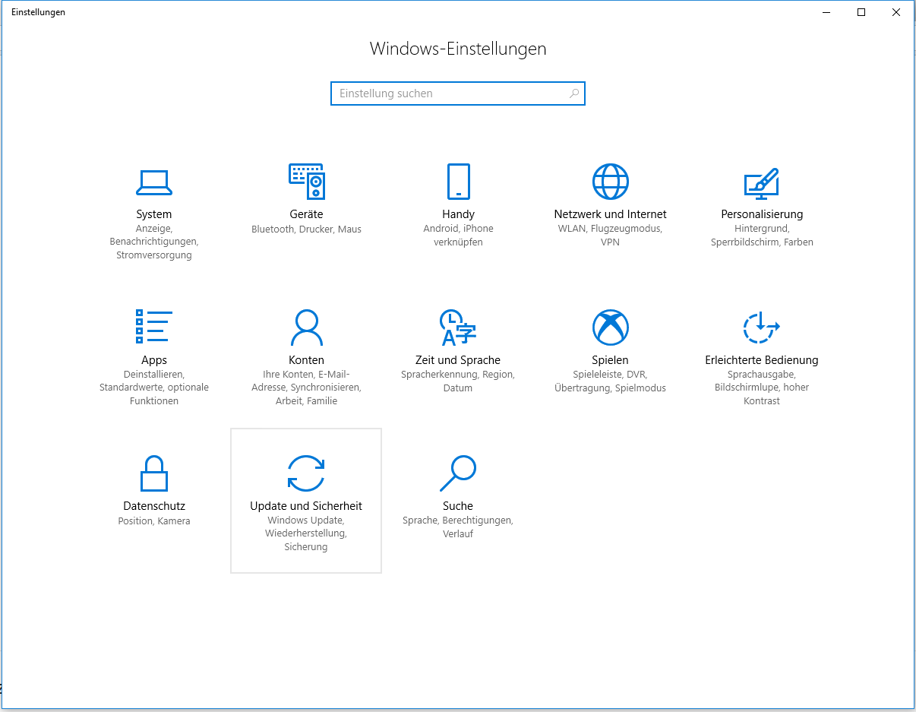
→ Update und Sichern
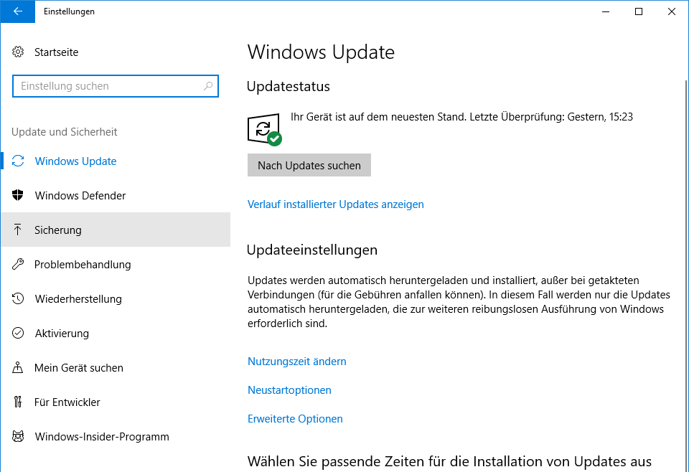
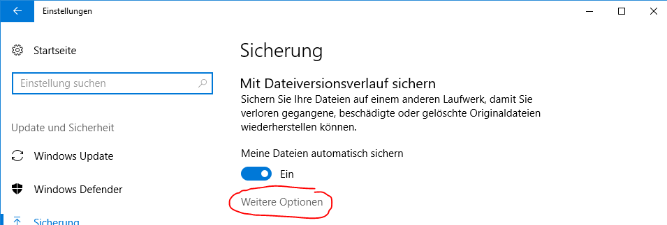
→ setting up personal data backup
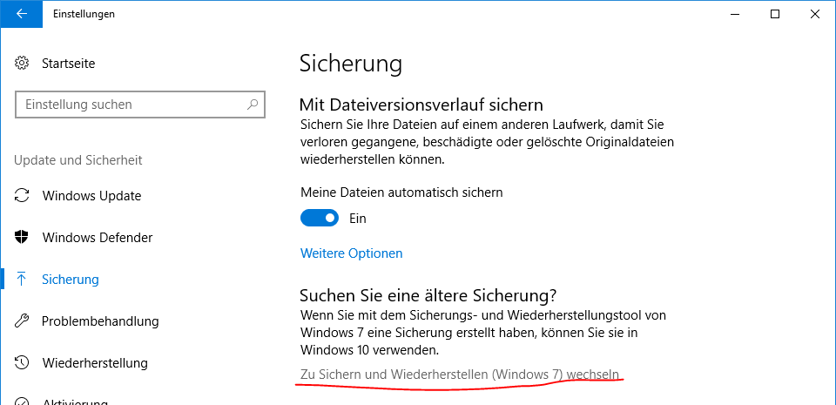
→ setting up system backup


