FaceRig
In order to start FaceRig, you have to doubleClick SteamLogin_FaceRig on the Desktop. Then you need to go to
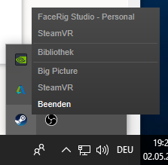
and select “FaceRigStudio Personal”

Streaming Avatar
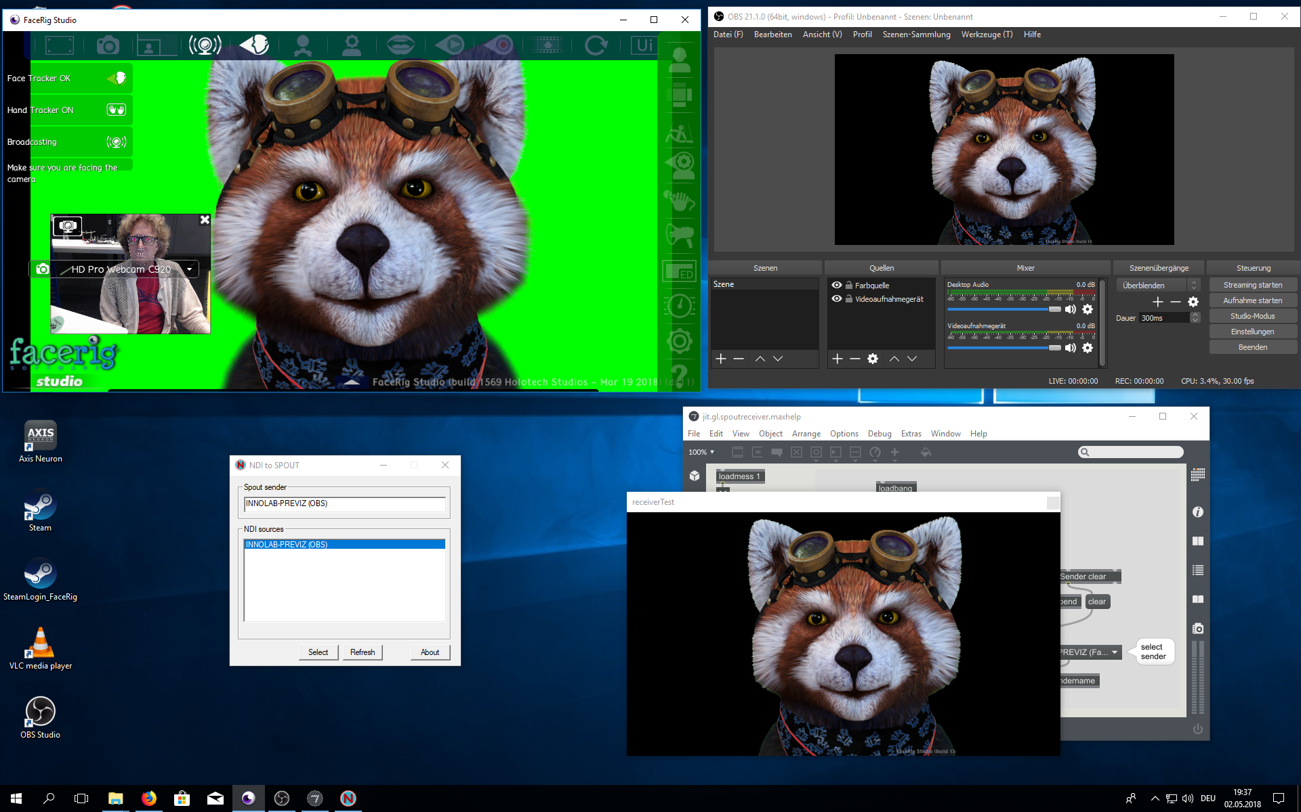
You need to have installed:
- OBS (Open Broadcasting Sofware)
- OBS->NDI
- NDI->Spout
- Spout
- Select “Broadcast” inside FaceRig
- Open OBS (Open Broadcasting Sofware)
- Create “Source/Quelle” → + → VideoRecording Device → select “FaceRig Virtual Camera”
- RightClick new Source → Filter
- Add Chroma Key
- Menu→Tools/Werkzeuge→NDI-OutputSettings
- Start NDI to Spout Application
- Select NDI source
- Open Spout Receiver

