Motive_Calibrating
When you start motive you should see the following:
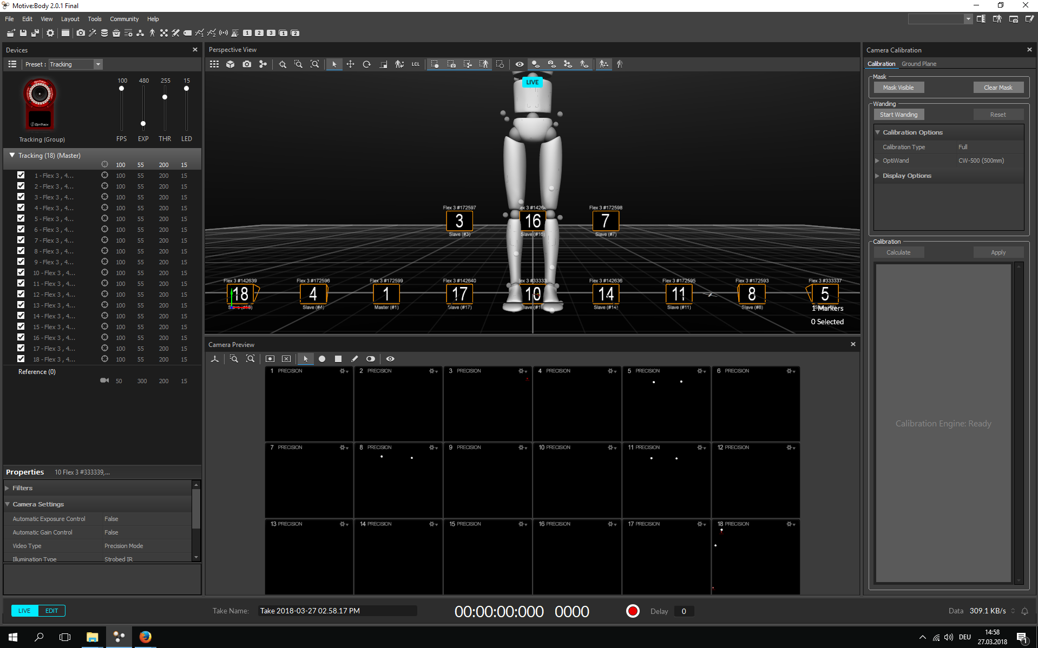
if not, go to menu > layout > callibrate
First you have to make sure no reflective objects are visible to the system.
Ideally it should look like this:
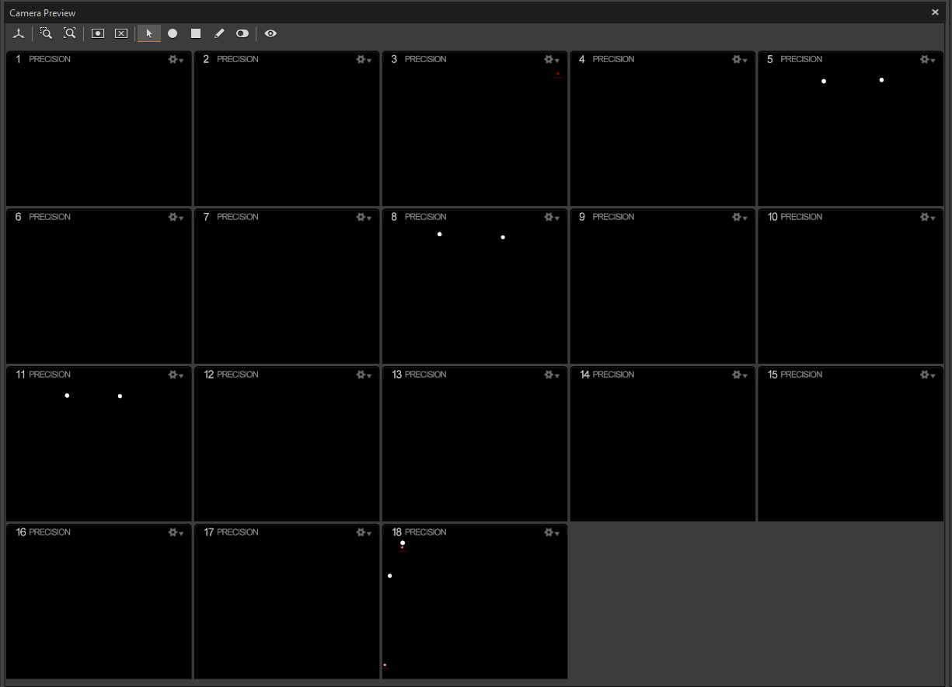
The only big refelections ara actually the cameras. everything else that reflects should be removed.
Many shoes have actually reflective surfaces, so make sure to either tape them or take them off for the following processes.
switch between the video modes to identify reflections:
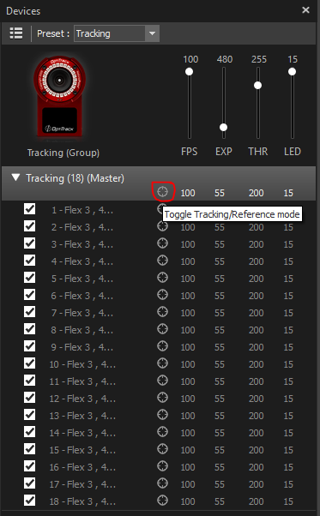
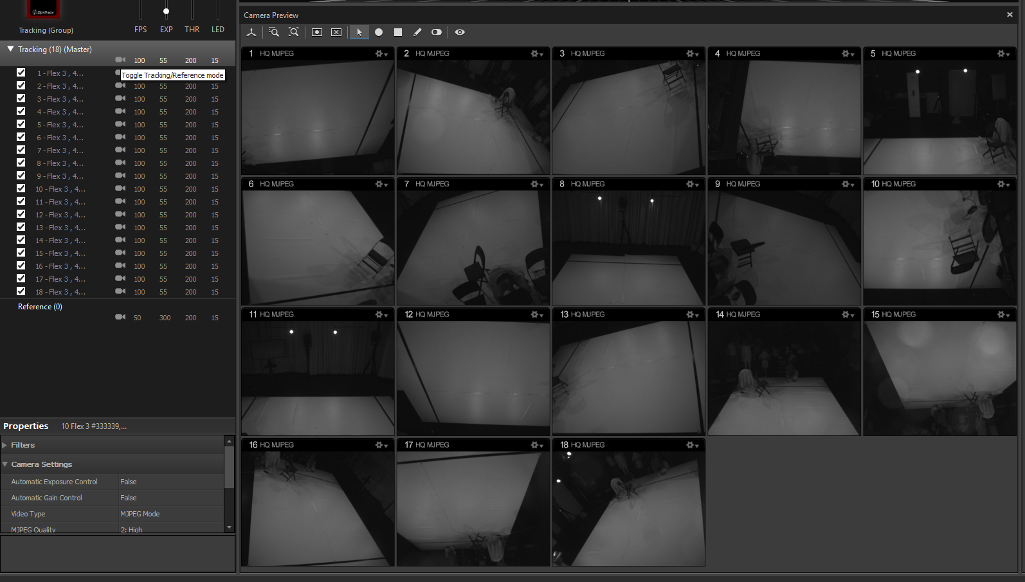
once all the refelctions are removed, clear the previsouly set masks (press “Clear Mask”):
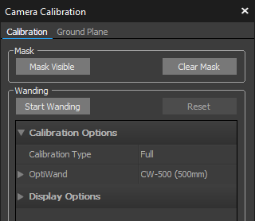
switch back the video mode to tracking mode.
check the Tracking Parameters
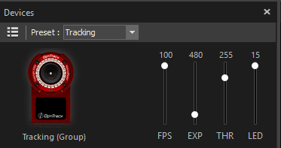
ideal settings are:
- FPS: 100
- EXP: 55
- THR: 200
- LED: 15
adjust this values until the reflections from the floor are acceptable.
then set the masks again (press “Mask visible”). it is important that nobody is inside the space at this moment.
once the masks are set, the space is ready for wanding. make sure you are using the correct wand (500mm)
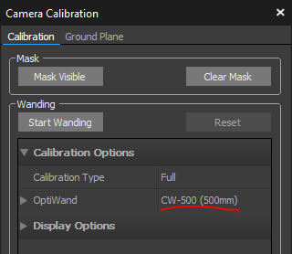
keep on wanding until each camera has at least 1500 Samples:
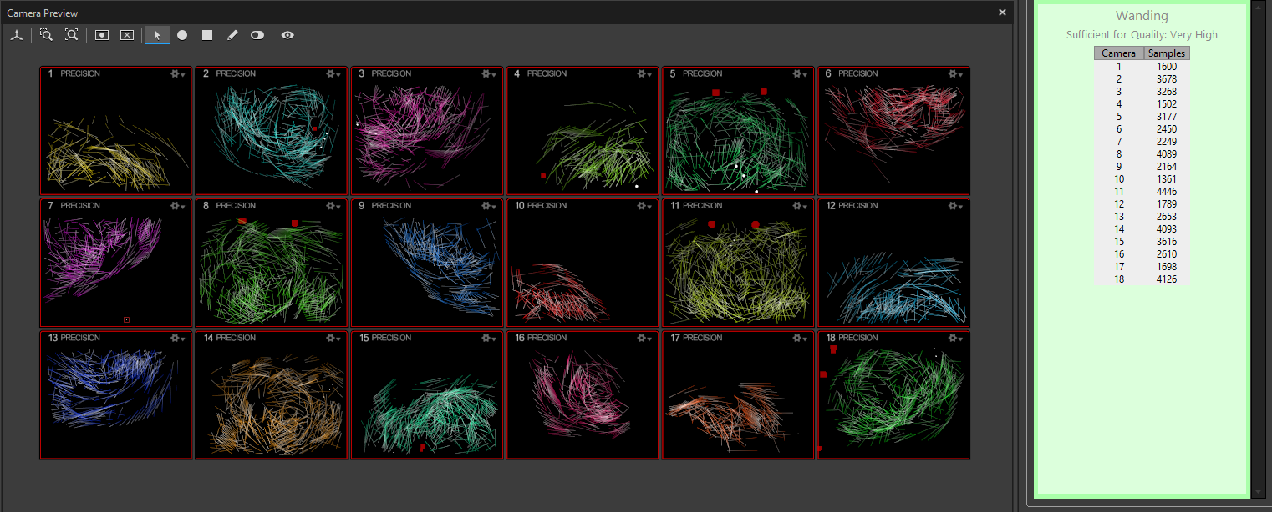
press calcualate:
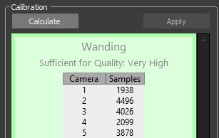
once the result looks like this:
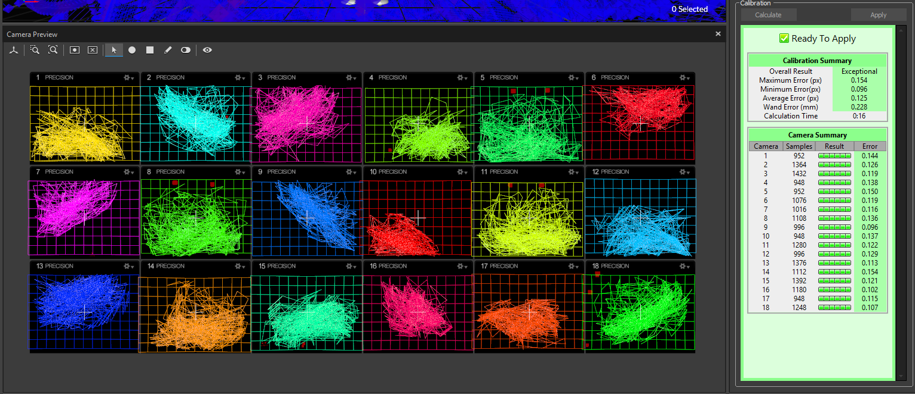
confirm to apply:
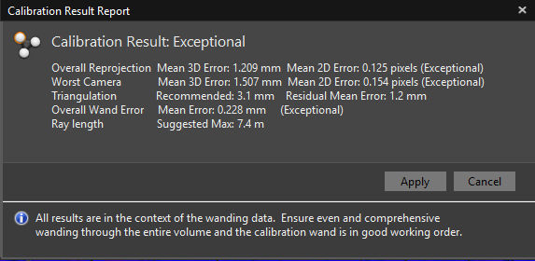
and as the last step set the ground plane:
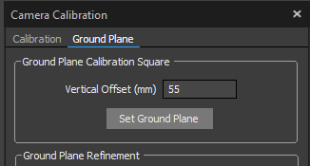
make sure the ground plane Z-Axis is pointing towards the computers. there are three markers on the trackingspace that indicate the position. If you plan to use the tracking system with projections, take care to position the groundplane as precise as possible over the markers.
save the callibration file inside your session folder.

