Create a rigid body
Motive > Menu > Layout > Create
Setup a rigid body. A rigid body should
- have at least 3 reflectors
- NOT be a symetrical
- NOT be just one line (i.e. like the wand)
Place the rigid body on the center of the trackingspace.
Select the reflectors of this body
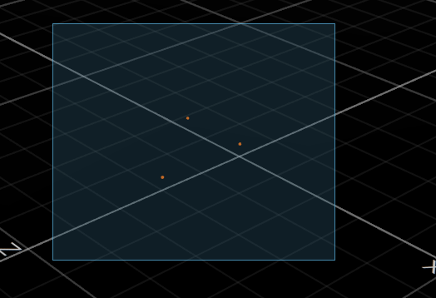
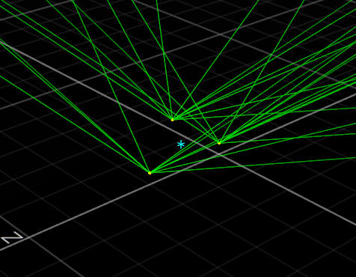
rightClick > rigid body > create
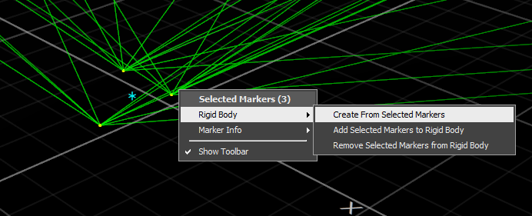
once created, give the body a unique name and choose a streaming ID.
adjust some additional properties:
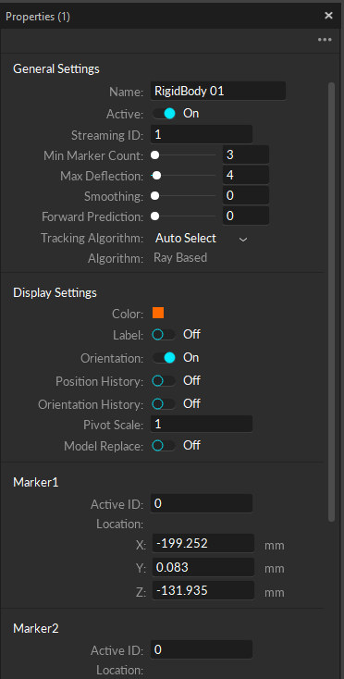
Smoothing - the higher the number, the smoother the tracking - but also creates more latency.

