Export animations
Select one or several takes you want to export. Right click > Export tracking data
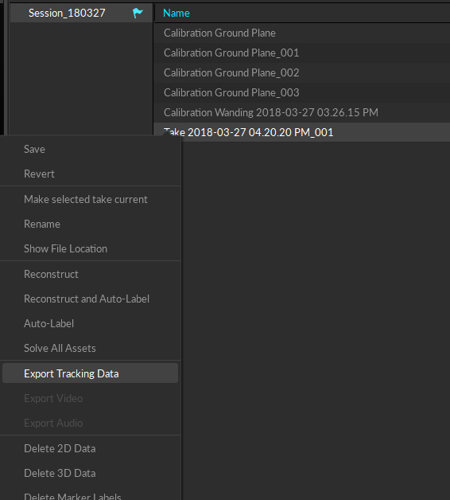
Choose your session folder.
Choose FBX Binary Format with folloing settings:
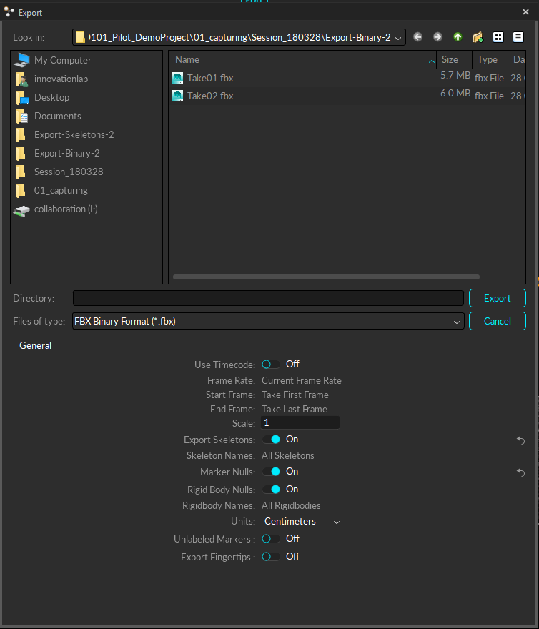
For every take, a FBX Binary file will be exported.

