Setup the tracking suit

Use the tracking suits ONLY with the black cotton-bodies underneath. It is the users responsibility to wash the bodies and bring them back in a timely manner.

Choose a suitable size suit for the actor. Make sure the suit fits tight and the top and pants cannot shift. Take off all the markers that are still on the suit.
Inside Motive Menu > Layout > Create.
We are using the Markerset “BaseLine + Hinged Toe” with 41 markers:
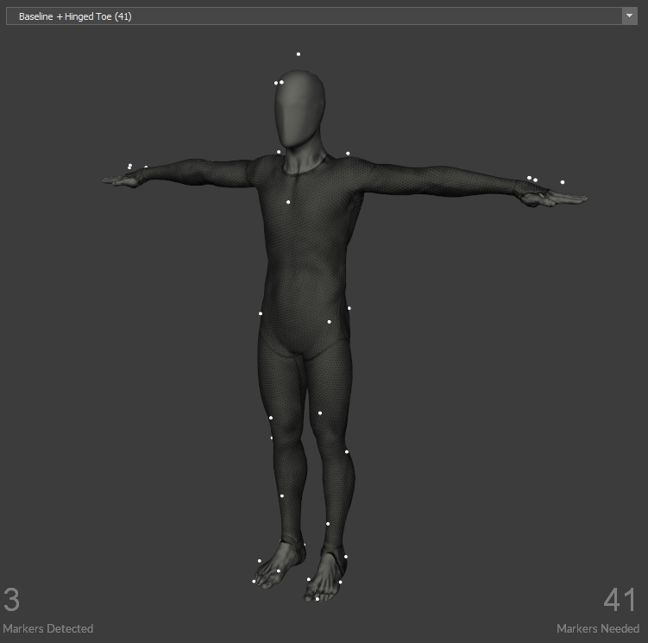
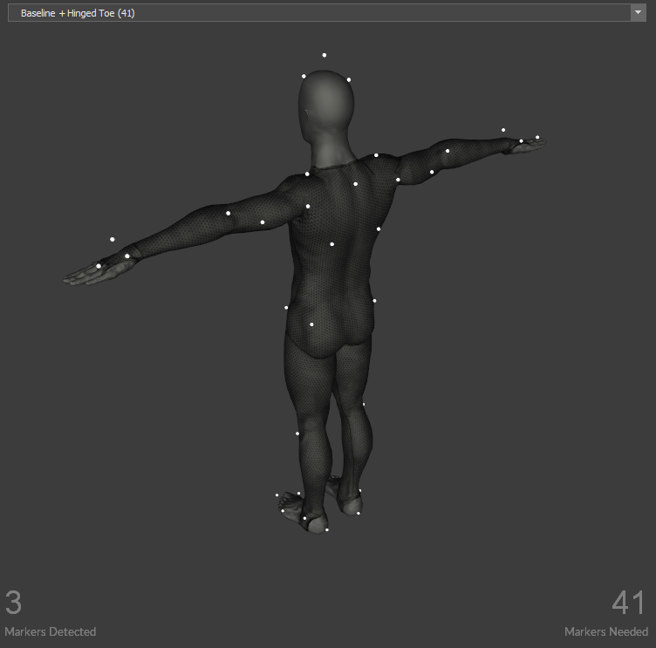
- feet: 5 (x 2)
- legs: 3 (x 2)
- hips: 4 (2 front - 2 back)
- back: 3 (triangle)
- shoulder: 2 (x 2)
- chest: 1
- arm: 2 (x 2)
- hands: 3 (x 2)
- head: 3
attach the markers according the model. take care at the joints. set the markers in such a way, that the marker defines the axis of the joint and doesn't move when the joint is used. (ankle, knee, shoulder, elbow.)
let the actor stand in the center of the space and take the T-pose.
the system should detect now all the 41 markers.
give it a name and press create.
If everthing went right, the virtuall character should appear inside perpective view. make sure the settings allow the display of the skeletons:
adjust manually each bodypart if they appear to be off.

