The NatNetThree2OSC software is located under
D:\Software\NatNet2OSC\Motive2.x
inside this folder is a batchfile called Motive2_to_App
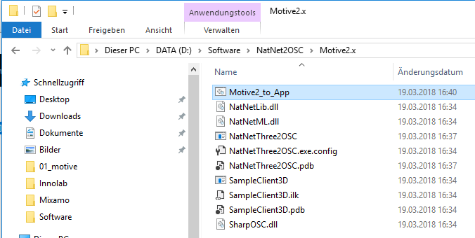
right-click - open and you can edit the startup parameters:
D:\Software\NatNet2OSC\Motive2.x\NatNetThree2OSC 127.0.0.1 127.0.0.1 127.0.0.1 54321 55555 1
- <D:\Software\NatNet2OSC\Motive2.x\NatNetThree2OSC> is the path to the NatNetThree2OSC.exe
- <NatNetLocal IP (127.0.0.1)>
- <NatNetServer IP (127.0.0.1)>
- <OscSendIP (127.0.0.1)>
- <OscSendPort (54321)>
- <OscListeningPort (55555)>
- <verbose [1]>
if you want to create another batchfile, simply copy this file and change the settings accordingly.

