The NatNetTwo2OSC software is located under
D:\Software\NatNet2OSC\Motive1.x
inside this folder is a batchfile called Motive1_to_App
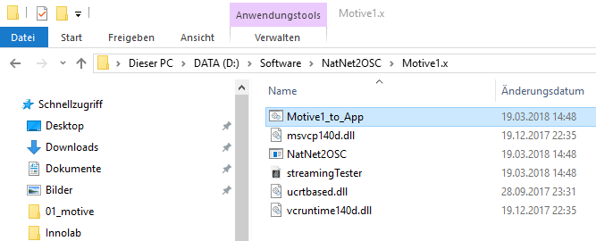
right-click - open and you can edit the startup parameters:
D:\Software\NatNet2OSC\Motive1.x\NatNet2OSC 127.0.0.1 54321 239.255.42.99 0 0
- <D:\Software\NatNet2OSC\Motive1.x\NatNet2OSC> is the path to the NatNet2OSC.exe
- <OscSendIP (127.0.0.1)>
- <OscSendPort (54321)>
- <Multicast IP (239.255.42.99)>
- <verbose [1]>
if you want to create another batchfile, simply copy this file and change the settings accordingly.

