Filer

Access from your personal Computer
In order to access the filer you need to be inside the zhdk-net. If you are outside ZHdK, you need to use a VPN connecton to the ZHdK first.
- Generic: filer.zhdk.ch/collaboration/IASpace
- Mac: smb://filer.zhdk.ch/collaboration/IASpace
- Windows: \\filer.zhdk.ch\collaboration\IASpace

Access from your personal Computer (MAC)
Open Finder > Go > Connect to Server…
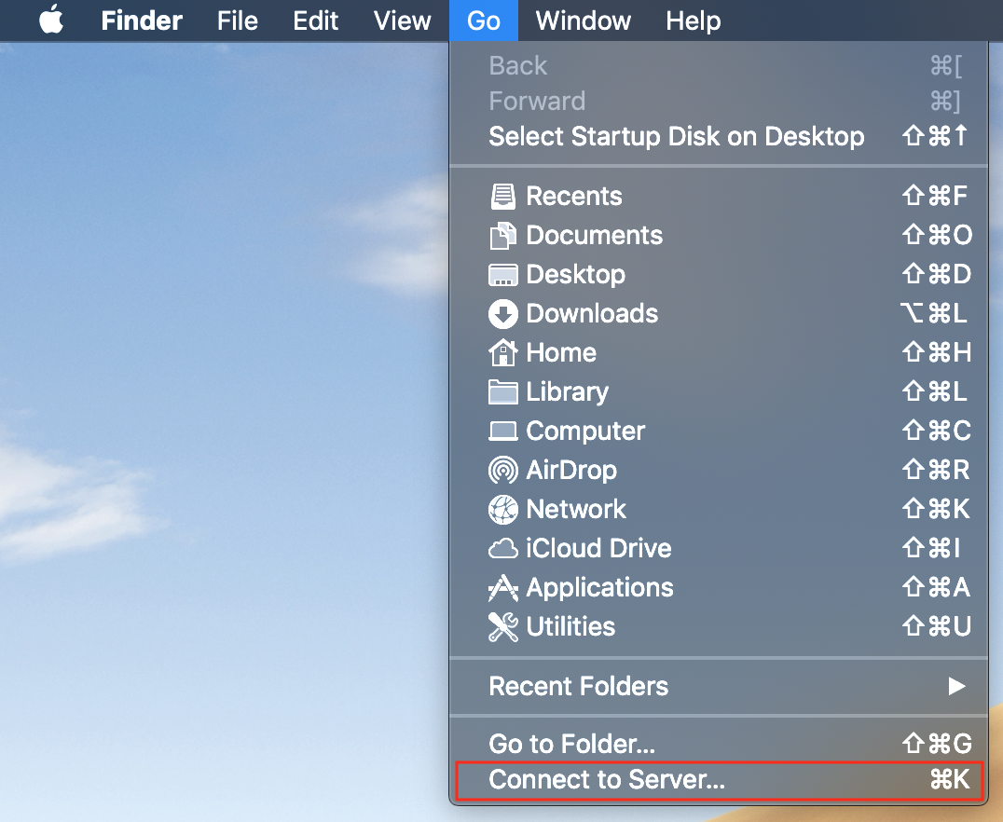
or
Open Finder and press Command (or Cmd or ⌘) + k.
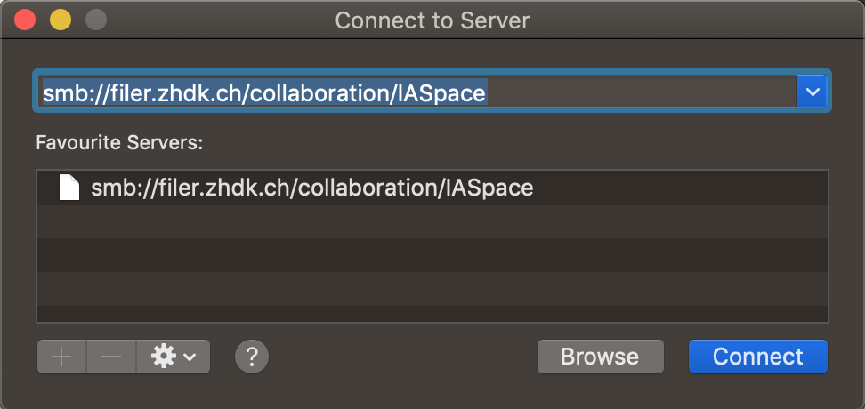

Access from InnovationLab Computer (Windows)
In order to access the filer, use the local collaboration (I:) drive.
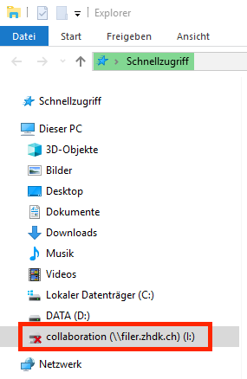
You need to login with your username. Press “Weitere Optionen” and “Anderes Konto verwenden” to enter your login info. Because these machines are in the BYO-domain, zhdk\ in front of your username is necessary.
zhdk\<your username>
password
Please do not save your login data and leave “Anmeldedaten speichern” unchecked.
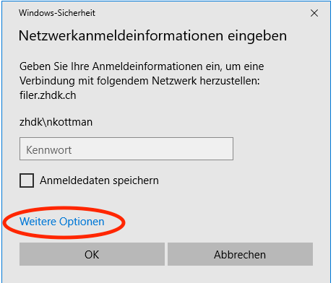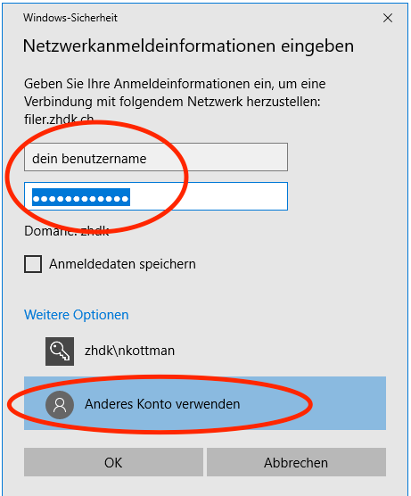

Organisation
These pages intend to describe how to use the Filer. Under Each folder you will find an individual input on what kind of infos you can expect to find, what data should be stored where and how you should structure the data.
Inside the filer all our knowledge we gather during the process of of the project - be it in form of howtos, tutorials, animations, code or models - will be stored. Knowledge is our most precious result and we should take care to create a solid and clean house for it.
00_howtos - all knowledge on how to do things
01_assets - all things to play with
02_personal - all things personal
03_projects - all things for your project
05_workshops - all things for / from a workshop
06_research - all research
07_lehre - all teaching
08_software - all things soft
09_hardware - all things hard
10_infrastruktur - all about where we play
11_mediathek - all about what inspires us
12_publication - all things we want to inspire with

