Antichamber
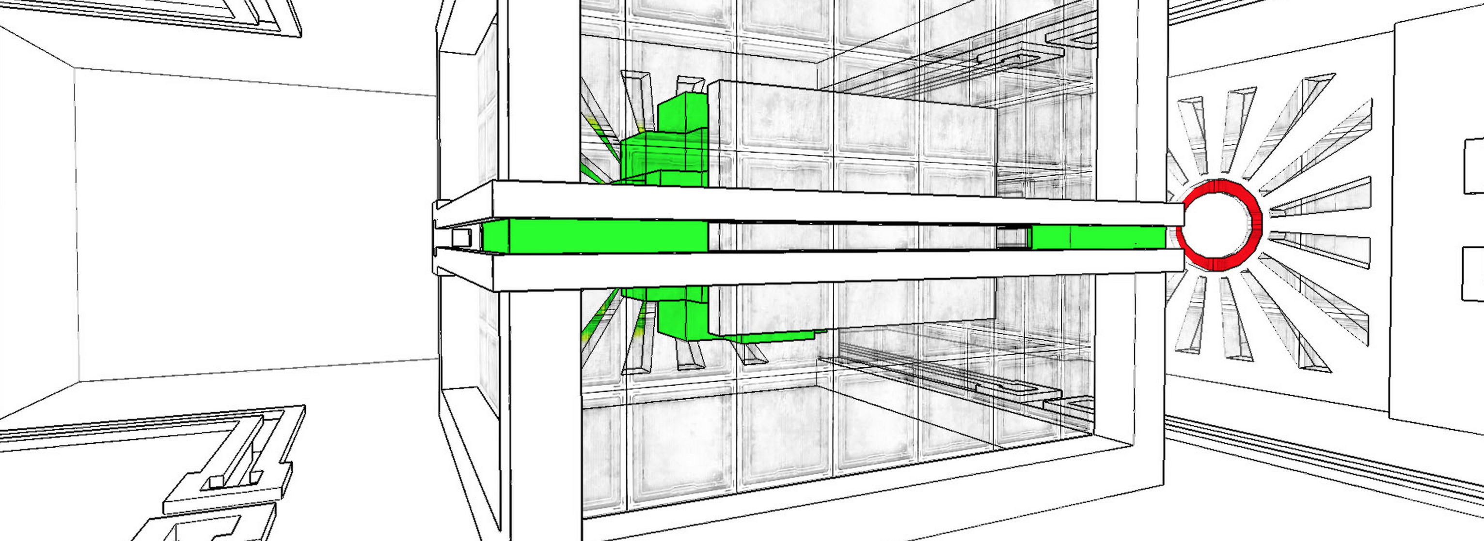

Spieldaten
- Genre: Puzzle-platform game, psychological exploration
- Plattform: Windows, Linux, Mac OS X
- Publikationsjahr: 2013
- Developer: Alexander Bruce

Spielbeschrieb
Antichamber (originally known as Hazard: The Journey of Life)[2] is a single-player first-person puzzle-platform video game developed by Alexander Bruce. Many of the puzzles are based on phenomena that occur within the Non-Euclidean geometry created by the game engine, such as passages that lead the player to different locations depending on which way they face, and structures that seem otherwise impossible within normal three-dimensional space. The game includes elements of psychological exploration through brief messages of advice to help the player figure out solutions to the puzzles as well as adages for real life. The game was released on Steam for Microsoft Windows on January 31, 2013,[3] a version sold with the Humble Indie Bundle 11 in February 2014 added support for Linux and Mac OS X.
Text von http://en.wikipedia.org/wiki/Antichamber

Sounds im Spiel
Atmosphäre
text
Interaktive Sounds
text
Narration
text

Gegenüberstellung von Portal und Antichamber
Insert sö Text here
Tunay Bora & Simon Gloor & Anna Nikitin

