Brawlhalla
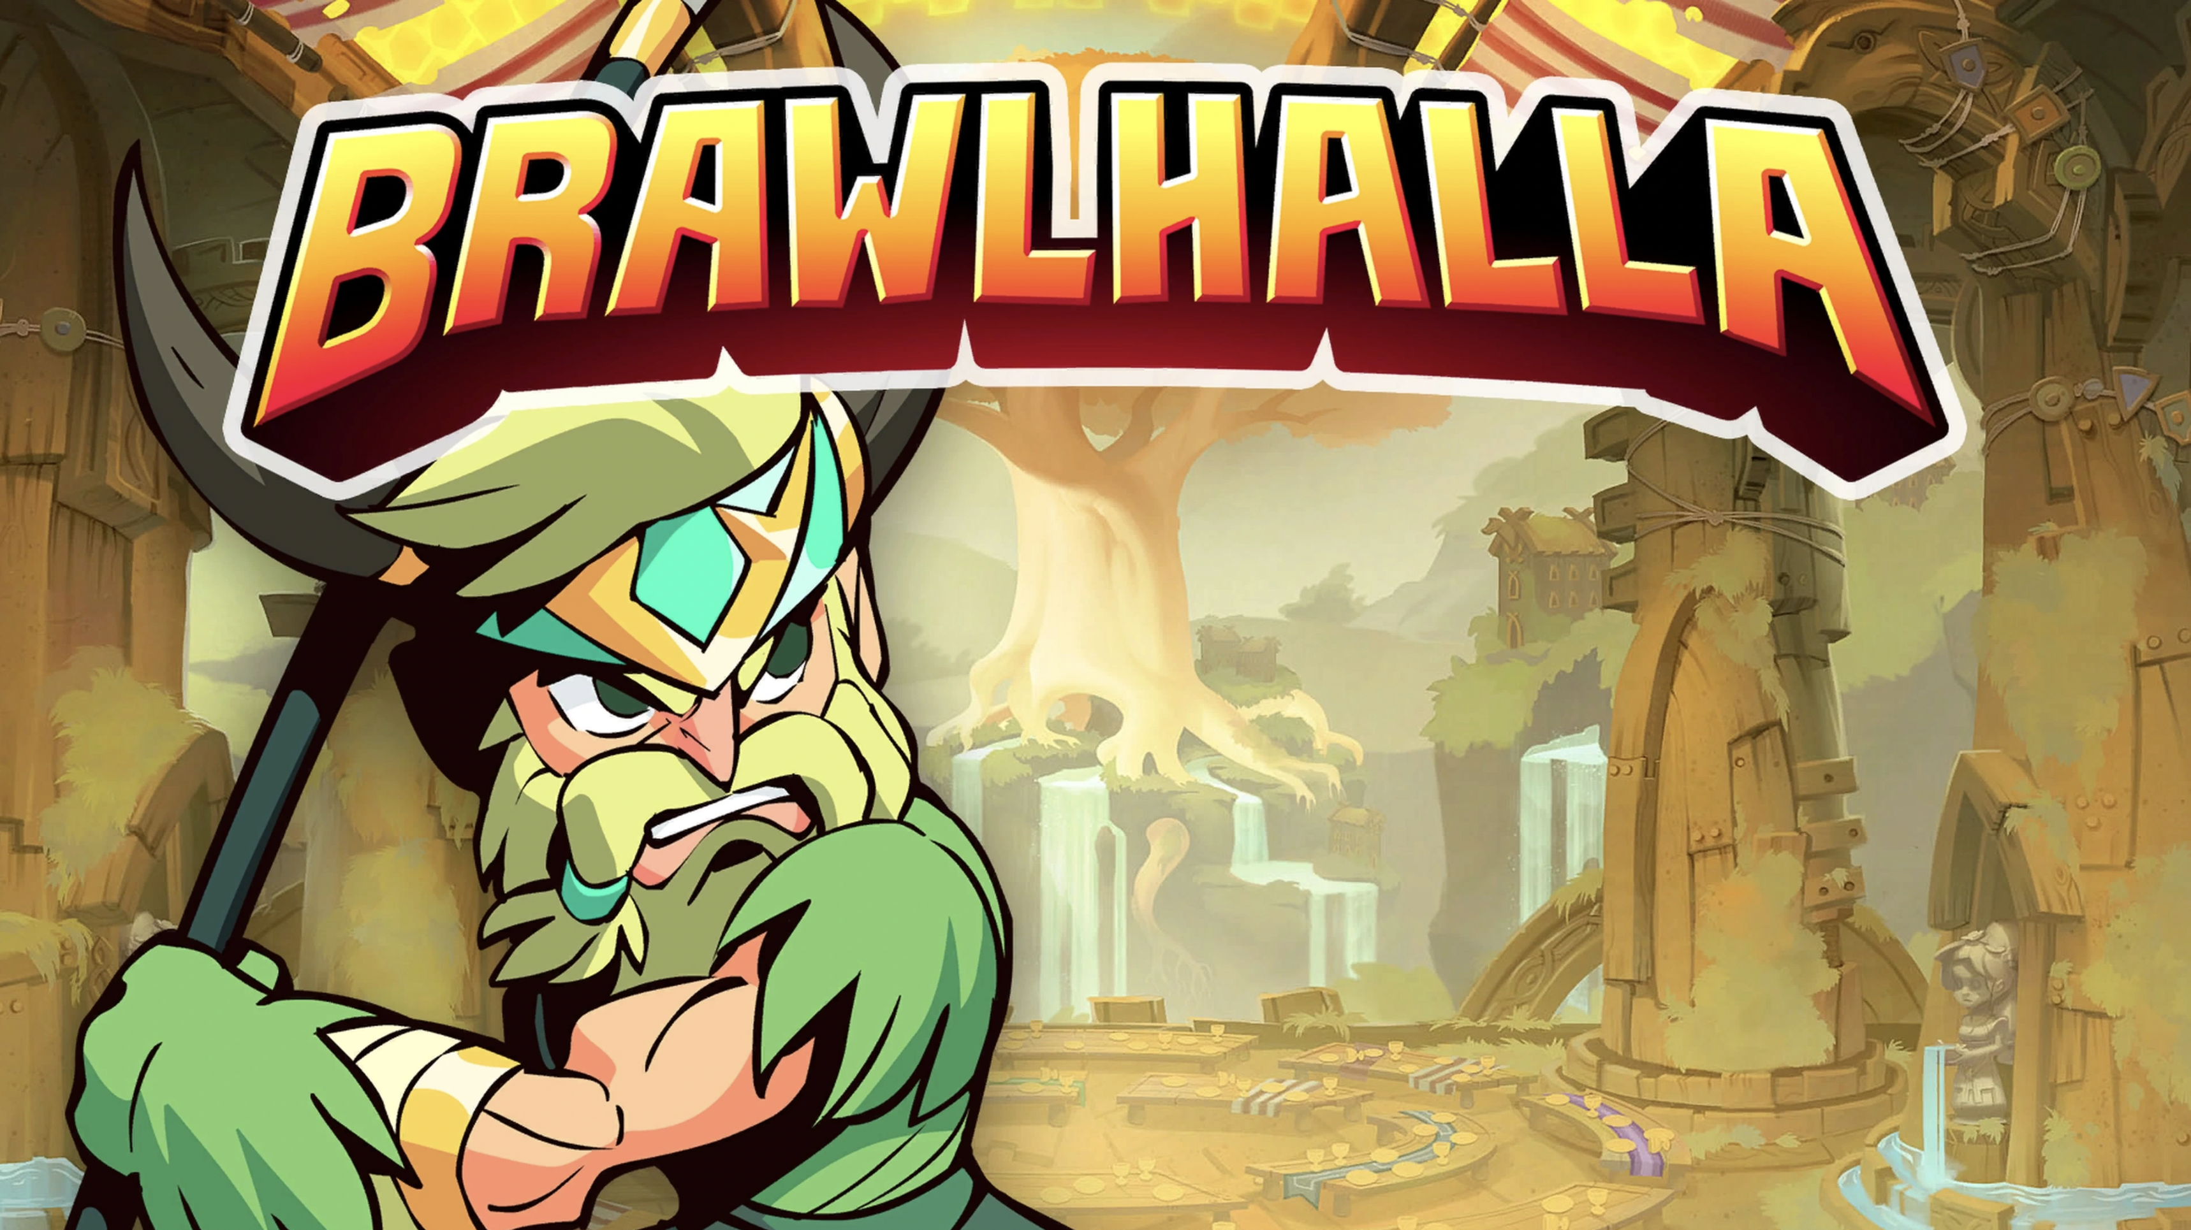
Genre: | 2D platformer fight game
Publikationsjahr: | 2017
Studio: | Blue Mammoth Games
Analyse von: | Nicola Kazimir, Charles Roberge, Dominik Stettler

1. Short Info / History
Brawlhalla is a 2D fighting video game developed, published by Blue Mammoth Games (Ubisoft). The game was released in Early Access in 2014, before its final release in October 2017 on PC and PlayStation 4. The game applies a free-to-play business model and features a game system similar to the games in the Super Smash Bros. franchise. Following the acquisition of the development studio by Ubisoft in 2018, the game was then published by the latter. At Gamescom 2018, Ubisoft announced that the game will be released on November 6, 2018 on Switch and Xbox One. The game is also released on PlayStation 5 and Xbox Series.

2. Main screen
The music is very epic oriented. It feels like a gladiator waiting for your turn in the back rooms of the colosseum. With its strong moments and calm moments, the music even addresses another aspect, storytelling. This is surprising because usually the main menu music remains simple as we rarely listen to them in full. The Ui sounds are very simple, but if the music is activated, you almost can’t ear them. Coupled with a screaming voice, the sounds of menu changes have a strong impact, as if a commentator was announcing your choice in the arena.
Brawlhalla - Main Theme | main_theme.mp3
Brawlhalla - UI | ui.mp3

3. Character Select Screen
The music of the character selection is like a continuation of the main music. it takes up the same aspects, the epic style but calmer, with a dimension of storytelling.
Brawlhalla - Character selection | charachter_selection_real.mp3

4. INGAME
In game there are 4 layers of sound:
- UI Sounds incl. announcers
- Character Sound EFX
- Stage Ambiances
- Stage Music
Attack sounds on Brawlhalla can give clues about your opponent's next attack. Each character has a different sound, and so does each of his attacks. The sound is released before the attack takes place. One can clearly hear the first phase of the sound, and the moment when the attack takes place. The music of each level is closer to the classic style that we know from fight games. Music with a rhythm, a faster tempo, and more electronic sounds. The direction is quite different from the first two home music. There are always some instruments and some orchestral parts that are the same, but we can almost believe that the music of the menu and the music of the nivaux are two different games
Brawlhalla - Level 5 | level_5.mp3
Brawlhalla - Level 9 | level_9.mp3
Brawlhalla - LevelBubble | levelbubble.mp3
Brawlhalla - attacks SFX | attacks_brawlhalla.mp3

5. Remaster of street fighter
Currently Brawlhalla is in collaboration with streetfighter, so the main music and character select music are street fighter remakes. However, we feel that these are remakes of street fighter 5 music, and not street fighter 2. It is therefore impossible to establish a real link to compare them.
Brawlhalla - 06.09.22 actual main menu | street_fighter_remaster.mp3
Brawlhalla - 06.09.22 actual character selection 5 | street_fighter_remaster_2.mp3

6. Comparison of Super Streetfighter II & Brawlhalla

6.2 Physicality
It is very apparent where the roots of most fighting games lie, Street Fighter II. Maybe it is easier to see where there are similarities between the two products. At some point a certain aspect, somewhat an inevitable realization happens, what makes these titles believable is the characteristic play of weight. All actions deal with a reaction, if hitting successfully the players get rewarded by a sound of impact, besides the fact that HP-bars get visually deminished (although most of the time characters also react with sound when being hit).
If we speak about physicalities let's go even further, weight implies speed and way of movement. While Street Fighter relies more on fist fights, Brawlhalla brings different elements or rather materials into the scene which further improve the amounts of possible sounds.

6.2.1 Orientation
As stated with the different potential actions, the difficulty of deciphering movement increases, but in both titles sound is used in order to let players rely on their ears and through that possibly reduce reaction times, which is crucial for games of this genre.

6.3 Dimension
They are alike in dimensions, so to speak both enable the players to move 2-dimensionally although brawlhalla brings something maybe more modern(?), the traversable space is now improved to higher and lower levels and is not limited to one line of movement only. this brings with it room, room for hearable volume which has on one side the capability of simulating distance, which is strongly used in this case, on the other side it brings with it a certain emptiness. comparing that to street fighter II, for sure there's a certain limitation to spacial perception, probably also due to hardware limitations, but all in all this gets rounded out by memorable sounds layered on top of each other, which strike out the need of space. Also if we visualize the idea of a fight in Street fighter, it is more of a cage fight, there is no way to escape and in this matter maybe it has not only been a limitation but also a decision to keep spacial aspect of sound out.

6.4 Battlecries
Which leads to the last sort of characteristic that we'll look at now. While Brawlhalla extents and also outplays Street Fighter in the technical aspect, still in some ways it is lacking. If we further observe this phenomena we can then find the reason. In Brawlhalla there are no recognizable battlecries, which compared to the completely voiced out Street Fighter, brings out a certain weakness so to say. It is almost monumental how timeless the simple implementation of Voices can be, which are still present even after 30 years.
Guile - Sonic Boom | guile-sonic-boom.mp3
Ryu/Ken - Shoryuken | ryuken-shoryuken.mp3

