Brawlhalla
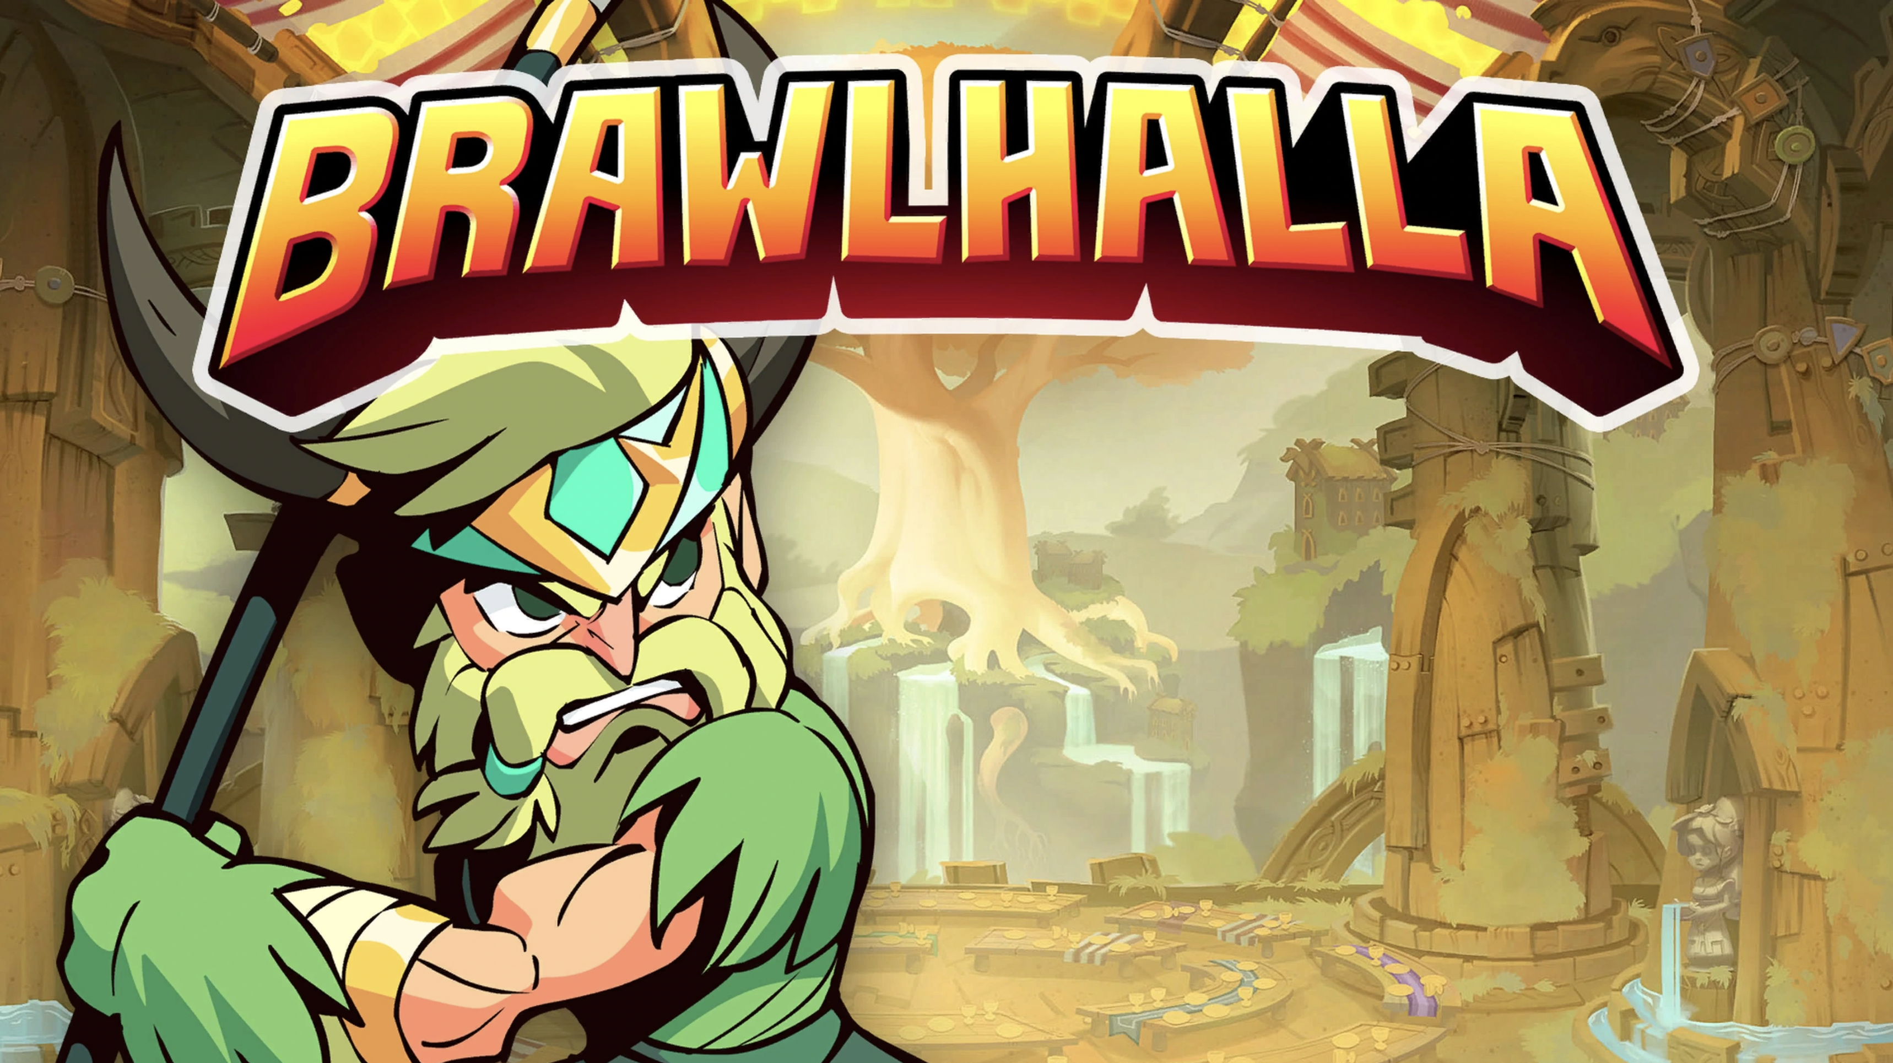
Genre: | 2D platformer fight game
Publikationsjahr: | 2017
Studio: | Blue Mammoth Games
Analyse von: | Nicola Kazimir, Charles Roberge, Dominik Stettler

1. Short Info / History
Brawlhalla is a 2D fighting video game developed, published by Blue Mammoth Games (Ubisoft). The game was released in Early Access in 2014, before its final release in October 2017 on PC and PlayStation 4. The game applies a free-to-play business model and features a game system similar to the games in the Super Smash Bros. franchise. Following the acquisition of the development studio by Ubisoft in 2018, the game was then published by the latter. At Gamescom 2018, Ubisoft announced that the game will be released on November 6, 2018 on Switch and Xbox One. The game is also released on PlayStation 5 and Xbox Series.

2 Main screen
The music is very epic oriented. It feels like a gladiator waiting for your turn in the back rooms of the colosseum. With its strong moments and calm moments, the music even addresses another aspect, storytelling. This is surprising because usually the main menu music remains simple as we rarely listen to them in full. The Ui sounds are very simple, but if the music is activated, you almost can’t ear them. Coupled with a screaming voice, the sounds of menu changes have a strong impact, as if a commentator was announcing your choice in the arena.
Brawlhalla - Main Theme | main_theme.mp3

3 Character Select Screen
The music of the character selection is like a continuation of the main music. it takes up the same aspects, the epic style but calmer, with a dimension of storytelling.
Brawlhalla - Charachter selection | charachter_selection_real.mp3

4 INGAME
In game there are 4 layers of sound:
- UI Sounds incl. announcers
- Character Sound EFX
- Stage Ambiances
- Stage Music
Attack sounds on Brawlhalla can give clues about your opponent's next attack. Each character has a different sound, and so does each of his attacks. The sound is released before the attack takes place. One can clearly hear the first phase of the sound, and the moment when the attack takes place. The music of each level is closer to the style of street fighter. Music with a rhythm, a faster tempo, and more electronic sounds. The direction is quite different from the first two home music. There are always some instruments and some orchestral parts that are the same, but we can almost believe that the music of the menu and the music of the nivaux are two different games

5Remaster of street fighter
Currently Brawlhalla is in collaboration with streetfighter, so the main music and character select music are street fighter remakes. However, we feel that these are remakes of street fighter 5 music, and not street fighter 2. It is therefore impossible to establish a real link to compare them.

