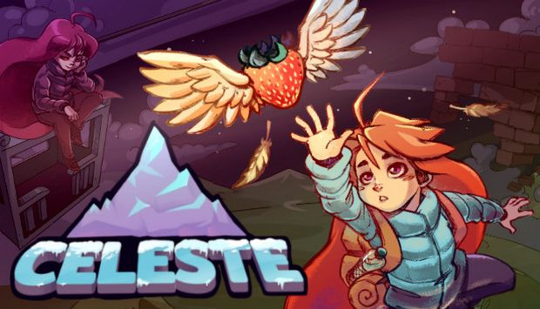
Genre: | Platformer, Indie
Release: | January 2018
Developers: | Matt Thorson, Noel Berry
Analysis by: | Agata Tselesh, Pietro Peduzzi, Kathleen Bohren

Game description
Celeste is a indie developed platformer. The story talks about Madeline a young girl that has decided she wants to climb the mount Celeste. Little she knows the mountain hide some secrets and obstacles that will change her forever. The player will proceed in the game by climbing and jumping from platform to platform. The world is divided in rooms, if the player dies he will be respawned at the start of the room he was in. All skills and movements are already given to the player at the start, the challenge stays then in using them in new ways to surpass more and more difficult obstacles.

Sound description
Celeste is a game that relies heavily on the anxiety and other emotions of the main character and this is mainly represented by the music that surrounds the gameplay. We then have the sound effects and the environmental sounds that then help the gameplay and immersion in the game world. The game is divided by chapters and so is the soundtrack, for each chapter there is one or more soundtrack that will guide the player though the gameplay.

Soundtrack
Prologue | celeste0.1_prologue.mp3
1. Forsaken City
2. Old Site
3. Celestial Resort
4. Golden Ridge
5. Mirror Temple
6. Reflection
7. The Summit
8. Core
9. Farewell

