Counter Strike 2
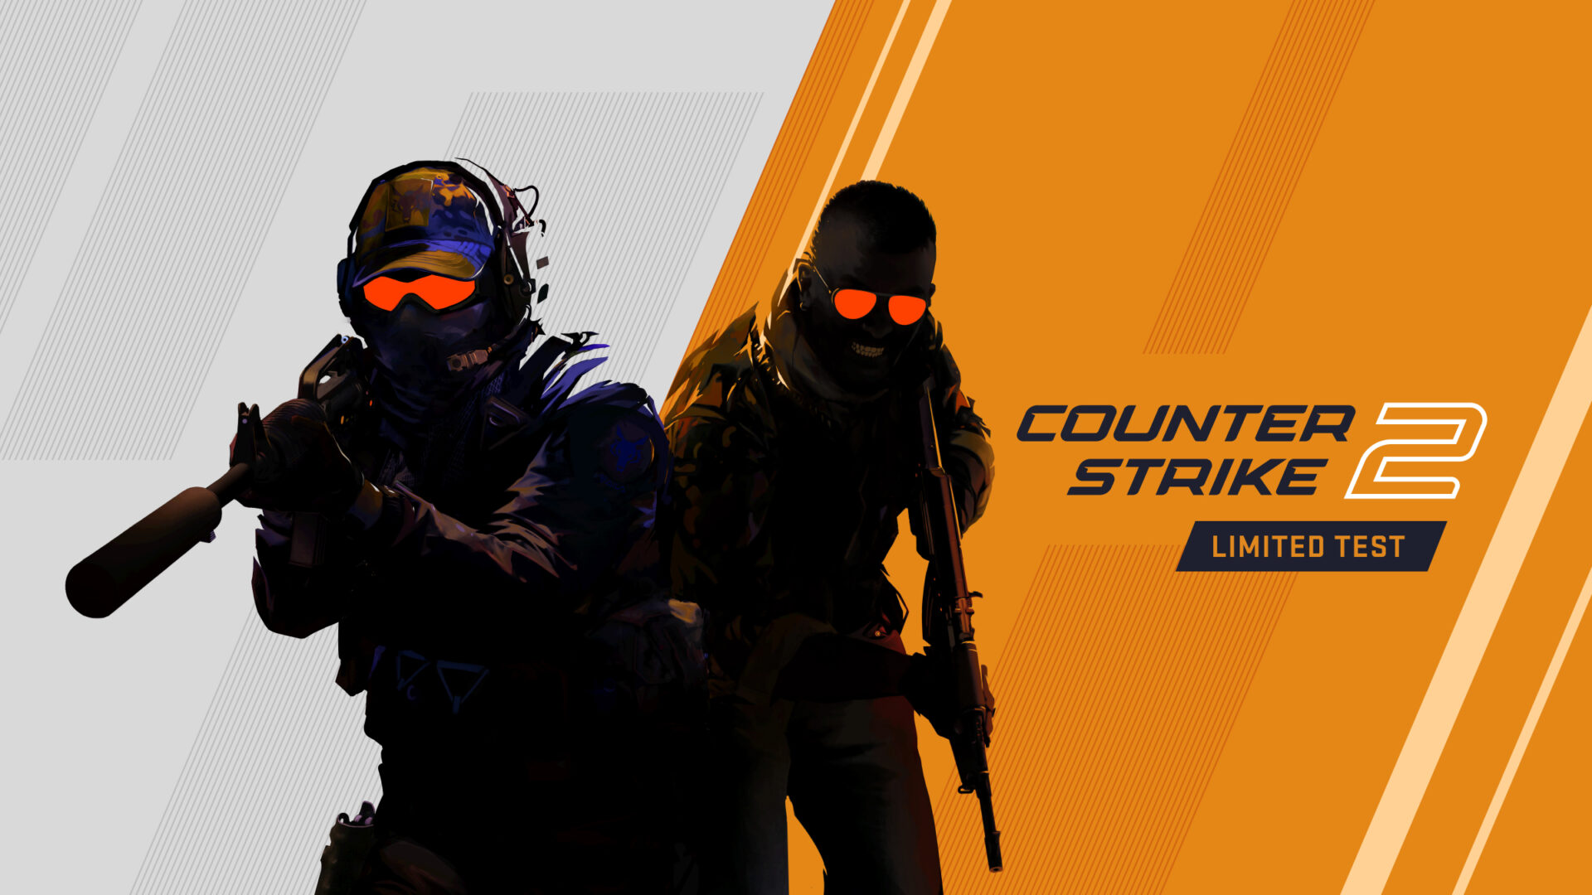
Genre | multiplayer shooter
released: | 2023
Developer | Valve
Analysis from | Muriel Ackermann, Gianmarco Di Vincenzo, Yevhen Kozlov

1. General Info
Counter Strike 2 is a competitive multiplayer tactical first-person shooter published by Valve. It is a successor of the very popular Counter Strike franchise that had its beginnings in the early 2000s. Counter Strike 2 was released in 2023. 10 players compete against each other in a 5 vs 5 being part of either the terrorist or counter-terrorist team. The terrorists try to plant a bomb on one of the designated bombsites and the counter-terrorists try to stop them by defusing the bomb. Terrorists and counter-terrorists have access to different weapons but have the same utilities. Setting: realistic

2. Importance of sound in Counter Strike 2
In Counter Strike 2 sound is essential. Players need all the information they can get to get an advantage over the opponent. Whether it is footsteps, grenades or the bomb being planted every sound is of high importance. So, it is important for all actions and weapons to have distinct sounds.

3. Footsteps
The footsteps of enemies are one of the most crucial information. Through the sound of footsteps and their position, you can assume the enemy’s position. Footsteps can be heard through walls in a specific proximity or the player model. They are somewhat muffled behind walls but still very noticeable and loud because they are important to gameplay. You can also hear if players step on different kinds of ground like sand or stone or metallic things. You can completely silence your movement by sneaking/walking.
Player footsteps: footsteps_cs2.mp3

4. Bomb
Planting or defusing the bomb are very important sound cues. Planting the bomb starts with a low-pitched double beep sound. After that, there are button press sounds and then a drop on the ground. After that, the bomb starts beeping at a very high pitch, getting faster and faster and closer to detonation. This sound is heard in large proximity of the bomb, so you can hear where it was planted and how far away you are from it. At 10 seconds before detonation, music starts playing, reminding you of the short time you have to defuse. The last few seconds of the sound have a much larger radius. When the time is up, the bomb explodes in a very loud explosion sound accompanied by a round-win sound for the terrorists. The explosion as a long reverb period, but the impact sound is instant and has no delay. If the bomb is being defused, there is the same pitched short triple beep sound at the beginning of defusing. While defusing, there is no additional sound, you can just hear the bomb ticking. When defusing is finished, there is another short triple beep sound that is deeper than the first one and sounds like a shut-down sound.
planting bomb bomb_planting_and_explosion_cs2.mp3
defusing bomb bomb_defuse.wav

5. Utility
In Counter Strike 2 every player has access to the same 5 utility grenades: Molotov, hand grenade, a flashbang, a smoke grenade, and a decoy grenade. All these utilities have distinct sounds. Also, their different stages of being equipped or detonating. You can also hear when an enemy is hit with a grenade or Molotov if you are close enough. Being burned by a Molotov gives of a very comical „steak on grill“- sound, which does not seem very realistic but brings the message across. If you get affected by a flashbang or a grenade, you get muffled sound and a ringing in your ear for a short period of time. Impairing your hearing giving you a disadvantage.
flashbang flashbang_cs2.mp3
burned by molotov burned_by_molotov_cs2.mp3

6. Character voiceovers
In Counter Strike 2 you have the in-game characters giving info and callouts. They scream when they use a utility grenade and when they are planting or defusing the bomb. The audio of these voice lines is distorted and bad quality. It tries to simulate a walkie-talkie sound. During the round, the characters only say useful information like what grenade they are throwing and only in the beginning or at the end of rounds they say some flair texts. These flair texts show that it's a game and not a very serious situation, which should be immersion breaking but actually makes the game more silly and fun.
throwing grenade grenade_throw_cs2.mp3
flair voiceline flair_voicelines_cs2.mp3

7. Weapon sounds
In Counter Strike 2 there are 34 different weapons, in addition to different knives and a taser. Each of them have different sounds, making them distinguishable between each other. All weapon sounds have a lot of reverb on them. More depends on the caliber of the weapon. In general, the guns try to sound accurate to their real-life counterparts. Even though the gun sounds would be much louder and more impactful in real life, it makes sense to tone them down for the gameplay experience so that the player can hear different sounds more clearly and to not overload the ear with loud annoying sounds. The gun sounds sound very clean and satisfying, making it enjoyable to shoot them. When you are low on ammo in a magazine the sound indicates that.
Desert Eagle desert_eagle_cs2.mp3
AK-47 ak-47_cs2.mp3
AWP awp_cs2.mp3

8. Taking dealing damage/ killing
Taking or dealing damage is a key mechanic of the game and has to be represented in the sound. Hitting an enemy in the body causes a sound like a blood splatter. You can only hear that sound if you are in proximity. If you get hit, the same sound plays. This sound is very wet and juicy but also sounds very impactful. Hitting a headshot or getting hit with a headshot gives a very loud and distinct sound. It is a high pitched bouncy and hollow sound. If it's a headshot kill the pitch is higher. That sound does not sound like a skull crushing or something like that it sounds more like a typical game sound that gets introduced to players that they just accept. Like a coin sound. Also this sound is an indicator sound and ignores the distance to the target. If you kill an enemy, you get a very subtle deep base sound confirming your kill. If someone or you die, the character lets out a moaning sound.
headshot and headshot kill headshots.wav
hitting enemy sound splatter.wav
kill confirming base sound distant_kill.wav
moan sound death_moan_cs2.mp3

9. General noise
There is some ambient noise at the beginning of rounds to give some more immersion, but as soon as the round starts, every environmental sound fades into the background. There are also ui noises for buying weapons and pining locations to your teammates. All common sounds except the bomb have a low pass filter when heard from a distance and the shape of the map does not affect the hearing range. Every location has it’s own ambient sound that is defined by a fixed volume (fades in/out when player moves to another area). Reverb is not very pronounced as in other games, most areas have identical reverb.

10. Conclusion
The sound in Counter Strike 2 is mostly very realistic. There is not too much sound and you can only hear things that give you information. For example, footsteps, and enemy reloading, the bomb being planted or defused. The sounds of the weapons are very clean and fit nicely. Maybe this is a biased opinion though since counter strike shaped the tactical shooter genre and some of those sounds are classics that we as players just understand as an original sound. These sounds inspired many games after and if they sound different from counter strike players might see them as not realistic since their ears are used to counter strike sounds.

11. Comparison with Valorant
Even though Counter Strike 2 and Valorant have completely different settings and styles, their gameplay is so similar that it makes sense they share many sound categories. While CS2 aims for a more realistic sound, Valorant incorporates a lot of futuristic and synth sounds.
Both games prioritize providing crucial information to the player through sound, but they differ in their approach. Valorant features numerous voice lines from in-game characters designed to aid team communication, such as characters calling out enemy positions. In contrast, CS2 relies on players using in-game voice chat for communication. Weapon sounds in CS2 feel heavy and impactful, also the reverb changes for every gun, signaling its strength and if it is silenced or not. In Valorant, gun sounds are somewhat hollow and high-pitched and so the weapons sound like they are made from plastic, even though their material is sometimes not easy to identify.
Valorant also uses distinct and noticeable sounds, like its very prominent kill sound that plays g major keys and completes it in a melody when a player kills 5 enemies. With Valorant big number of agents possessing various abilities, each with unique sounds and voices, players must learn to recognize and react to them. Despite the variety, these sounds share a technical, futuristic quality.
In CS2 all agents have the same abilities, so you don’t need to differentiate between their voices. Also, the kill confirm sound is not as noticeable as the one in Valorant. Headshot noises are treated very similarly in both games. As they are used as an indicator sound that plays no matter the distance from the enemy.
In general, the reverb in both games sound a bit flat which makes sense, since real life gun reverb is very loud and wouldn’t be pleasant to hear while playing. In Valorant this is more prominent though. Where it feels like the sounds don’t represent the environment and feel very flat and empty.
CS2, as the successor in a long-standing series, benefits from nostalgic and iconic sound effects. From weapons to the iconic voice lines, CS2 sounds just „feels right,“ making it hard not to see it as the original and Valorant as a copy. Ultimately, Counter-Strike’s classic status and sound design makes it feel whole, while Valorants feels a bit empty sometimes.

