DOOM Eternal
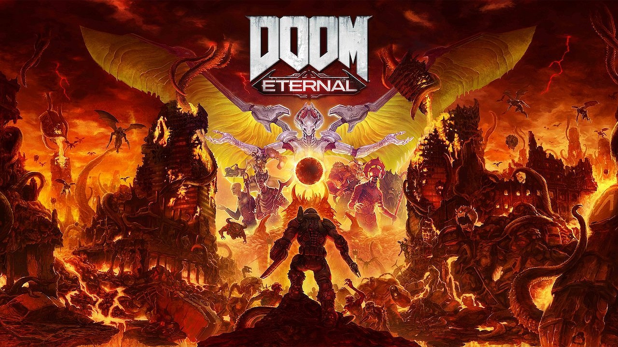
Introduction  DOOM Eternal is a fast-paced first-person shooter developed by Id Software.  It is part of the DOOM series and it features a grand single-player campaign and a multiplayer mode.  In DOOM Eternal, you play as the DOOM Slayer, a man tormented by unrelenting bloodlust. You must protect the Earth from demons. Amongst other places, you venture to hell and back to achieve this feat.  Sound and especially music play a great role in this game. On one side, Mick Gordons Metal-Electro fusion soundtrack takes the stage, but the sound effects themselves also really help keep the players hyper-violent power fantasy alive.
  Genre: | First-person shooter
  Release: | 2020
  Platforms: | Microsoft Windows, PlayStation 4, Stadia, Xbox One, Nintendo Switch, PlayStation 5, Xbox Series X/S
  Developer: | id Software
  Publisher: | Bethesda Softworks
  Analysis by: | Michael Staub, Dorias Schärer

Music

Environment
Here are the different environmental soundscapes that DOOM Eternal uses to immerse the player. (Note that the actual corresponding soundscapes start only after a couple of seconds, and they switch between different locations inside the level)
Cultist Base Mars Core Arc Complex Doom Hunter Base | Hell on Earth Nekravol Sentinel Prime Super Gore Nest | Exultia Final Sin Taras Nabad Urdak
Let's take a closer look at Super Gore Nest (that's the bottom middle one). Firstly, theres a faint sound of wind. Extremely distant howling and thunder create a sense of a big open space. Closer, you can hear some otherwordly sounds. These paint a picture of a soundstage that is near the listener: A soundstage that reminds of living and breathing flesh, pulsing. You can hear monsters growling, some closer and some further away.
The sounds of Urdak (bottom right) are also quite impressive. Synthesizers are used to gives tones of „energy“. Repeating melodies of energetic arcs swing through the air. The atmosphere feels tense, charged with electricity.
The sounds of these environments do not change over time. In DOOM Eternal, there exists no real sense of day- or nighttime: It feels like time has stopped. This also plays into the apocalyptic setting.
A lot of DOOM Eternal's environments use sound to portray this uneasiness that is present through the game. Deep bass roars and shrill wind tones combine into a background sound that is inherently hostile; like everything is dead, except the beast below.

Sound Effects

UI
menu_sounds.mp4 | The Menu Sounds in the game are kept to minimal clicks.

Guns
shotgun.mp4 | The Shotgun is the game's starting weapon. Using a weapon mod, you can also shoot sticky bombs with it (that's what's shown in the beginning. The S=shotguns reload sound does have some higher pitched components, making it feel and sound not as hefty as some of the other weapons, which is fitting since the shotgun is a weapon with relatively low damage.
assault_rifle.mp4 | The Heavy Cannon is a full-auto assault rifle. When hip-firing, the sound it creates consists of a higher pitched rattling (presumably from some kind of bullet-feeding chain) and of a loud bass noise. When firing full auto, this bass illustrates the power behind each shot. When scoping in, you can hear a high pitched sound when the gun is done scoping in. This gives feedback to the player when the gun is ready to shoot. Finally, the shots while scoped in are deafeningly loud; so much so that the player doesn't even hear the bang to its full extent. This bang also travels outwards and echoes around the room and back to the player, really showing how loud it is.
plasma_gun.mp4 | The Plasma Gun has a bit of a different sound signature than the other guns. The upper and middle frequencies consist of this energetic „laser beam sound“ that quickly sweeps from a high to a low pitch. Of course, once you fire full auto, the individual shots combine into a sort of chain. In the lower frequencies there is a fuzzy bass that gets especially prevalent once you stop shooting. After the Plasma Gun has fired enough shots, it can release a burst of energy. This is a bit less bassy, but after the sound starts high-pitched in the middle of the sound stage, it travels outwards and its pitch gets lower.
super_shotgun.mp4 | The Super Shotgun is a fan favourite and its sound design won't disappoint. The shot itself starts with loud bang that continues outwards as a thunderous roar. The shells are then ejected with a low-pitched plop. Finally, a clear mechanical click tells the player when the gun is ready to shoot again. All these sounds combined give the weapon a great feeling and motivate the player to keep on using it.
chain_gun.mp4 | The Chain Gun is a heavy, belt-fed gatling gun. As you start firing, the individual shots start to shift their pitch upwards, until the gun has reached its peak speed. When switching into turret mode, a high click, combined witha mechanical thud confirm that the gun is again ready to fire. In turret mode, there is also a noise that becomes higher pitched over time, indicating the gun heating up. The player is able to use this sound to know when to stop firing so that the gun doesn't overheat.
rocket_launcher.mp4 | The Rocket Launcher has a extremely sharp, high-pitched noise when firing, like metal hitting against metal. While rechambering the next round, pistons can be heard pushing the next rocket into the chamber. The rockets explosion itself is a distorted bassy thud.
crucible.mp4 | The Crucible
ballista.mp4 | The The Ballista

Roundup
All of the weapons in DOOM Eternal use sound as a way of describing their power; each and every weapon feels strong and unwieldy. Of course, all of this goes into the power-fantasy that is prevalent in DOOM. Each gun uses a deafening bass to convey the power it posesses and to some extent the power of the DOOM Slayer himself.
In my oppinion, the weapons' sounds are designed really well. They inform the player if the gun is ready to fire and are easily distinguishable.

Movement

Other Actions

