Five Nights at Freddy's 1 (FNAF)
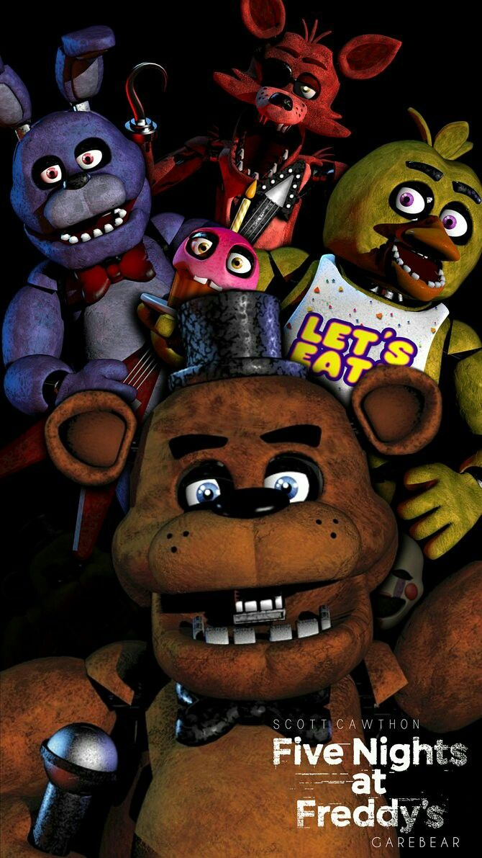
Genre: | Survival Horror, Point and click
Release: | 2014
Platforms: | MS Windows, PS4, PS5, Xbox One, Nintendo Switch, iOS, Android, Oculus Quest
Developers: | ScottGames, Steel Wool Studios, Illumix
Publishers: | ScottGames, Clickream LLC USA, Illumix
Analysis by: | Chaowei Arakawa, Charisse Ann de Leon, Gabrielle Gerber & Sofiia Yurchenko

1. Gameplay
The Five Nights at Freddy's series consists of horror-themed video games in which the player is usually a night-time employee at a location connected with Freddy Fazbear's Pizza, a fictional children's restaurant that takes inspiration from family pizza chains like Chuck E. Cheese's and ShowBiz Pizza Place. The restaurant has life-size animatronic characters that perform at children's parties. The animatronics wander the restaurant at night and the guard is instructed to watch over them. To progress through the games, the player must guard themselves against animatronics with a variety of tools. Also every night the player has a phone call. This is an important piece for people who are interested in the story behind it all. The phone calls also explain to the player how the game works. They are from a man who worked your shifts before you, and is finishing up his last week. In Five Nights at Freddy's, the player can control the two security doors connecting their office to the adjacent hallways as a barrier against animatronics in the vicinity. Each night, the player has a power supply that depletes faster when a tool is used. If the power goes out, the player can no longer use any tools and is defenseless against the animatronics.
Five Nights at Freddy's - Trailer: https://youtu.be/Ws-yd9YPfdE

2. Sound
The basic mood of the game is rather dark. As a player, you have no possibility to move or protect yourself, nor do you have much information about what is happening. Therefore, you have to rely on the audio and visuals of the game. Five Nights at Freddy's consists of advantageous audio, immersive sounds and detrimental audio. The advantageous audio helps to navigate where the animatronics are, when the cameras are not working. The immersive sounds are used for atmosphere, mood and what the game world would sound like. The detrimental audio is used for the horror and unease of the game.

2.1 Advantageous Audio
Audio Clues
Animatronic in the Kitchen | chicainkitchen.wav
Freddy's Laugh | freddylaugh.wav
Game State

2.2 Immersive Sounds
Diegetic Sound Effects
Camera glitching | cameraglitching_anematroniclookingatit.wav
Door Lights buzzing, On & Off | door_lights_buzzing_turnon.wav
Camera panning | camerapanning.wav
Door closing | doorclosing.wav
Animatronic Running | foxyrunning_chasingafteryou.wav
Animatronic knocking | foxyknocking_foxybehinddoor.wav
Non-Diegetic Sound Effect
Bonnie or Chica (Animatronics) appear at your Door | theyarehere_standingoutsidedoor.wav

2.3 Detrimental audio
„Muddied“ Sounds
Camera glitching | cameraglitching2.wav
Fan
Red herrings
Ambiance 1 | ambiance.wav
Ambiance 2 | ambiance2_theygettingcloser.wav
Circus Organ, played randomly | mascot_tune.wav
Foxy singing | foxysong.wav
Vaguely Vocals and Sounds„ | Bonnie / Chica (Animatronics) right in front of the door angry | itsme_chicabonnieangry_night5_6_7.wav | | Night 5 Phone call | 5nightcall.wav | | Animatronic in your Office | theyarein_bonniechicasnuckin.wav | | Freddy's laugh | freddylaugh.wav | ====== 3. Conclusion ====== We enjoyed the game Five Nights at Freddy's, you can name it basic in the horror genre. It's quite scary because of the spooky, moody music, the sounds, the scary characters, the location — a children's pizzeria, all these things create a great creepy atmosphere. Depends on the player, if you don't play horror games because it's really scary for you, then the game will be very vibe and grisly. It has good graphics, it has a story, interesting gameplay, because with each night it gets harder and harder for you to survive. Of the minuses, the player can't walk but just sits in place and turns his head in different directions. It would be really interesting to be able to get up, walk around the location, look at the animatronics, run away from them if they see you. It would have been nice to have the choice to move or sit where you are and look at the cameras. It has pretty primitive approach to scaring the player — full screen scrimmer and screaming. For lovers of scary games and for players with less experience in horror games, this game will be very terrifying indeed, especially if played at night. ====== 4. Comparison with Outlast ====== ==== 4.1 General Comparison ==== ==== 4.2 Sound Comparison ==== Soundtrack Noise/Tone Voice Over User Interface**

