gone_home
Originaldatei

Gone Home
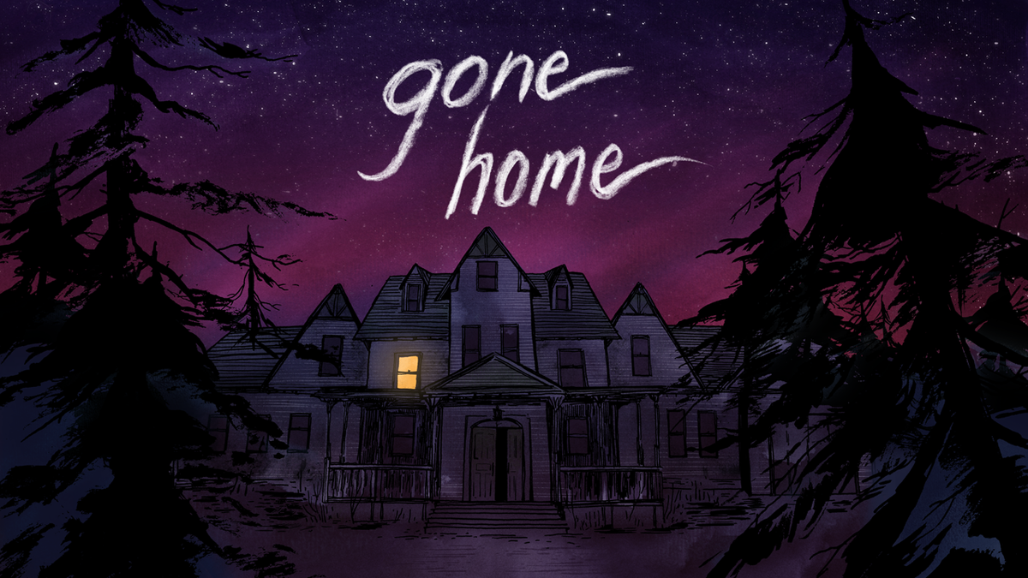
GENRE | ADVENTURE
RELEASE DATE | 2013
STUDIO | THE FULLBRIGHT COMPANY
ANALYSIS FROM | NOE ARNOLD, RAHEL GAMMA

1. GAME DESCRIPTION
Gone Home is an adventure game from 2013 that tells an interactive story. Set in the year 1995, //Gone Home// puts the player in the role of a young woman returning from overseas to her rural Oregon family home to find her family currently absent and the house empty, leaving her to piece together recent events.
Trailer
https://www.youtube.com/watch?v=DMDaMK-9Tzc
Walkthrough
https://www.youtube.com/watch?v=SS5eQmRgBlY

2. SOUND DESCRIPTION
“He used vintage piano sounds, such as Wurlitzers and Fender Rhodes, in order to create the distinctive sounds needed for the time and place that the game was set in. However, it also needed to blend into the background; one note that Gaynor kept bringing up was for there to be "less melody" and for Remo to "pull it back". It resulted in a very subdued melody that underscored every audio diary, and worked to contrast the sound with the secondary riot grrrl soundtrack.” -quote about Chris Remo (composer of the music for Gone Home).
The feeling of coming back home after a long time and sadness over discovered stories and memories within the game are all translated into sound. The setting has an overall soundtrack playing in the background. In addition to that, contemporary music can be found throughout the story, giving a time and place for “Gone Home”.

2.1 ATMOSPHERIC SOUNDTRACK
Considering the fact that the player doesn't leave the house or “indoors” throughout the length of the game, there are still faded atmospheric sounds from outside influencing the overall ambient inside, like the rain and light storm. In the house itself there are the muffled noises resembling the sounds of the old building. The noises are all captured in a low and rustic tone.
Titel | Beschrieb | Meinung | tmw_atmosphre.wav
Titel | Beschrieb | idk | Button

2.2 ACTION
The core mechanic of the game “Gone Home” is the exploring of the empty house and discovering/picking up story-telling items. The most important objects being the journal entries which are accompanied by a voice over. These core mechanics are highlighted with an importance of volume and sound, when being picked up.
Every action in the game gives a clear response to the player. The basic actions, like opening a door or turning on a light, are underlined and exaggerated in the game, maybe not mimicking real life very realistically but giving a satisfying feedback to the player, that something happened in-game or an action was achieved. The action sounds are subtle and underline the importance with increased volume.
Titel | Beschrieb | idk | Button
Titel | Beschrieb | idk | Button

2.3 COMMUNICATION WITH PLAYER
The game communicates subtly with the player and can, for example, lure them in a certain direction with an object-bound sound that plays from another room and strikes new interest. Almost no sound is classified with a fully bad or good response for the player, instead they simply communicate their meaning and nature, like turning on a tape recorder, reading a journal or simply clicking through the map.
There is no permanent UI on screen but an inventory which can be opened and shows the player found “Items”, the “Map” of the house and “Journals”, in this menu the sounds are held very monotone and have a similar sounding effect like the rest of the objects in-game, when they are picked up.
Titel | Beschrieb | idk
Titel | Beschrieb | idk

2.4 ROOM
SETTING
A toned down but melodic soundtrack is used which fits the surrounding of the game and plays in the background throughout the entire story. This soundtrack can increase and decrease in certain moments of the game, for example when the atmospheric sound from outside intensifies, it almost fades completely, giving space to the rain or thunder. It doesn't differentiate too much however, playing a very similar sounding theme overall and the transitions from one track to the next are subtle.
RECORDS
There are multiple objects scattered in the house that the game takes place in, which break the soundtrack in the background and play their own music, with much higher volume. These sounds are a strong contrast to the otherwise calm sounding theme and differentiate from classical music to punk rock.
Titel | Beschrieb | idk
Titel | Beschrieb | idk

2.5 NARRATION AND DRAMATURGY
FEELING
The game “Gone Home” uses silence and music to create tension and atmosphere and build this sad, hollow feeling for the player to recapture the empty house they found themselves in. With the soundtrack underlining the story, it plays in a rhythmic up and down going tension, with only a subtle upwards curve towards the end, where the narration takes a hopeful turn and the music plays happier tunes.
VOICE OVER
The main character can’t be heard in the game (other than her footsteps), so it can be difficult for the player to capture her emotions or intentions in every moment. However, a family member reappears over and over throughout the story. The younger sister “Sam” of the main character is heard through her journal entries to Katie, where she talks to her about important events or emotions. This story is being highlighted for the player and really pierces through the soundtrack as well as the sound effects.
Titel | Beschrieb | idk
Titel | Beschrieb | idk

3. AESTHETIC DESCRIPTION

3.1 STYLE, GENRE
The sound in “Gone Home” creates a living and breathing setting, which brings the empty house to some extent back to life. The game has a gloomy and depressing genre. And the voices and stories heard, together with the music playing from the tapes or old record players really bring the dark genre together with the year that the game is playing in and create a realistic style for the time the game is capturing.
Titel | Beschrieb | idk
Titel | Beschrieb | idk

3.2 SOUND QUALITY
The game has a very muffled characteristic sound overall, which fits the theme. The quality of the sound holds up quite well, except for a few action sound effects, which come across a little outdated. The different sounds audible within the game play well into each other, the change of soundtrack in the background is almost seemingless.
Titel | Beschrieb | idk
Titel | Beschrieb | idk

4. OVERALL IMPRESSION
IMPRESSION
Gone Home is supported by a beautiful atmospheric sound design for the player to listen to and emerge into the story. It plays well with the theme and leaves a rather sad and almost daunting impression when listening to it. However, besides the occasional voice overs which capture and nicely highlight the story of one specific person in the game, there are not many elements which would tell the player what exactly is going on. So even with a very airy soundtrack, while exploring the game, it is hard to tell the story without seeing the screen. “Gone Home” is deeply intimate and emotionally honest, while telling the personal story of a family, which harmonizes with all its components together; sound, visuals, space and mechanics.
COMPARISON “TELL ME WHY”
The game...

