GRIS
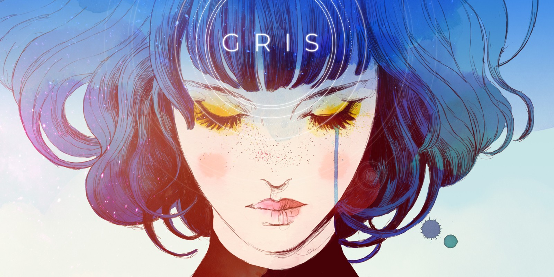
Genre: | Platformer, Adventure
Publication date: | December 2018
Studio: | Nomada Studio
Analysis by: | Denise Meier, Léa Coquoz, Martin Hodler

1. Game Description
GRIS is an atmospheric platform video game. You hop into the role of Gris, a young girl dealing with a very painful experience in her life: grief. You accompany Gris on her journey through that experience and witness how her view on the world changes gradually. One of the key elements of Gris is its colors. We start in a greyscale world and slowly get the colors back, as well as the character capabilities.
Full walkthrough video (no commentary):
GRIS walkthrough

2. Sound Description
The character goes through a variety of emotions and environments, which are both translated into sound. Sadness, anger, fear, joy, love. Each setting has its own soundtrack and soundscape. In addition to that, key melodies and sound effects indicate important steps in the character’s journey or guide it in the game world.

2.1 Atmospheric Soundtrack
Music has a great value in Gris and was developed hand-in-hand with the game, with the two thriving on each other. It emphasizes the emotions and different locations’ atmosphere. The overall mood is dreamy, but stays dynamic as it adapts to the player’s actions. As the player enters a puzzle area, the music switches from intense or emotional to more discreet to let the player concentrate. If it passes through a zone and passes again but with new elements, the music also changes. When we look at the waveform of the music, most of it is alternating melodies and silences, which makes it easy to loop a certain part until the player reaches a point where the music continues until the next loop seamlessly and so on. Everything can be adapted in order to have the perfect timing.
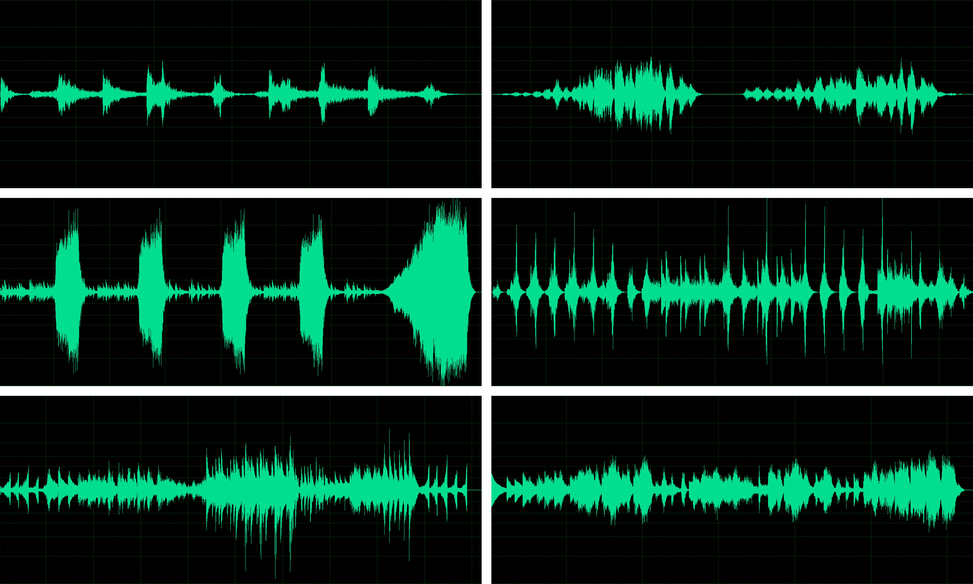
 | Soundtracks | Soundscapes
Mainhub | meridian.mp3
Grey | debris.mp3 | soundscape_grey.mp3soundscape_grey2.mp3
Desert | perseverance.mp3 windmill.mp3 | soundscape_desert.mp3 soundscape_desertwind.mp3 soundscape_abyss.mp3
Forest | komorebi.mp3environments.mp3 | soundscapeforest.mp3
Water | ascension.mp3descent.mp3 | soundscape_water.mp3soundscape_water2.mp3
Sky | firmament.mp3 | soundscape_sky.mp3
Silence has frequently, yet in a clever way, been used in Gris. After intense moments to allow the player to cool down or before important moments to create anticipation and make the player more attentive. Because music and sound has so much importance during the game, silence also is powerful, contrasting with the bewitching music and immersive soundscapes.

2.2 Perception-based
A lot of the character’s movements will produce a sound. They adapt to the material the character is on and to the architecture of the scene, whether it’s a cave, an empty building, a forest or underwater.
walk cycles
In a more discreet manner, many ambient sounds will be triggered with the character’s movements (and not its actions), adding to the immersion and density of the environment.

Ambient Sounds
Birds | birdflyaway.mp3
Mushrooms | mushroomssqueak.mp3
Bells | bellring.mp3
Water | splash.wav
Fan | fanopening.mp3

2.3 Related to (inter)action - sound?
Every action the player performs triggers a sound which adds fluidity and gives a sensation of good responsiveness from the controls.

Controls
Jump | grisjump.mp3
Land | fallland.mp3
Box | grisbox.wav
Stone Rustling | stonerustling.mp3
Slide | slidebranch.mp3
Fly | grisfly.wav
Swim | grisswim.wav
Sing | grissing.wav

2.4 Related to communication with player
Using no text in the game, Gris relies a lot on visuals and sound to deliver messages to the player, give it feedback or warnings. On her journey, the character collects glowing orbs which we will call stars. They have their own distinct range of sounds which give the player feedback on some status.

Stars
Close to Star | starclose.mp3
Picked Up | starcollected.mp3
Stars Missing | starmissing.wav
Stars Filling In | startoskymainhub.mp3
Another element Gris can encounter is mementos, representing memories. They are collectable which activate as you pass in front of it.

Memento
Memento Activated | memento.mp3
There is no real enemy in Gris but we can identify a threatening figure, under the form of a shapeshifting black substance. It follows the character and appears from time to time, with a characteristic theme and orchestration.
black thingy soundtrack
It also has a strong identity in the sound fx used for it. Very low, deep growling and rumbling when it’s moving and a chilling scream, broken voice coming from deep down. This figure has its own language and is then simple to apprehend for the player.
scream, destructive noise, substance
At two steps of the game, a mechanic consists of a repetitive, regular event the player has to deal with. Both are pre-announced to warn the player so it can have the correct timing. The change of gravity also is symbolised by a sound.
organ, ice, upside down

2.5 Related to space
For every section of the game Gris uses music which fits every surrounding of the game. Beside the beautiful soundtrack it uses sometimes a bit more sometimes a bit less environmental sounds like leaves, thunder, wind or little animals which you can hear in the woods. Even if the player doesn’t travel the same location twice it has its own landmarks. Somebody who played the game can tell in which part of the game which ambient was played if they can listen to it.

2.6 Related to narration & dramaturgy
Like mentioned in section 2.1 Atmospheric Soundtrack Gris uses silence and music to create tension or to relax the player. A player can tell just from the audio if something is going to happen or if he/she has time to overcome a puzzle.
epilogue, prologue

3. Personal Conclusion

4. Comparison to LIMBO

