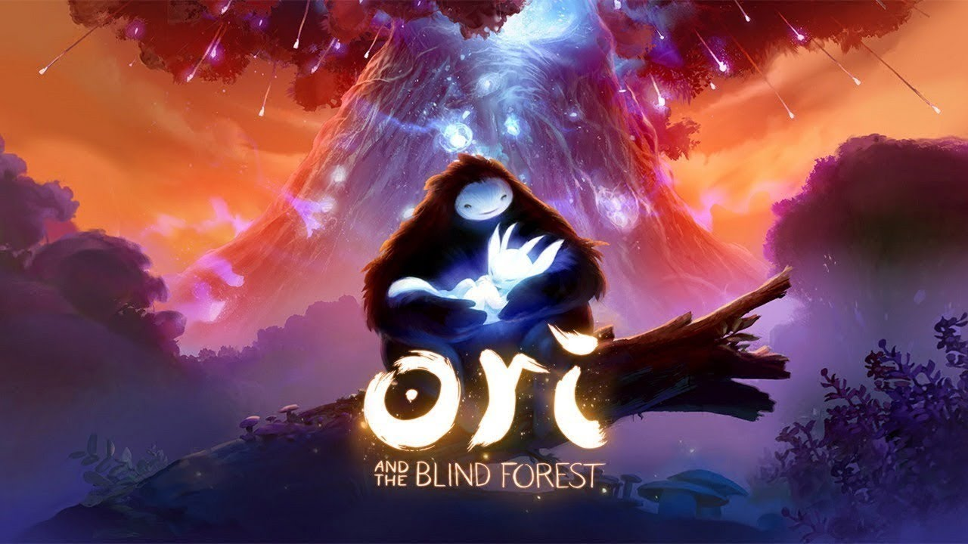
Genre: | Meroidvania, Action-Adventure, Platformer
Release: | Windows, Xbox One March 11, 2015
Studio: | Moon Studios
Analyse by: | Agata Tselesh, Kathleen Bohren, Pietro Peduzzi

1. Game Description
Ori and the Blind Forest is a platform-adventure Metroidvania video game. Players assume control of Ori, a small white guardian spirit, and Sein, the „light and eyes“ of the Forest's Spirit Tree. Players are tasked to move between platforms and solve puzzles. The game features a save system called „Soul Links“, which allows players to save their progress at will with limited resources, and an upgrade system that gives players the ability to strengthen Ori's skills.
Playthrough No Commentary: https://www.youtube.com/watch?v=fXUrR6EiEcY

2. Sound Description
From the opening track, with its simple piano melodies, Middle Eastern themes and some beautiful vocals, Gareth Coker’s soundtrack grabs you and takes you on a fantastic journey. Great use is made of the full orchestra, with layers of sound built up using the different instruments and unexpected delights appearing out of this fantastic orchestral background. The tracks are quite different, yet held together by simple themes that are adapted to suit the tone of each track. The main game theme occurs a number of times in piano, string, flute and vocal parts, ranging through elegantly haunting, gloriously powerful and sinisterly staccato depending on the track. It really ties the album together as a whole piece.

Soundtrack from Ori and the Blind Forest:
Track Titel | Soundtrack
Main Theme | 01._main_theme.mp3
The Prologue | 02._the_prologue.mp3
First Steps into Sunked Glades | 03._first_steps_into_sunked_glades.mp3
Finding Sein | 04._finding_sein.mp3
Up the Spirit Caverns Walls | 05._up_the_spirit_caverns_walls.mp3
The Spirit Tree | 06._the_spirit_tree.mp3
Kuros Tale I - Her Rage | 07._kuros_tale_i_-_her_rage.mp3
Through the Darkness | 08._through_the_darkness.mp3
Dash Through Their Home | 09._dash_through_their_home.mp3
The Ancestral Trees | 10._the_ancestral_trees.mp3
Gumo and Ori | 11._gumo_and_ori.mp3
Climbing the Ginso Tree | 12._climbing_the_ginso_tree.mp3
Restoring the Light Facing the Dark | 13._restoring_the_light_facing_the_dark.mp3
The Waters Cleansed | 14._the_waters_cleansed.mp3
A Closer Understanding of the Past | 15._a_closer_understanding_of_the_past.mp3
Lost in the Misty Woods | 16._lost_in_the_misty_woods.mp3
Home of the Gumon | 17._home_of_the_gumon.mp3
Kuros Tale II - Her Pain | 18._kuros_tale_ii_-_her_pain.mp3
Completing the Circle | 19._comepleting_the_circle.mp3
Arrival at the Sunstone | 20._arrival_at_the_sunstone.mp3
Approaching the End | 21._approaching_the_end.mp3
Mount Horu | 22._mount_horu.mp3
The Crumbling Path | 23._the_crumbling_path.mp3
The Finale | 24._the_finale.mp3
Light of Nibel | 25._light_of_nibel.mp3

2.1 Perception Orientation
In Ori and the Blind forest, the character crosses several types of environment. These steps therefore change if he is in the water or on the grass and so on.

Walk \ Run
Run on Grass | run_on_grass_2.mp3
Run on Wood | run_on_wood.mp3
Run on Sand | run_on_sand.mp3

Climbing
Climbing on Grass | climbing_on_grass.mp3

Jumps
Some jumps | jump_series_treetrunk.mp3
Double jump | 2_jumps.mp3
Spin and jump | spin_and_jump.mp3

Swimming
Swimming breath | underwater_deep_breath.mp3

2.2 Action - Sounds
In the forest, Ori has to fight enemies. He acquires new abilities or weapons throughout his quest that makes him stronger and help him to defeat his enemies.

Attack
Hammer attack | hammer_attack.mp3
Sword attack | sword_attack.mp3
Fire torch attack | fire_torch_attack.mp3

Revards / Bonus
Receiving Reward | receiving_rewards_points.mp3
Receiving Bonus | receiving_bonuses_points.mp3

Damage
Player getting damage | player_getting_damage.mp3

Opening / Rotating
Open stone door | open_stone_door.mp3
Open stone door 2 | stonedooropen.mp3
Rotating gears | rotating_gears.mp3
Stone Block | stoneblock.mp3

2.3 Dynamic Soundtrack
The ambient sound changes and becomes deeper and more stressful when approaching a boss. A positive sound informs the player that he has completed a quest and obtained a new ability.

Dramatic
Meeting a Boss | bossmeeting.mp3
Meeting a Boss 2 | boss_2.mp3
Meeting a Boss 3 | boss_3.mp3

Happy
Magic | dramaticpositive.mp3
Quest completed | missionisfinish.mp3

Music Dynamics
Depending on what is happening in the scene, the music is dynamically amplified to create a more dramatic effect and convey a full atmosphere, thereby promoting along the storyline or warning about danger.
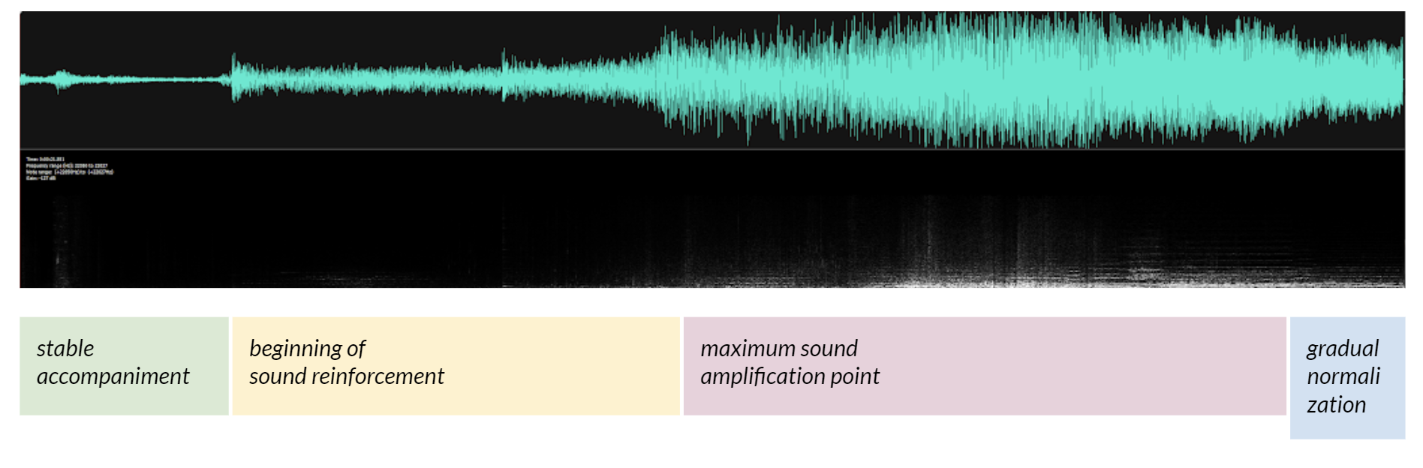

2.4 Сommunication
To communicate the characters of ori speak in an incomprehensible way. The tone of the voice gives information about the emotions of the character in question.

Voise Over
Happy | voiceover_1.mp3
Informative | voiceover_2.mp3
Deep | voiceover_3.mp3
Mysterious | voiceover_4.mp3
Really Deep | voiceover_5.mp3
Baby | voiceover_6.mp3
Annoyed | voiceover_7.mp3
Informative | voiceover_8.mp3

2.5 Environment
The game contains realistic background sounds such as birds or tree branches. These realistic sounds are mixed with magic sounds which gives to the player the feeling of this magic forest.
Sad bird | birds.mp3
Birds | birds_2.mp3
Wind and Leaves | wind_and_leaves.mp3
Whaterfall | waterfall.mp3

