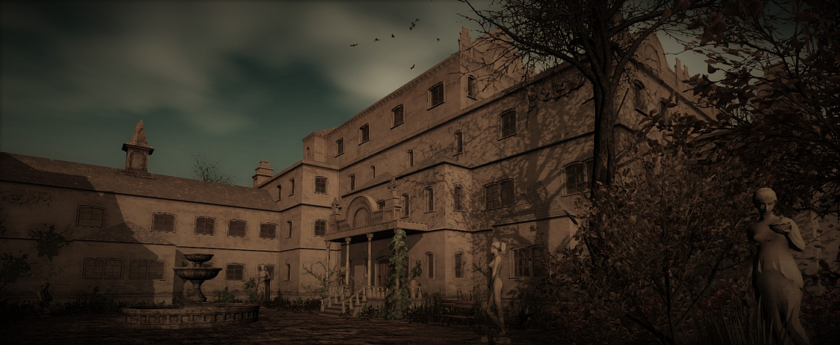

Pineview Drive

Developed by Visual Imagination Software, Pineview Drive is a psychological horror game that invites players in a haunting and suspenseful experience. A significant aspect of its immersive gameplay lies in its thorough sound design. Let's explore how it contributes to the game's eerie atmosphere, psychological tricks, and overall impact on player.
Genre | Action-Adventure, Indie Horror
Release | 31 Jul, 2014
Developer | VIS-Games, Germany
Publisher | United Independent Entertainment
Platforms | Windows, Linux
Analysis by | Maksym Kliuzko, Marcel Gamma, Nio Saner

Background
The ambient background is constantly alive with eerie sounds that reminding classic 90's horror movies, however they work very well and deal great impact on player. These sounds, despite the absence of immediate threats at first, are effectively heightened in tension and anticipation. This is made for the player who expects something to come, even though nothing will probably be there.

Sounds Effects
The game employs a diverse range of sound effects, showcasing attention to detail and sound quality. The grandfather clock alone features 11 different sounds for both TICKS and TOCKS, as well as the wallclock, so the total sound list has 44 variations. And it should thus add depth and realism to the game environment. Additionally, the game follows an interesting sound scheme, for example - msx_ambience - A (01, 02, 03), B, C (01, 02), D, E (1, 2), F, G, H, and so on, like every instance has a specific purpose.
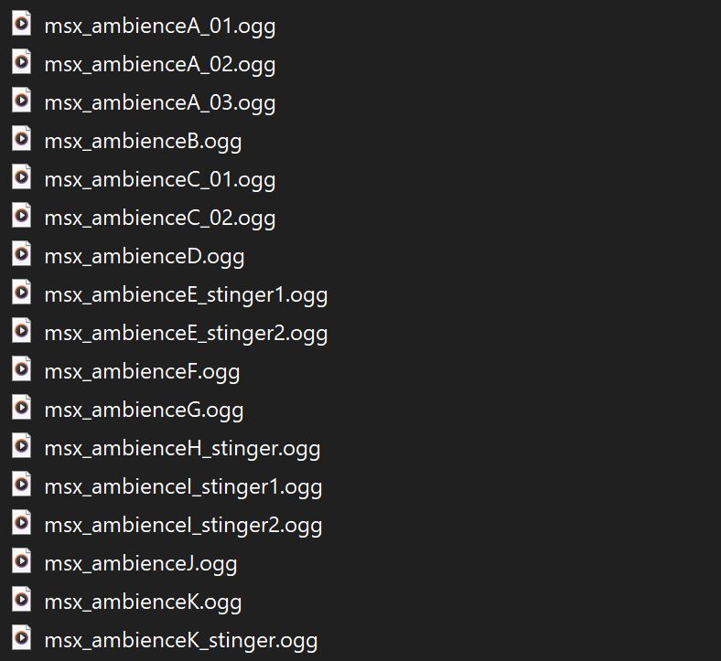
The sound design successfully maintains a sense of immersion and unease throughout the game. Carefully compiled background score consists of subtle and unsettling elements such as distant whispers, creaking doors, and low-pitched drones; wind blowing through the trees, raindrops falling, or thunderstorms (indoors, outdoors), swarm of flies, crows sound and taking off; consists of subtle, unsettling sounds like distant whispers, ghost stinky breath, creaking doors, random knocking sounds (muffled, unmuffled), phone calls, in tunnels - distant steam release;
- your own footsteps echoing in empty halls, floorboards creaking under your weight, and doors opening or closing with distinct sounds - all this for the indication of isolation
- quite piano roll of ease (8 different) when player has found the note and the dawn comes; also when coming in the house, dramaticaly indicating the start of something, 30 different short piano melodies for the star of each new night;
- stingers, sudden very loud noises (clown laugh, cat loud screech etc.)

Player
- 85 different breaths sounds - 165 different sounds of player footsteps, on different surfaces (brick, concrete, wooden floor, hollow wood, gravel, 47 different footsteps sounds in grass)
- sounds play as psychological trick: if the player turns to the source (list: piano sounds, marble bust, wooden angels on stairs, rumble in the other room, PSSs, etc.), the game will take the points and you lose some of sanity. so the point is to ignore the sounds in the haunted house which is nearly impossible.

