Rome Total War Serie
Release Date | 14. Februar 2017 | 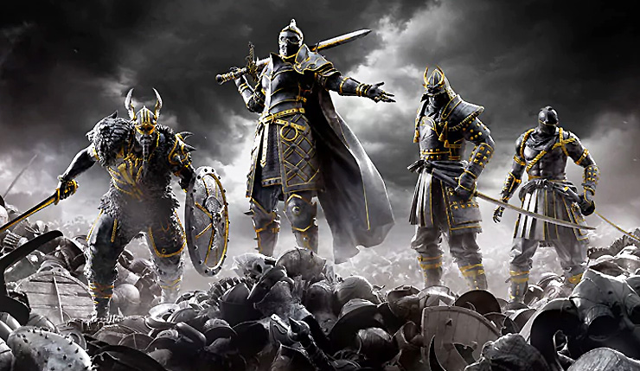
Plattform | PC, PS4, Xbox One
Genre | Melee combat
Entwickler | Ubisoft Montreal
Publisher | Ubisoft

