Sapiens
- Tayla Sommer
—
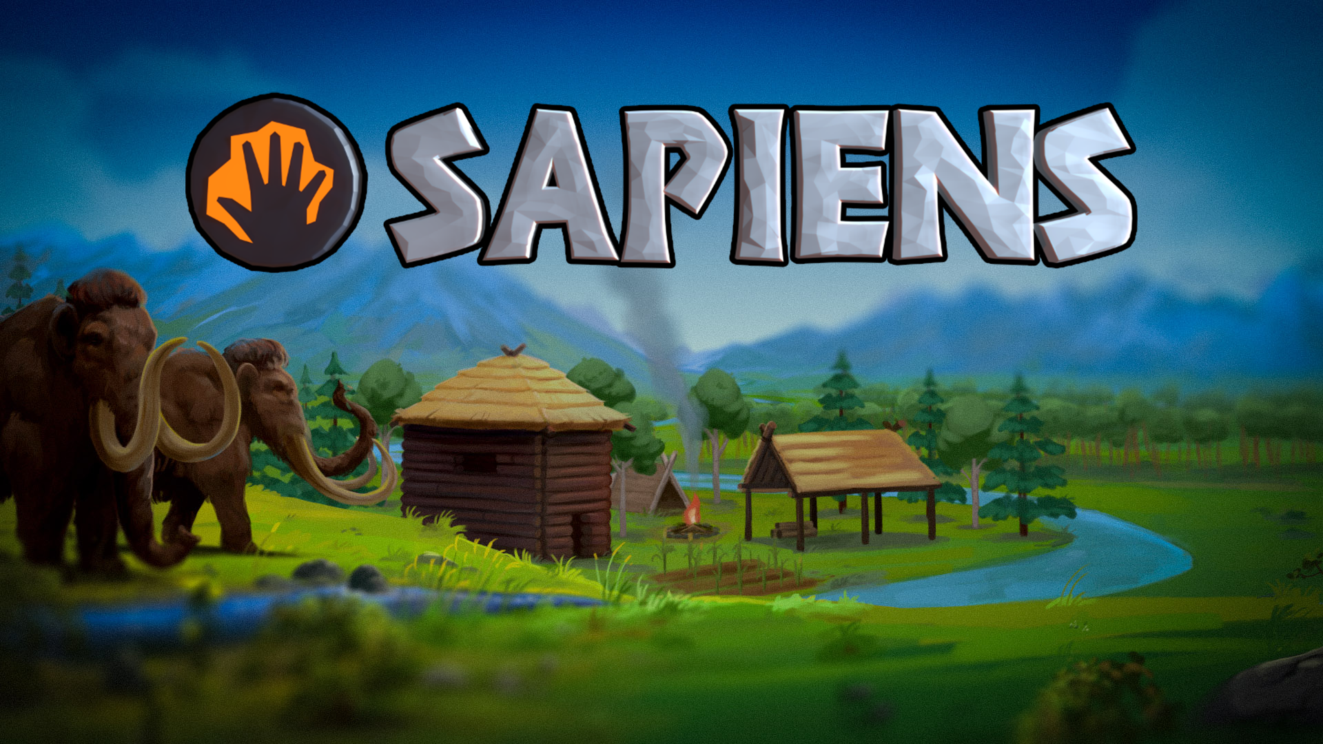
—
 | Genre | Sandbox
 | Early Access | 26 July 2022
 | Publisher | Majic Jungle
 | Studio | Majic Jungle
 | Game Modes | Single Player
 | Game Engine | In-House Engine
 | Plattform | Linux, Mac OS, Windows
—

Game Description
Sapiens is a sandbox „tribe leadership“ game made by a single developer called Dave Frampton (Majic Jungle). It is currently in early access.
It takes place on a simulated world, larger than the earth and you are free to choose your starting positions anywhere on the planet with varying challenges. The goal of the game is to build up a stone age civilization by researching new technologies and building houses, storage rooms, castles, palaces, pyramids and more with many different materials.
Multiplayer is currently not supported but will be in the future.

Trailer
https://www.youtube.com/watch?v=CFI3anJLhBg&pp=ygUPU2FwaWVucyB0cmFpbGVy
—

Objective Sound Analysis

Music
The music already provides a good feeling for the entire sounddesign of the game. it is calm, laid back and not all too loud.
sapiens_soundtrack_example.mp3

Soundscape
The soundscape of Sapiens is extremely relaxing. You are not overwhelmed with sounds and notifications at all, and even then they are quite tame and faint, but still recognizable enough to know that something happened. What might be missing is when Sapiens are in danger, having wandered to closely to Mammoths and got hurt in the process. You only hear about it once they got injured.
sapiens_soundscape.mp4

Ambience
Since there are not many other sounds which play throughout your playtime, the ambience sounds, such as birds, the wind, rain, storms, animals in the distance, etc. are much more important. You spend most of your time zoomed out, where most faint sound slike the crackling of fire, footsteps, carving a bone, etc. cant be heard. But the ambience sound is always present.
sapiens_ambience.mp4

UI Sounds
UI sounds are either extremely faint, or non existent. The sound is kept quiet and mostly immersive in the game, mimicking heavy boulders being dragged over a rocky surface. Fitting to the UI design.
sapiens_ui_sounds.mp4sapiens_menuplace.mp4

Sapiens
The Sapiens are the characters you control, they have needs and wants, can get tired and hungry, wet and cold. They talk to oneanother in an invented language (conlang) by the developer. I dont think you can particularly make out what the different words mean, if anything. Other than that sapiens do not make many other sounds, only when walking, crafting or playing music.
sapiens_walking.mp4sapiens_attack.mp4sapiens_music.mp4

Wildlife
There are currently no real enemies in the game. Besides Llamas and Chickens, there are also the mighty Mammoths which are the main danger of the game. Herds can come through your camp and hurt your Sapiens. The trumpet sounds and heavy footsteps warn the player beforehand.
sapiens_enemies.mp4

Other Sounds
There aren't many other sounds that are wholly required for the game. Simple sounds such as chopping down a tree, digging a hole, mining a rock, etc. have their own sounds. But some actions seem to be missing some sound, most notably the building. The sounds are kept in a more realistic standard and were actively recorded by the developer himself.
sapiens_treechop.mp4sapiens_stonedig.mp4sapiens_digging.mp4
—

Subjective Sound Analysis
The soundscape and music of the games is extremely relaxing. You do not feel pressured to accomplish something right away, nor is there any real danger you need to be aware off. Sapiens can get hurt or catch a virus, but most of the time its no big deal and easily treatable in the later stages of the game.
—

Comparison with Castle Story

Genre
Both games follow the same genre and provide a similar gameplay loop. Gather supplies, build structures, protect your people, rince and repeat. It is quite simple but in my opinion both games do it in a great way and provide different ways for construction.

Music
While both have very well made music, they could not differ more in style. Castle Story sometimes being extremely hectic and fast while Sapiens takes its time, sit back and relax. The music differs but is extremely fitting for each game.

Sound
The sound, while similar in some aspects, give of quite different vibes from one another. Castle Story keeps this cartoonish, cutsie style within their sounddesign, while Sapiens tries to be more realistic in their approach. Castle Story feels much louder and quicker with its sound design, while Sapiens is extremely laid back, sometimes having no sound at all for certain actions, just because it is not needed.
All in all I do enjoy both games and while they can be quite different in their vibe, they tickle the creative senses in me in just the right way. Back to building I go!

