Super Street Fighter
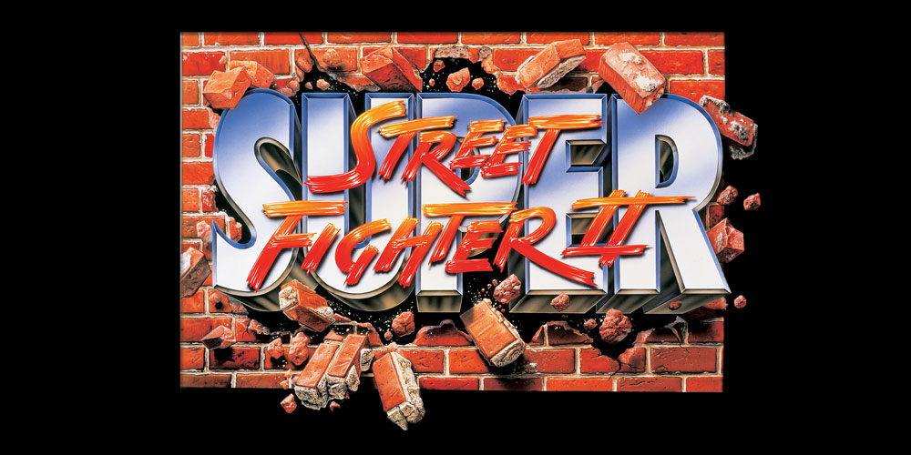
Genre: | Beat em Up
Publikationsjahr: | 1993
Studio: | Capcom
Analyse von: | Nicola Kazimir, Charles Roberge, Dominik Stettler

1. Short Info / History
Street Fighter II is regarded as one of the greatest video games of all time and the most important and influential fighting game ever made. Its launch is seen as a revolutionary moment within its genre, credited with popularizing the fighting genre during the 1990s and inspiring other producers to create their own fighting series. It sparked a renaissance for the arcade video game industry and impacted competitive video gaming and wider popular culture such as films and music. 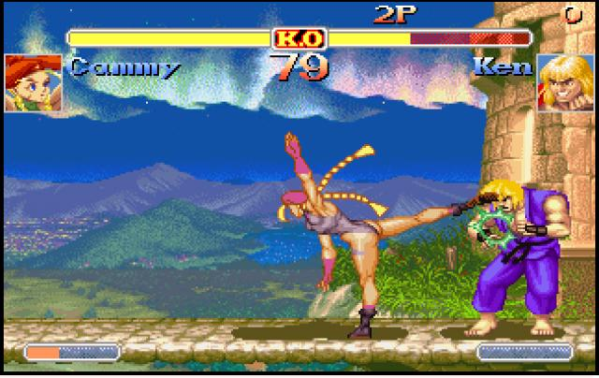

1.1 Sound Design History
It's Sound-Design is seen as a pioneering one. In many regards Street Fighter II became a sound-design template for many other fighting games until this date. The main composers were Yoko Shimomura & Isao Abe. The design decisions of binding the characters to unique sounding locations resonates in many ears and designs to this date- same goes for the unique attack sounds - Hadoken. 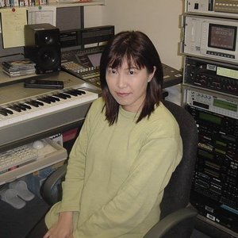

2. Functional Sound analysis

2.1 General Sound EFX/Compositions
As its a game that was made during the 16bit era and the sounds are made for the SPC700 Sound chip - it always will have that recognizable 16bit sound to it where the capacity of the layers, spacial placement and size how big the the file size could be, was very limited. To compare the sounds with a synthesizer a Yamaha DX7 which boasts FM-Synthesis is very resemblant of the sound aesthetics during that time.
You won't have low basses in these type of games, but most sounds will have more low-mid to mid-high frequency placements.
The voices in the game will sound harsh and lo-fi to todays ears because of those above mentioned restrictions.
The music composition is very funk/jazz orientated and tried to fuse different genres which could evoke that feeling of that particular stage they are set in.

2.2 Main screen
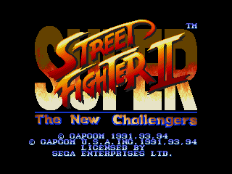
After a short intro with music and animations - the player is guided in to menu screen. Its quiet - no music is playing almost as if it would be the quiet moment in a locker room before the big fight. If the player switches menu points the UI Sound is pretty satisfying and clear. This sound will be continued in3 the player select screen when switching players so it needs to communicate to the player in clear way that he moved his cursor and have a satisfying timbre so it doesn't get on the players nerves as it will be repeated a lot.
Select Sound | select.mp3
The confirmation sound is very affirming, simple and kept short, it has a positive composition to it - almost as it would communicate to the player that they are ready for the challenge.
Confirmation Sound | confirmation.mp3

2.3 Character Select Screen
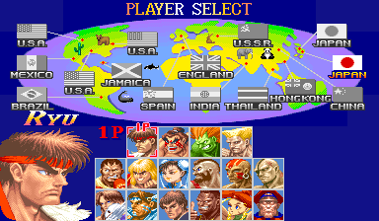
In beat'em ups / fighting games - the character select screen is the screen you will see over, over, over, over again as these games are mostly played in co-op multiplayer mode (during the arcade era even more) so it needs to be a place where the player gets amped up for the fight and simultaneously the player wants to find themselves again while spending their time wisely to select the right character. The UI sounds and most importantly the character select music must be ready for this task. There is an unwritten rule about fighting game soundtracks: If the player select screen music is great - the stage compositions will follow that lead. The SSFII one is a great composition you won't get tired of: it has an interesting tempo slightly over your hearts bpm (to get you ready fo the fight), its melodies suggest you choice and pushes you but not to much.
Character Select Theme | charachter_select.mp3

VS Screen
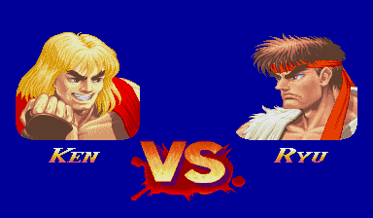
The final face-off - the players see the character portraits and a small jingle ups the tension - seconds away from the fight. The small jingle is composed in climactic, tension building way.
super_street_fighter_ii_vs_screen_theme.mp3

2.4 INGAME
In game there are 4 layers of sound:
- UI Sounds incl. announcers
- Character Sound EFX
- Stage Ambiances
- Stage Music

Right before the round starts
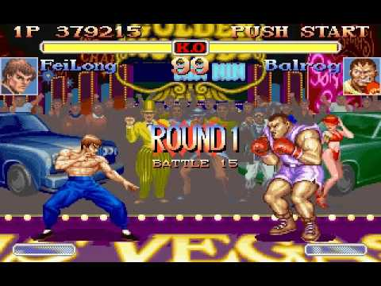
As soon as the players are in game the music, ambiances and an announcer(which announces the round and signals the the start to the battle) kick off - there is no dynamic fading, or easing in of the sounds - it's a full force right from the start. Mostly a design choice to give the player a certain urgency about the situation they're in. The player has no control over these sounds.
Round Start | beginning.mp3

During Round

UI Sounds incl. announcers
Is not active until the end of the round

Character Sound EFX
Normal character hit, hit-confirmation, block, movement SFX are composed in a way that they are immediate and communicate in a clear way to the player so they know within fractions of seconds how to react next. Also the general mixing of these sounds in the ingame-mix is loud and not realistic to enhance player-immersion.
Hit / Block Sounds | hit.mp3
Special attacks have voice lines - they might sound harsh today, but indeed are legendary. These voices lines became a big identification factor for the franchise, people remembering them more than the names of the actual characters says a lot about the achievement in sound-design. Mostly they signal an attack and are very short and immediate.| There aren't any dynamics to be found in these type of sounds as they are short battle cries. These sounds have a very pleasant/addictive sound about them, players love to hear and spam them all over again.
Hadoken | adoken.mp3
Tiger | tiger.mp3

Stage Ambiances
Due to the limitations of the chip and filesize only few ambiances found their way into the sound-design. Mostly its noisy cloud-cheers, animals or general-setting ambiance which repeat in a loop to add to the immersion of the stage. Its not insignificant but also not really important - the mixing in the in-game mix confirms this: it's somewhere in the back as its one of the less loud sounds in the game.
Hit / Block Sounds | hit.mp3

Stage Music
Stage music plays an important factor in the game. Its a important component of a stage-look, stage-sound, character look immersion and identification which is based around nationality in SSFII. Different stages are based in different countries and the composers tried to evoke a particular designed instrument/melody within the composition that resembles that country. Mixing-wise its also very present in the in-game mix - fitting perfectly in between all the Character SFX and generally rounding the sonical experience.
If a player has low HP the music speeds up - upping the tension of the fight.

End Of the Round
UI Sounds of the score and announcer announcing the winner kick in. The score sounds are comparable to the Menu UI in terms how they are composed and how they sound. Getting high scores should sound rewarding and it does.

2.5 End Of The Match

VS Screen
One winner, one looser - the short jingle condenses the epic consequences of the fight. Its a cheeky, dramatic yet funky jingle that does this.

Countdown
The players running this countdown down should feel even more devasted as the defeat itself wouldn't be enough. The music is again jazzy but dramatic. The announcer is counting down and depending on your will to continue you will get a retry or defeat character sound:
Retry: https://www.youtube.com/watch?v=zvXvenO6lwY&t
Defeat: https://www.youtube.com/watch?v=8tlR9Tq0Wlg

2.6 Conclusion / End
Overall the sound-design is captative and keeps the player in the immersion and never wants to let you go - it achieves that quite well despite its retro nature nowadays. As mentioned before it is seen as a pioneering game and its sound-design takes a lot of credit for that as well.

3. Comparison Super Street Fighter II & Brawlhalla
It is very apparent where the roots of most fighting games lie, Street Fighter II. Maybe it is easier to see where there are similarities between the two products. At some point a certain aspect, somewhat an inevitable realisation happens, what makes these titles believable is the characteristic play of weight. All actions deal with a reaction, if hitting sucessfully the players get rewarded by a sound of impact, besides the fact that HP-bars get visually deminished (although most of the time characters also react with sound when being hit).
If we speak about physicalities let's go even further, weight implies speed and way of movement. While Street Fighter relies more on fist fights, Brawlhalla brings different elements or rather materials into the scene which further improve the amounts of possible sounds.
As stated with the different potential actions, the difficulty of deciphering movement increases, but in both titles sound is used in order to let players rely on their ears and through that possibly reduce reaction times, which is crucial for games of this genre.
They are alike in dimensions, so to speak both enable the players to move 2-dimensionally altough brawlhalla brings something maybe more modern(?), the traverseable space is now improved to higher and lower levels and is not limited on one line of movement. this brings with it room, room for hearable volume which has on one side the capability of simulating distance, which is strongly used in this case, on the other side it brings with it a certain emptiness. comparing that to street fighter II, for sure there's a certain limitation to spacial percaption, probably also due to hardware limitations, but all in all this gets rounded out by memorable sounds layered on top of each other, which strike out the need of space.
Which leads to the last sort of characteristic that we'll look at now. While Brawlhalla extents and also outplays Street Fighter in the technical aspect and soundwise ………

