The Last of Us
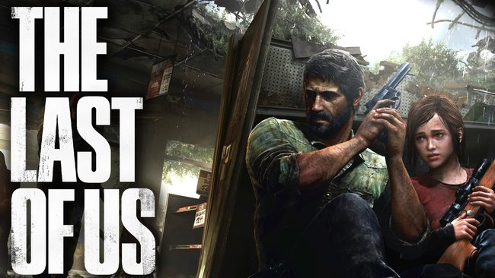
Genre: | Action-Adventure / Survival-Horror
Release Year: | 2013
Studio: | Naughty Dog
Analysis by: | Joachim Merchie & Jan Hobi

1. About the Game
Set in the post-apocalyptic United States, the game tells the story of survivors Joel and Ellie as they work together to survive their journey across the country to find a possible cure for the modern fungal plague that has nearly decimated the entire human race.
Trailer: https://www.youtube.com/watch?v=W01L70IGBgE
The Last of Us received a Part II sequel in 2020.

2. Sound Analysis

2.1 Introduction
Like in many other games, in The Last of Us, the player is treated like an actor walking on a stage full of props. All the characters, enemies, environments change as the player interacts with them, therefore these changes should also be reflected in the soundscape. Naughty Dog uses Systems that go hand in hand and layer sound on top of each other to create a narrative tool that allows an extremely fluid experience.
The overall soundscape of the game is fairly minimalistic. Of course, the technical side of it is huge but the actual variety and theme of sounds have a strict and coherent purpose. In some moments the game is stripped of almost every sound and in others, the action is enhanced through a variety of dramatic tunes, without being overloaded. The concept of subtracting and negative space is used a lot throughout the sounds of the game, a simplistic and minimal approach to achieve the exact emotions the creators want the players to have.
To keep this analysis in a reasonable size, I focused on the main aspects of the gameplay sounds.

2.2 Environment
The roots of The Last of Us are based on reality so naturally the soundscape is extremely real and authentic. This realism is especially heard in the environment and the players interaction with it. Details like different pick-up sounds for different amount of screws picked up, different material of objects and footsteps changing depending on what kind of material the ground consists of.
Footsteps | environment_sound_footsteps_dry_wood.mp3
Footsteps change | environment_sound_footsteps_from_wet_to_dry.mp3
Inside to outdoor | environment_sound_inside_to_outdoor.mp3
Pick-up single screw | environment_sound_pickup_metal_screws.mp3
Pick-up multiple screws | environment_sound_pickup_multiple_metal_screws.mp3
Pick-up wood plank | environment_sound_pickup_wood_plank.mp3

2.3 Enemies
Besides human enemies the bigger emphasis lies on the infected. The sound for the infected varies on the stage of the infection. The longer an infected is alive the less human like they sound. The narration is reflected in this transition.
In the Runner stage, the human voice is still recognisable. Though not very clear but a voice as if the inner human is still somewhat there and is fighting against the infection.
Runner | enemies_runner_sound_idle.mp3
Stalker | enemies_stalker_sound_idle.mp3
As the Clicker stage kicks in, there is no humanity left. The horrific animal sounds show off the horror of such a creature and establish a fear in the player.
Clicker | enemies_clicker_sound_idle.mp3
Bloater | enemies_bloater_sound_idle.mp3

2.4 Communication
Even though the sounds manage to communicate a lot through natural sounds there are still some artificial hint and feedback sounds that help and guide the player. Satisfying clicking sound in the inventory and softer hints for alerts and pop-ups.
Danger | communication_sound_danger.mp3
Tutorial pop-up | communication_sound_tutorial.mp3
Button press prompt | communication_sound_button_press_cue.mp3
Open inventory | communication_sound_inventory.mp3
Inside inventory | communication_sound_inventory_open.mp3
Upgrade | communication_sound_upgrade.mp3
Swap weapon | communication_sound_swap_weapon.mp3
The crafting sound is quite fascinating since it starts of with natural sounds and to let the player know the crafting is finished it ends with a hint sound.
Crafting | communication_sound_crafting.mp3

2.5 Personal Conclusion
I really like the minimalistic approach of the game sounds, it creates a very bold and confident way of creating a narrative that manages to evoke certain emotions. It’s fascinating to see that even though a game sound can almost be fully made with natural sounds there are still certain moments artificial sound is needed.

3. Comparison
The difference between The Last of us and The Last of Us Part II are stylistically not that big. The biggest differences are the quality and variety of the sounds. The sound design of the first game was already great and fitting, so they fully embraced it with the second one and managed to push the realism and attention to detail of the whole game, together with the sound, to another level altogether. The general quality got increased, and especially the variety in sounds for slightly different situations got raised dramatically. Also because the animation work was pushed hard for Part II and with it the detail in the sound. In both games, it's apparent that the sound already played a substantial part in development from the beginning, visible in enemy and gameplay design. In The Last of Us Part II, quite a lot of character animations are driven by the sound. Like the whole breathing system, which reacts to how much energy the character is using (long sprinting, climbing, close combat etc.), how badly injured she is, or to things like height if the character has acrophobia. These can drive facial or shoulder and arm animations.

