The Last of Us Part II
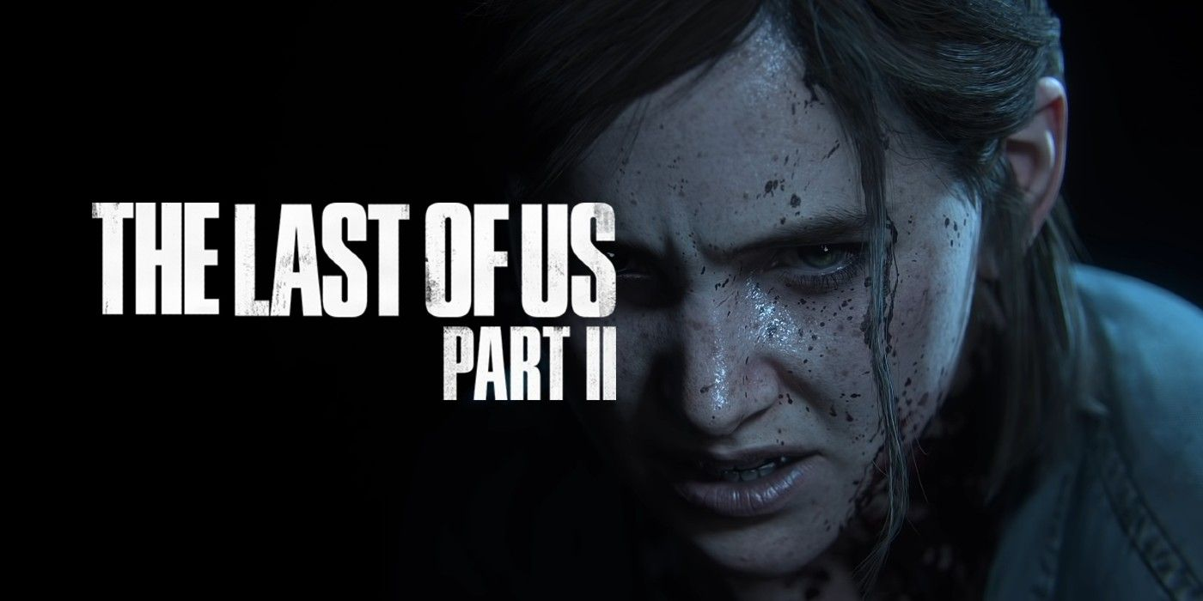
Genre: | Action-adventure
Release Year: | 2020
Studio: | Naugthy Dog
Analysis by | Jan Hobi & Joachim Merchie

1. About the Game
The Last of Us Part II is an action-adventure game developed by Naughty Dog and published by Sony Interactive Entertainment. It's set five years after The Last of Us (2013) and, as its predecessor, focuses on storytelling and immersion into the post-apocalyptic United States. The outbreak was nearly 25 years ago and was caused by a mutated strain of the Cordyceps fungus, that can infect humans. It grows in the brain and slowly starts to take control over the host, turning it into a zombie-esk creature, called the infected.

Trailer

2. Sound
It's noticeable that sound design was a key part in the development of The Last of Us Part II. It is strongly focused on immersion and realism. Every little detail has its distinct sound, but still the audio is always focused on the essentials and on the player. It plays in an almost theatrical way around the player's actions, in a responsive manner.

2.1 Environment
A ton of attention was put into making all environments sound as authentic as possible. With every little interaction of the player and other entities generating the according sound. Like footsteps, arrow hits, throwing items, etc. everything different according to material they hit. The soundscape also adapts very nicely to the room the player is currently in, and transitions between e.g. outside and inside places realistically and dynamically.

2.2 Enemies
Stealth is a big part of the gameplay and this is well represented in the sound of all enemies, most enemy types have their distinct sounds, making them easily recognizable without having to see them.

Infected
There are different stages of the Cordyceps brain infection (abbreviated as CBI) and they got categorized into different enemy types. Each one has its distinct attributes and behavior, which also get represented in the sounds they make.
Runner
The earlier stage of the CBI infection. The sounds they make still sound like coming from a human, and the difference of male and female specimen is quite audible.
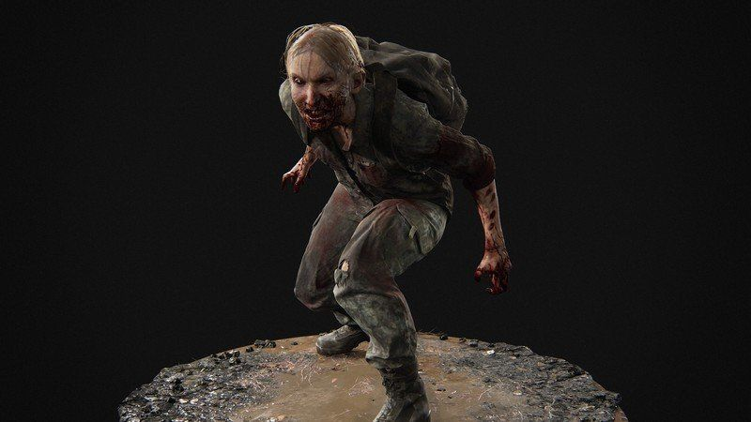
Female Runner: | tloup2_female_runner.mp3 | Male Runner: | tloup2_male_runner.mp3
Stalker
A more advanced stage, still a bit human sounding. The difference between female and male stalkers is less audible.
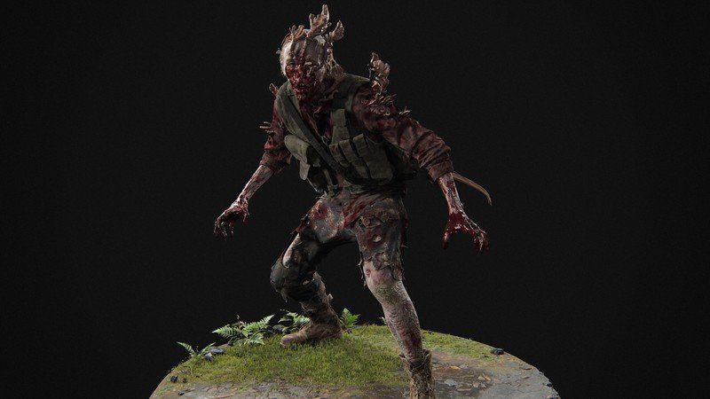
Female Stalker: | tloup2_female_stalker.mp3 | Male Stalker: | tloup2_male_stalker.mp3
Clicker
Advanced stage, there isn't much human left in their sounds. Female and male specimen sound basically the same. Clickers have lost their eyesight and orientate themselves using clicking sounds.
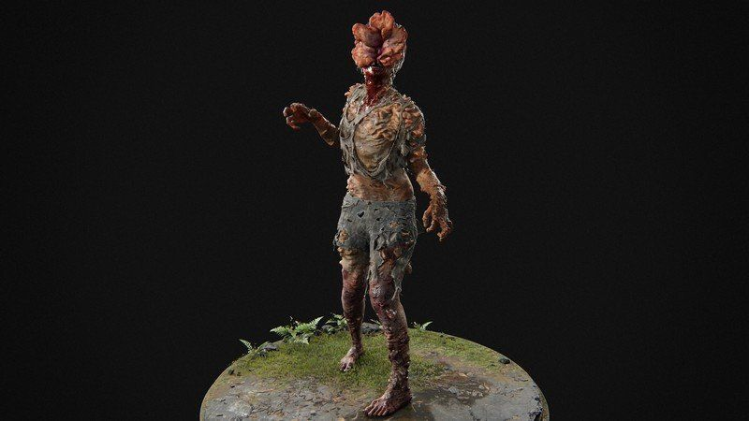
Clicker: | tloup2_clicker.mp3
Shambler
Very advanced stage, making more creature than human sounds, with lots of grunts and gurgles. Although there still is some human resemblance in the breathing.
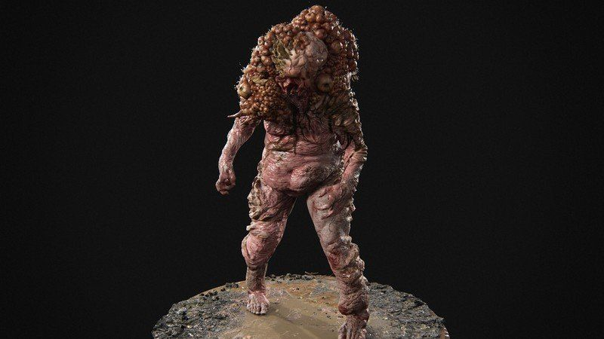
Shambler: | tloup2_shambler.mp3
Bloater
Another very advanced stage, making even deeper creature-like grunts than the Shamblers. They also have similarities to Clickers and make some deeper clicking sounds.
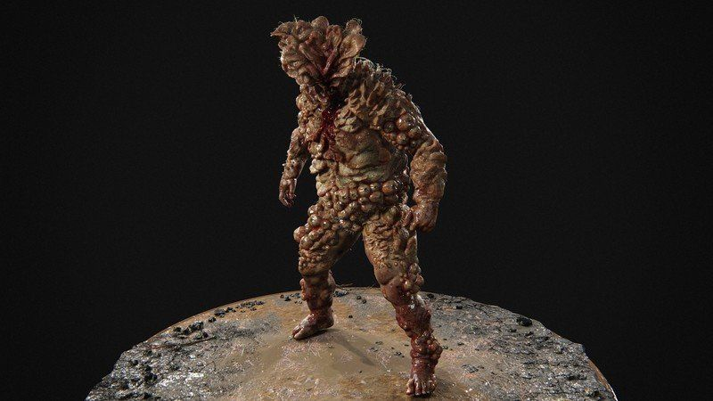
Bloater: | tloup2_bloater.mp3
Rat King
The most advanced stage currently known, a super-organism composed of multiple stalkers, clickers and a bloater. Accordingly, it sounds like a mix of all of them.
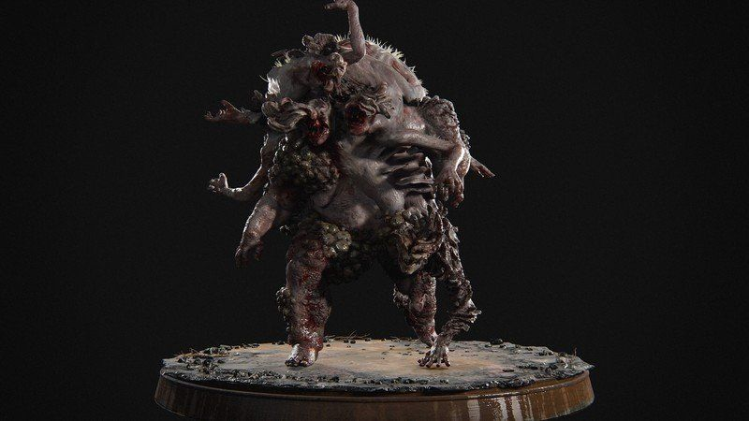
Rat King: | tloup2_rat_king.mp3

Humans
Most of the surviving humans have rallied into smaller or bigger groups, even founded settlements and small towns. During the game you meet multiple of them and most of the time they react hostile to outsiders. Their barks are particularly interesting, since they often talk to each other about events in the world or their specific group. Like everything else in the game, they are particularly responsive to the players actions. For example, calling out dead members by their name or surrender to the player, if they realize they have no chance. One group is especially interesting, the Seraphites (Scars). They communicate manly with different whistle sounds. And with confronting them more and more, you start to learn what the different sounds mean.
For example, the call and the answer:
tloup2_whistle.mp3

3. Comparison
The difference between The Last of us and The Last of Us Part II are stylistically not that big. The biggest differences are the quality and variety of the sounds. The sound design of the first game was already great and fitting, so they fully embraced it with the second one and managed to push the realism and attention to detail of the whole game, together with the sound, to another level altogether. The general quality got increased, and especially the variety in sounds for slightly different situations got raised dramatically. Also because the animation work was pushed hard for Part II and with it the detail in the sound. In both games, it's apparent that the sound already played a substantial part in development from the beginning, visible in enemy and gameplay design. In The Last of Us Part II, quite a lot of character animations are driven by the sound. Like the whole breathing system, which reacts to how much energy the character is using (long sprinting, climbing, close combat etc.), how badly injured she is, or to things like height if the character has acrophobia. These can drive facial or shoulder and arm animations.

