Game Sound Analysis Limbo

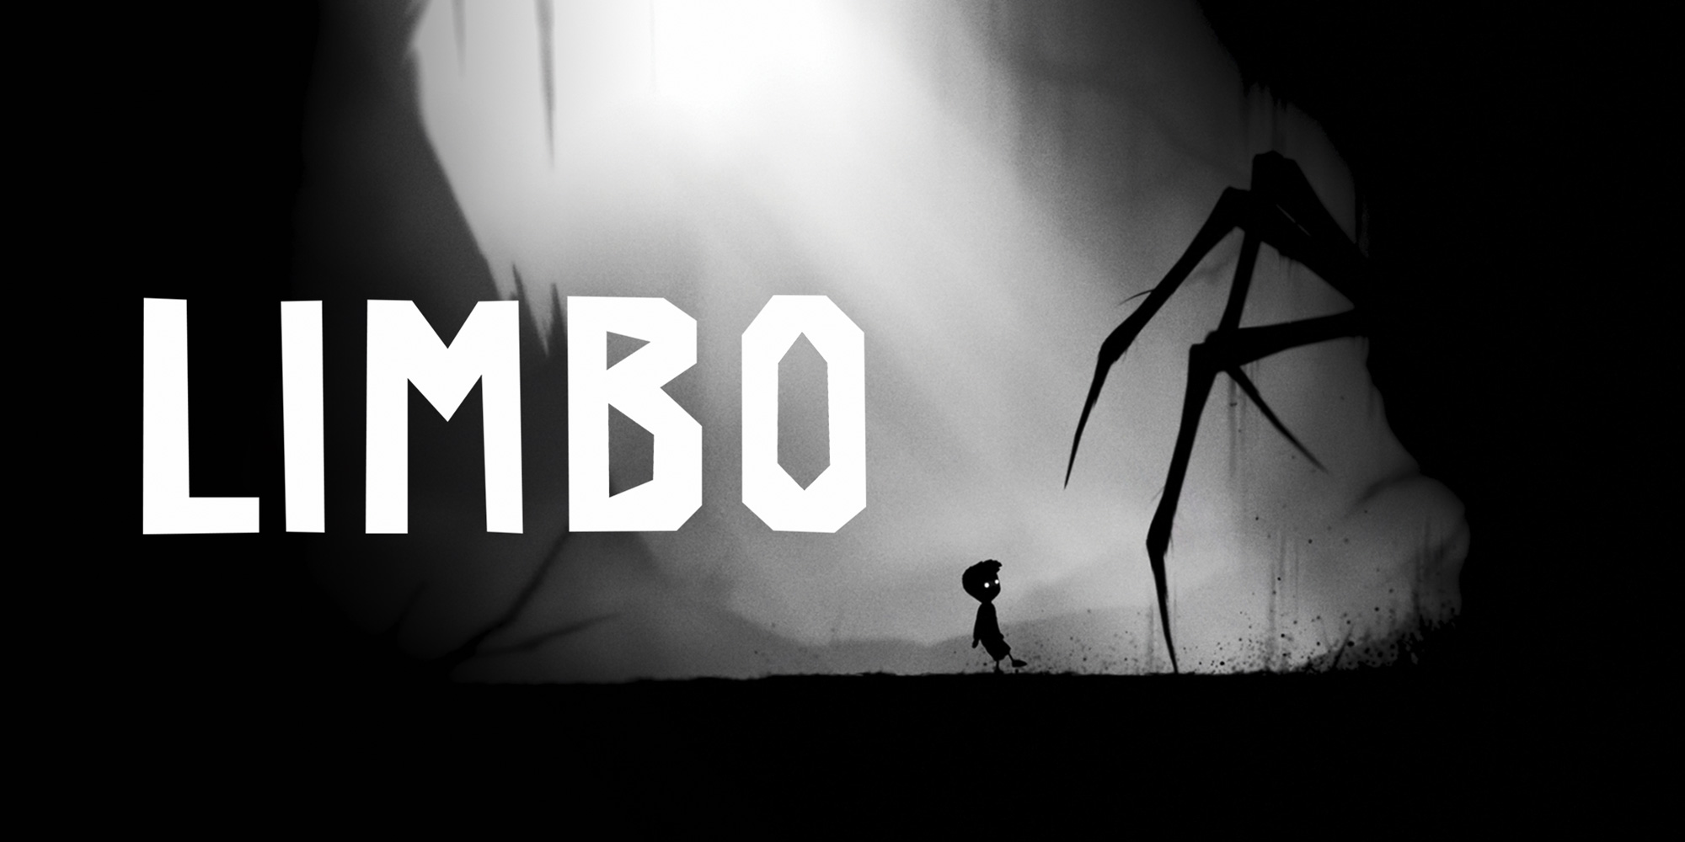

Genre: | Atmospheric Puzzle-Platformer
Published: | July 2010
Studio: | Playdead, Double Eleven
Analysis from: | Denise Meier, Léa Coquoz, Martin Hodler

Game Description
Limbo is a puzzle-platform video game which takes place in the afterlife of the played character. Through the game he is confronted with his own fears like the fears of spiders, his social anxiety and the fear from heights. The game uses physics for most of the puzzles presented to the player like pushing a box in front of a wall to overcome it or placing bear traps to cut off a spider's leg.
Limbo is presented in grayscale only which creates a darker look. Apart from the visuals Limbo makes use of a lot of sounds to emphasize on the dark almost horror-like atmosphere of this afterlife. The goal of the game is to reach his last rest.

Full walkthrough video (no commentary)
https://www.youtube.com/watch?v=WxL4xfqUq4s

Sound Description

Atmospheric Soundtrack
Limbo doesn’t make a lot of use of musical-soundtrack. There are some soundscapes which are using instruments to get the feeling but they mostly just play a single note.
The soundscape adapts to the physicality of the environment. If you are staying in the forest we can hear birds, leaves, wind and so on. Beside the environmental sounds it uses a lot of noise or vinyl crackling sounds mixed into those physical sounds.

Perception-based
Limbo is set in the afterlife and mostly in a forest, cave or in a factory-like setting. The game switches from setting to setting visually as well as auditively. In caves all the interaction sounds receive a hall-effect to emphasize the physicality of the cave or factory the player is moving through.
As stated in the chapter before Limbo makes use of a lot of environmental sound to create great immersion.

The game uses different sounds for different ground which the player can move on.

Walkcycle steps dirt
Walkcycle steps wood
walkcycle steps wooden platform
walkcycle steps concrete
walkcycle wet ground
walkcycle steps metal platform

Almost everything that moves because of the player is doing something like climbing up a rope creates sound. Because a lot of sound is used to warn the player from dangerous elements which can kill him, they decided to use the sounds to create fear that something is going to happen like the sound of a rope which almost can’t hold the players weight.

Rope sound
Chain sound

Related to (inter)action - sound?
All of the sounds which get produced due to direct player input like a jump or sliding down are a bit more lowered than in other games. It doesn’t take a lot of attention but it still makes the immersion stronger.

Jump
Slide

Related to communication with player
Every danger in the game has its own strong distinguishing sound effect. In the beginning the player gets introduced to the sound of water in the game and that the player will drown if he tries to swim through it. In a chapter where the player has to run away from a spider he/she can hear the sound of water below while the player has to balance the character on a rolling rock, but the water itself is not visible.
Because the game is displayed in greyscale it has to work a lot more with sound to give the player the information he needs. In the city part of the game the player has to overcome a neon sign. It shines bright and some of them turn on and off again. To tell the player that these signs are dangerous they have a strong buzz sound and an even stronger turning on and off one.

Spider “droning”

Electricity (dangerous)

neon sign on
neon sign buzz
neon sign off (maybe all in one)

big moving rocks
miniguns

gravity changes

Because some puzzles could be overlooked and forgotten because sometimes the player has to take something with him back to where he already was they used some droning sounds around the object the player has to interact in a way. If the player gets closer to it, it gets louder. As soon as the puzzle is solved the sound quickly fades out.

PuzzleDroning

Related to space / environment
Limbo uses different soundscapes for different environments. It uses a lot of environmental sound in the different parts of the game. The game starts in the woods with sounds of wind, leaves and sometimes birds and frogs. As the game progresses the player traverses a cave where the sounds change to a deeper howling of wind, water drops and some bat noises. To create an even more acceptable setting every sound played through interactions or reactions are played with a hall effect to reflect the real physicality of a cave.
On the other hand every place has its own mix of environmental sounds. Sometimes the same sounds were used but the pitch or volume was changed.

Water
Machinery
Drops
Dogs barking

Related to narration & dramaturgy
In the second half of the game the player reaches a girl who is burying someone. As soon as you almost see her on screen a musical but still atmospherical piece blends in. Apart from the other atmospheric sound this one is played in a major key. On this one of two moments in the game it expresses a sound of “hope”.
In the track “Sister” you can find the musical change in the end of the track where the overall key switches to major.

Instrumental part to highlight sister burying him

Personal conclusion

At some places Limbo is missing sounds. One of the first wooden ladders doesn’t create any sound while climbing it but later in the game there are wooden ladders which create such a climbing sound.

The game makes good use of sounds especially for the environment to let it feel bigger than it is displayed on screen and give some depth to it.

