Interaction Design Wiki
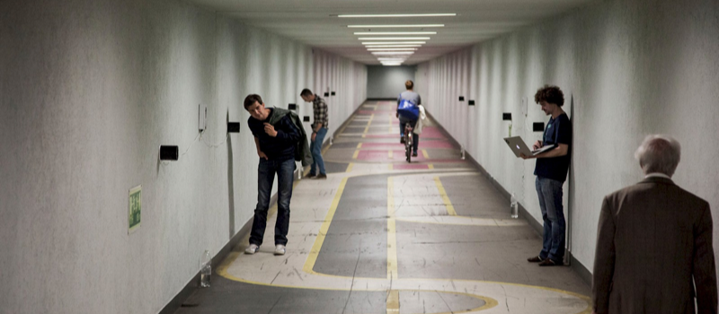

Bachelor Courses
BA Interaction Design Overview
1. Semester: Interaction Design Basics  Inter-Action Design  Bits & Atoms 1  Designing Object / Experience  Interaction Narratives  Creative Coding  Reactive Signs  Physical Computing | 2. Semester: Human-Centered Design  Interaction Design Methods  Bits & Atoms II  Interaction Design Process  Graphical User Interface II  Webtechnologies | 3. Semester: Aesthetic Exploration  Aesthetics of Interaction  Bits & Atoms III  Soft Architecture  Data Visualization  Robotics / AI
4. Semester: Spaces and Services  Design, Technology & Society  Bits & Atoms IV  Spatial Interaction  Service Design | 5. Semester: Embodied and Situated Interaction  Sweet Dreams Are Made of This  Mobile User Interface  Free Flow Retreat  Embodied Interaction  BA Thesis Concept Seminar | 6. Semester: Thesis  Bachelor Thesis  Field Trip | Other  Interdisciplinary Modules  Workshops  Tuesday Eve Bash  Sonic Interaction Design  Digital Fabrication

Master Courses
MA Interaction Design Overview
1. Semester: Explore  Inter-Action  Emerging Technologies  Interaction Research 1  Inter-Action Design  Design Research Introduction & Methods  Junior Design Research Conference | 2. Semester: Cultivate  Ecological Interactions  Interaction Research 2  Environment, Society, Technology  Study Trip  Design Process 2  Design Research Methods  Media Production & Workshop Introduction | 3. Semester: Prototype  Thesis Development 1  Inter-Action Design  More-than-Human Design  Junior Design Research Conference
4. Semester: Manifest  Thesis Development 2  Master Thesis | Other  Reader

Knowledge Base
Technology  ⚡️ Electrical Engineering  🔭 Computer Vision  😎 Programming  ⚙️ Systems Engineering  🖥 Web Development  🛠 Design Tools  🔬 Biodesign | General  📔 Student Handbook  🏝 Summer Reader
Internal

