MATERIAL AND TECHNIQUES
Britannica. List of painting techniques
Victor Cheung (2015) Print matters: the cutting edge of print. Hong Kong: Viction:ary. ZHdK-MIZ signature 283- 94
Max Dörner (2009) Malmaterial und seine Verwendung im Bilde. Ed. by Thomas Hoppe. Freiburg: Christophorus. ZHdK-MIZ signature 2150- 112
Agathe Jacquillat, Tomi Vollauschek @FL33 (2009) Mode & sold: toys, t-shirts, prints, zines and other stuff. London: Laurence King. ZHdK-MIZ signature 267- 40
A.P. Laurie (1926) The painter's methods & materials : the handling of pigments in oil, tempera, water-colour & in mural painting, the preparation of grounds & canvas, & the prevention of discolouration, together with the theories of light & colour applied to the making of pictures.
Taka Nakanishi (2007) A book about special print effects : as printed matter becomes a precious commodity : the invitation to touch makes the product more touching. Hong Kong. ZHdK-MIZ signature 2207- 151
Georg L. Stout (1948) The care of pictures.
ZHdK Workshops

MIXED MEDIA TECHNIQUES
Information found on the web. Click on images to access websource.
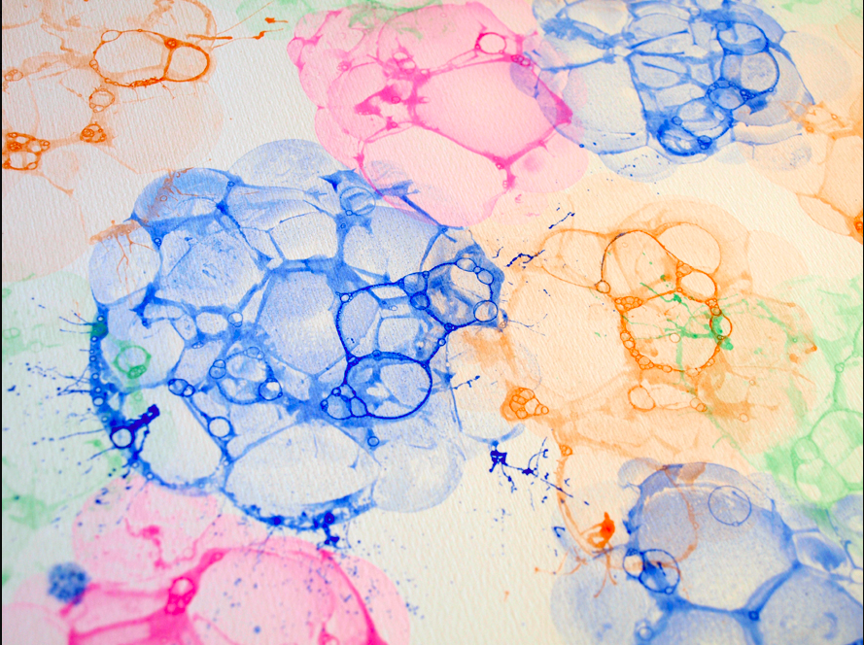
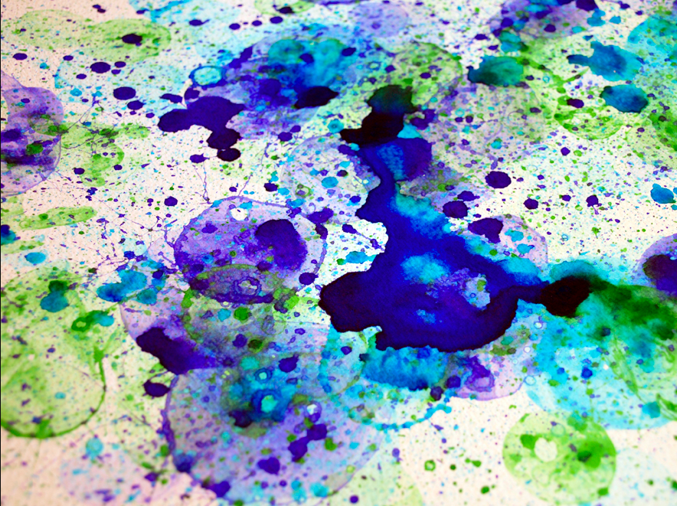{{:material_techniques:sponge.png?200|

