GIANLUCA TRIFILO

Autumn semester 2018

Spring semester 2018
Ornament_v3.5.1
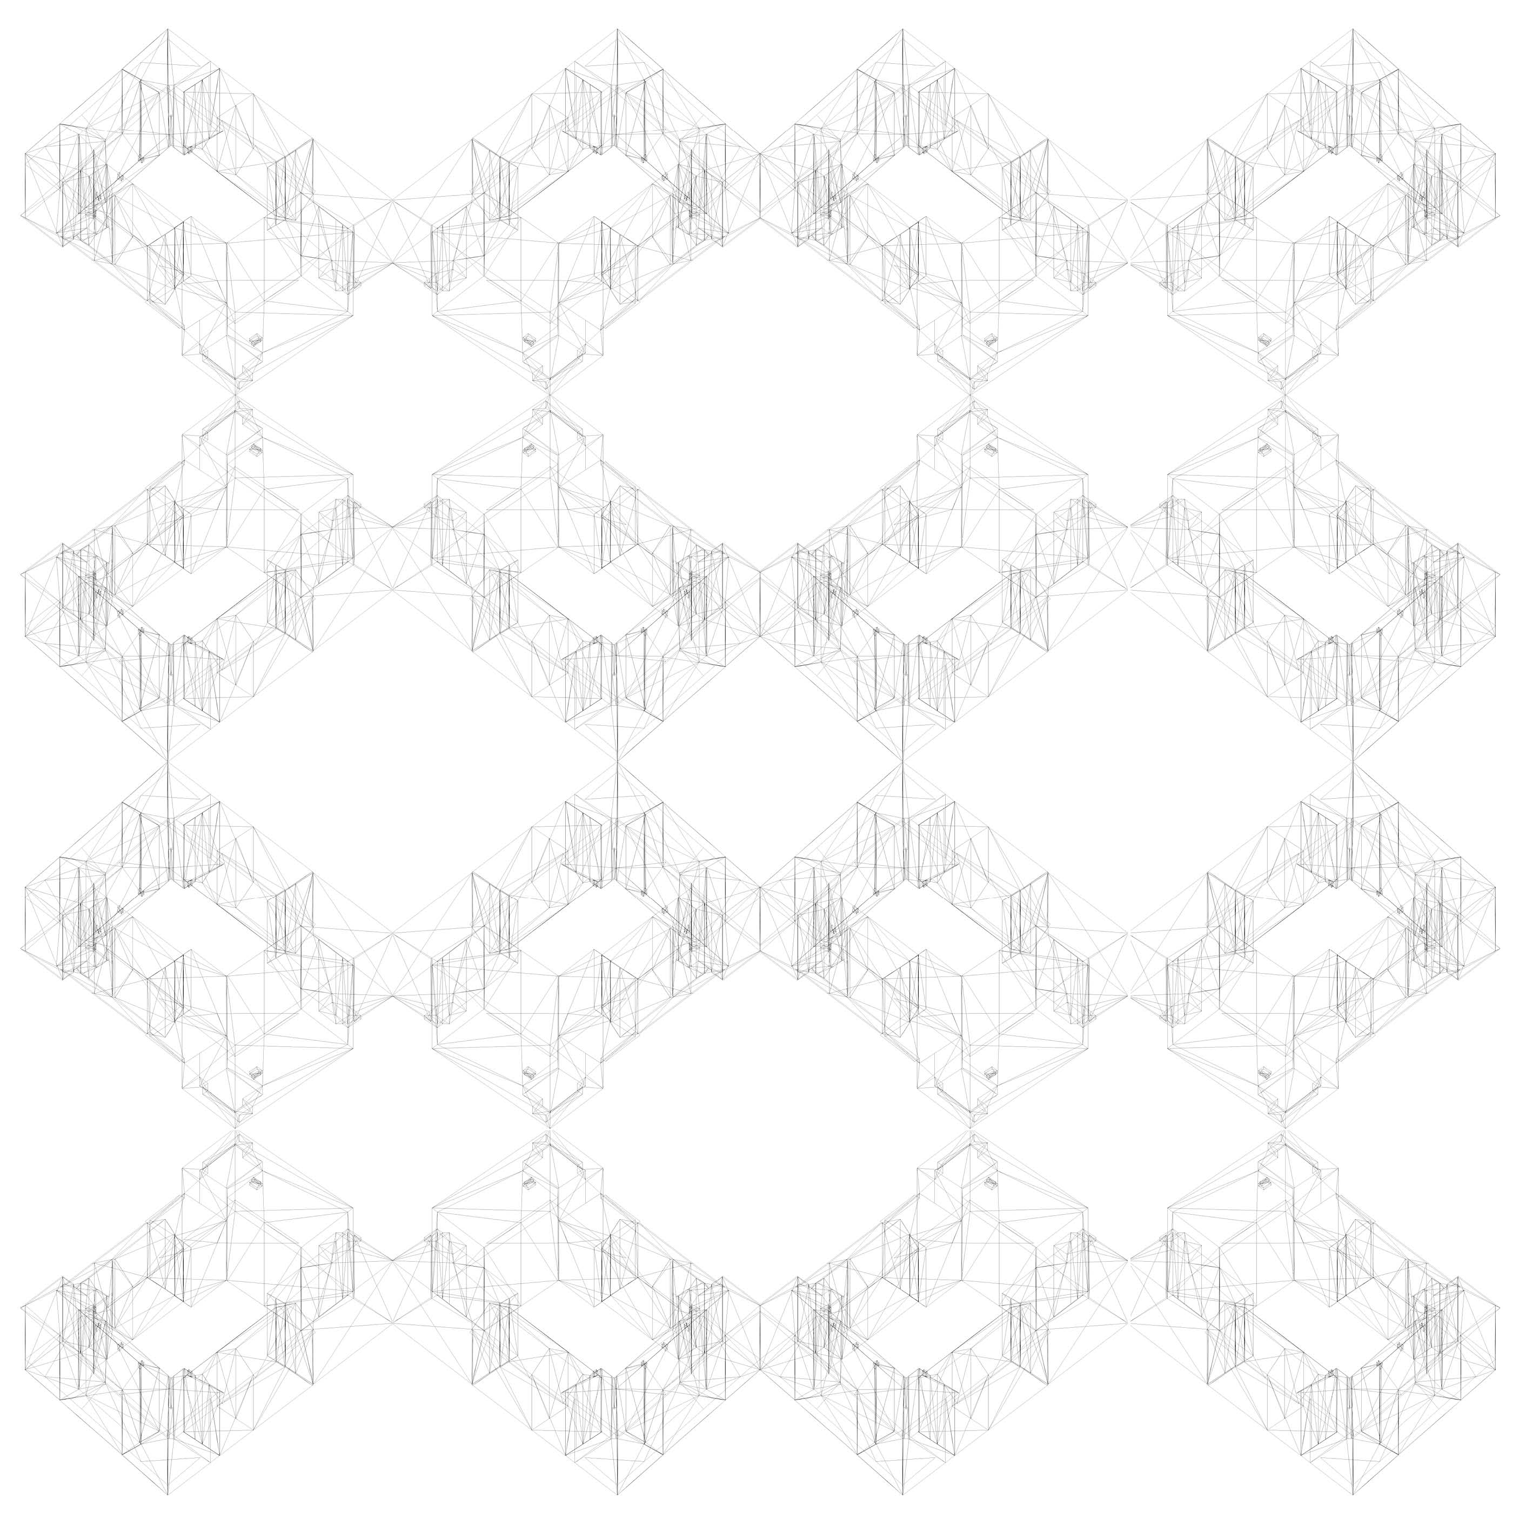Ornament_v3.5.1
Ornament_v3.4.1
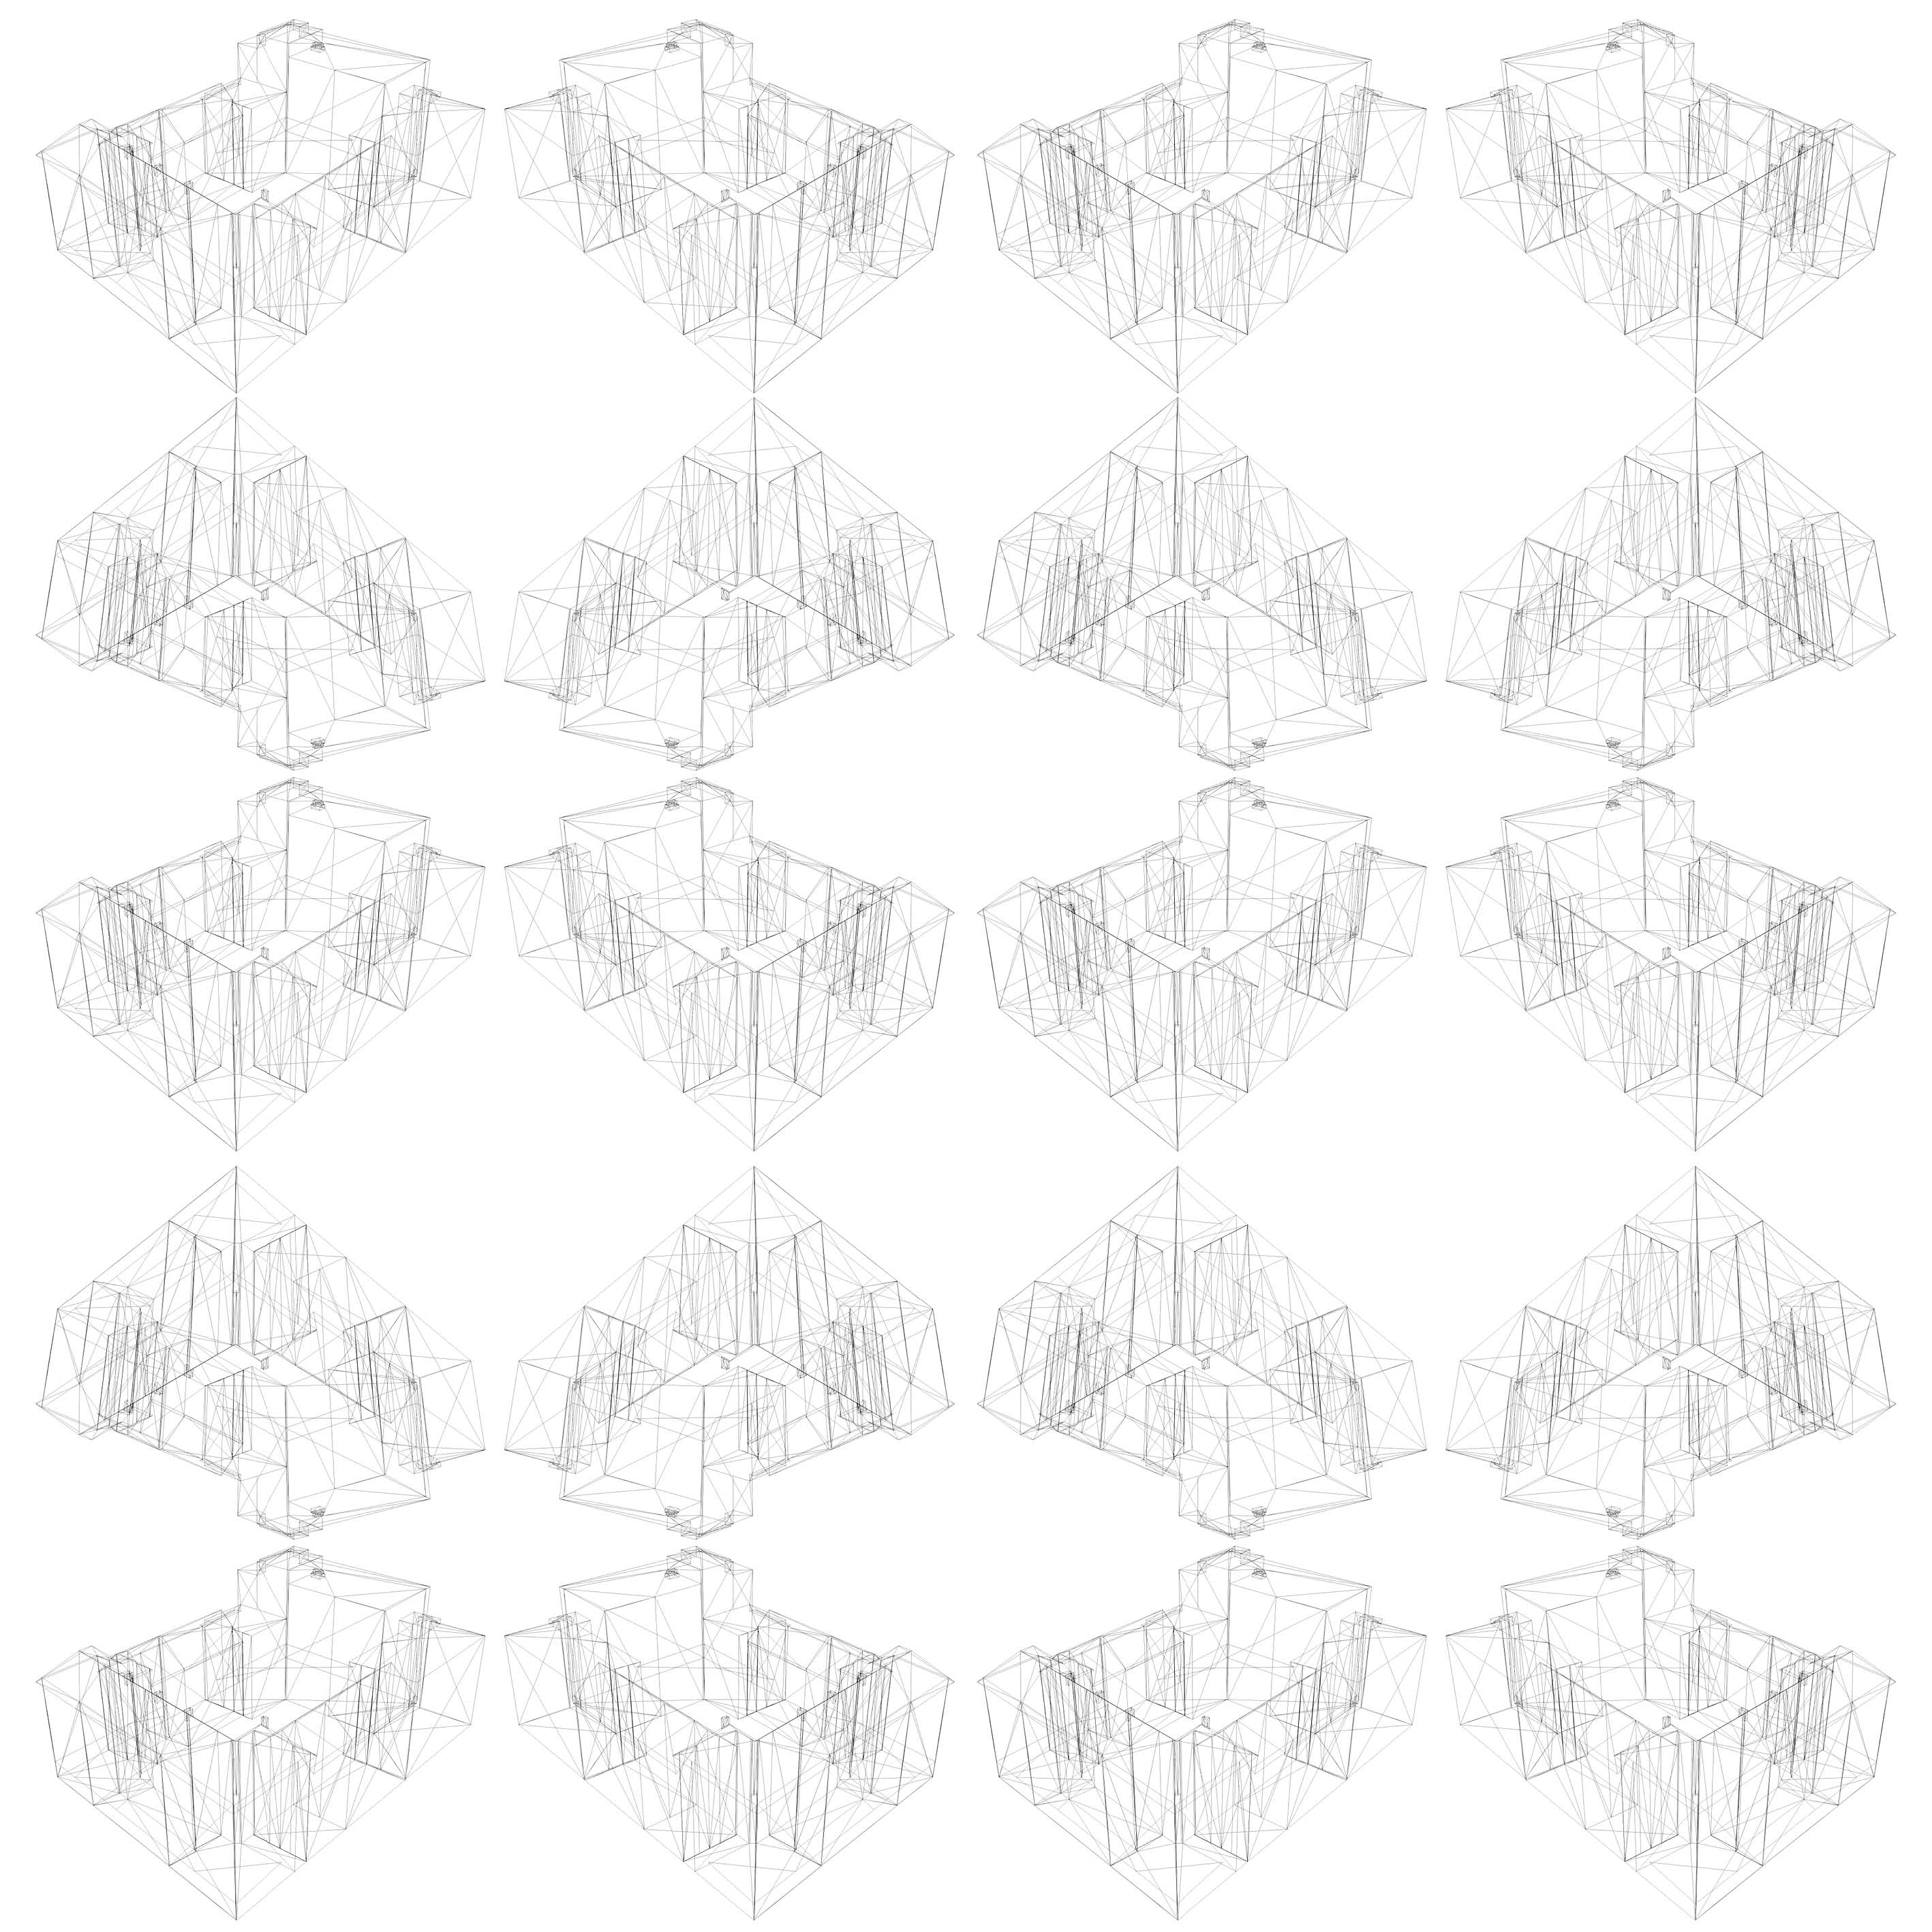Ornament_v3.4.1
Ornament_v3.3.4
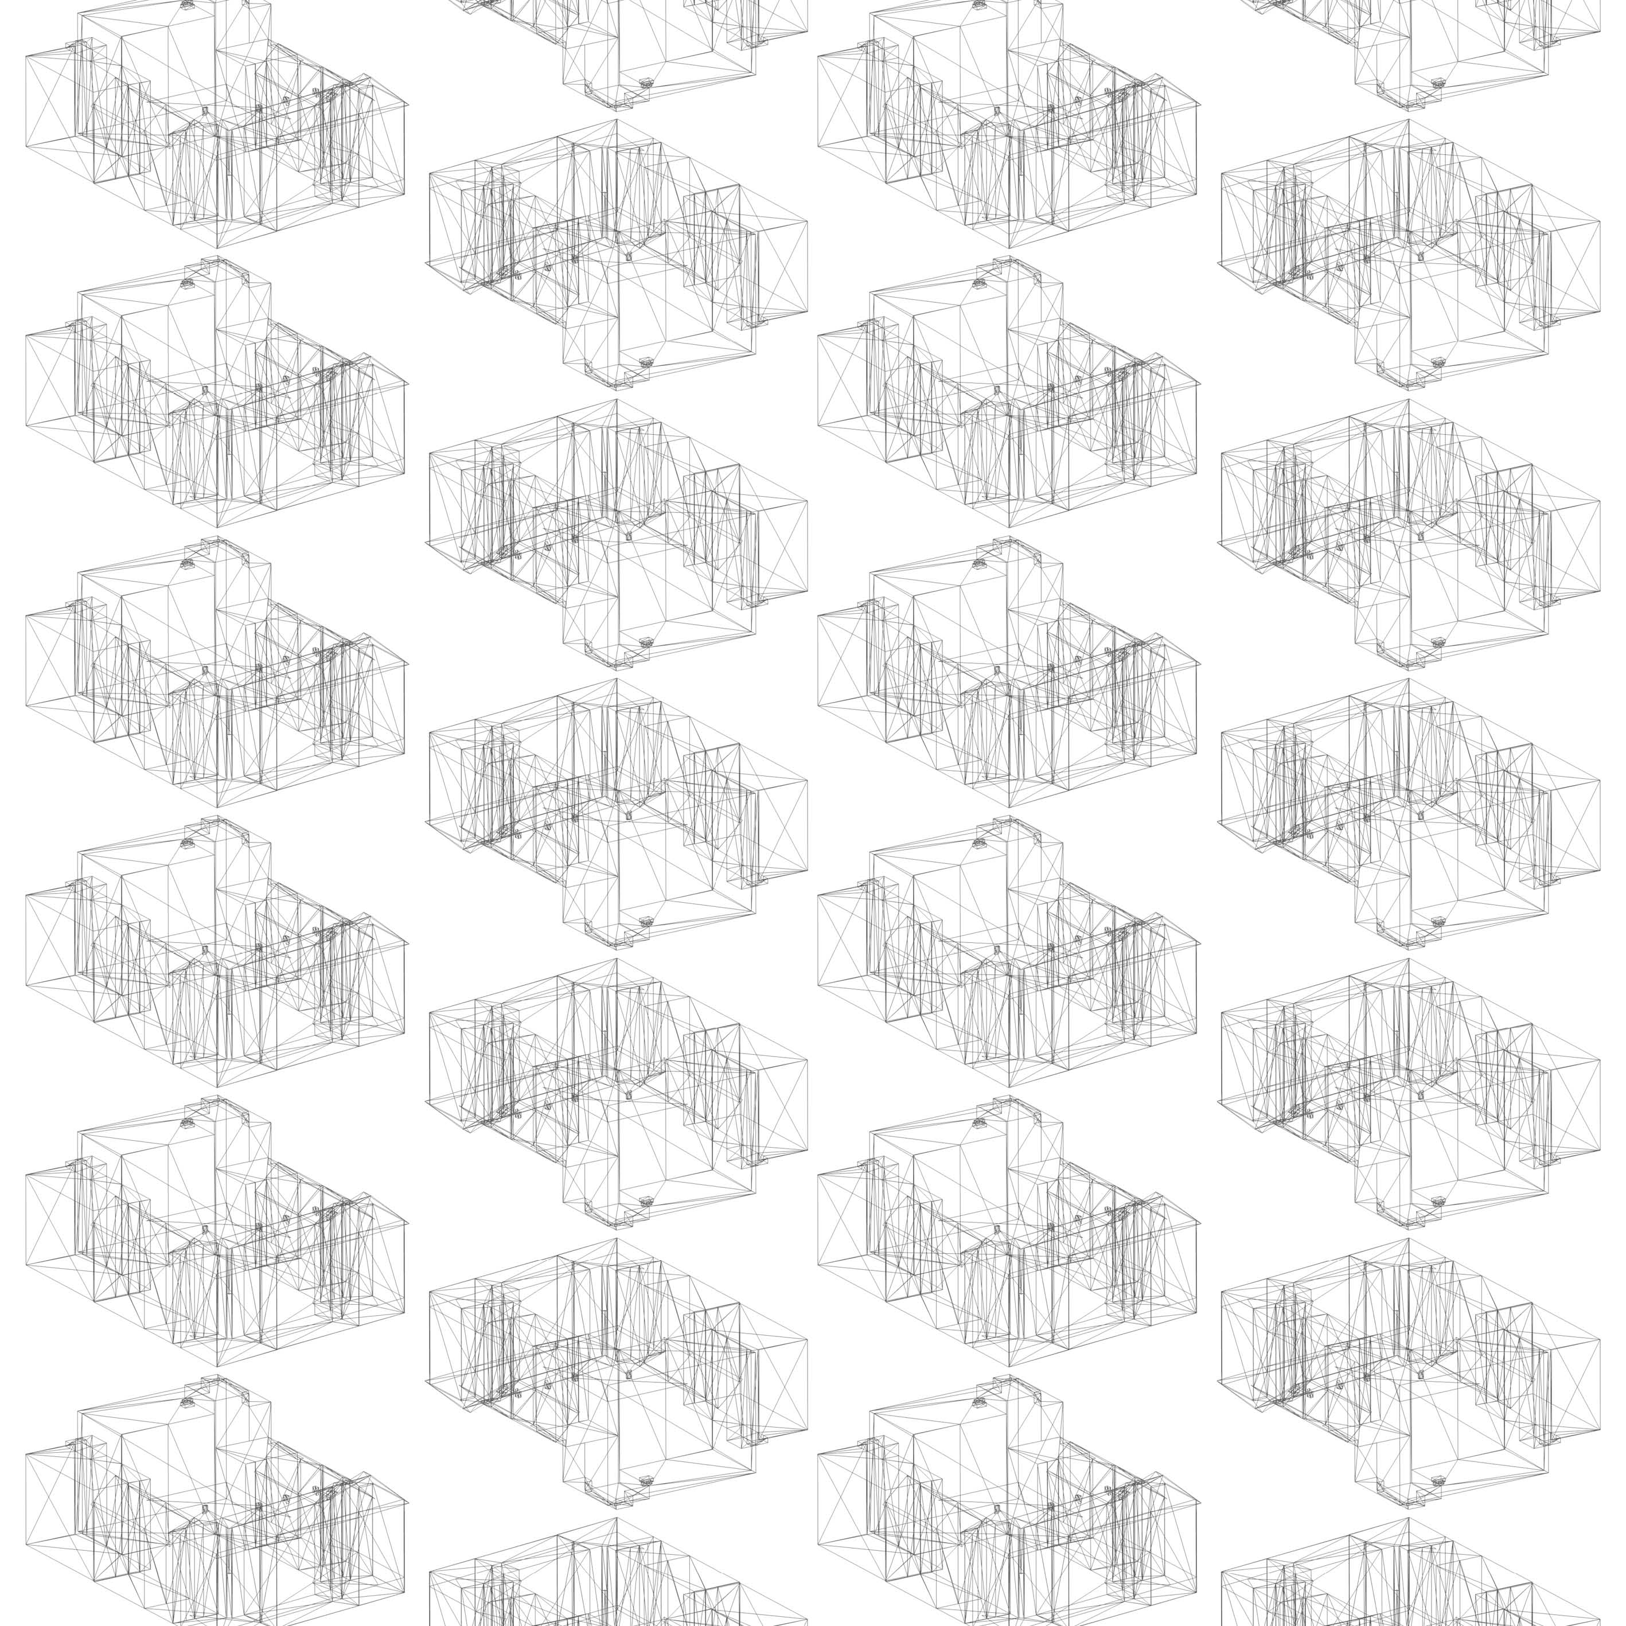Ornament_v3.3.4
Ornament_v3.3.3
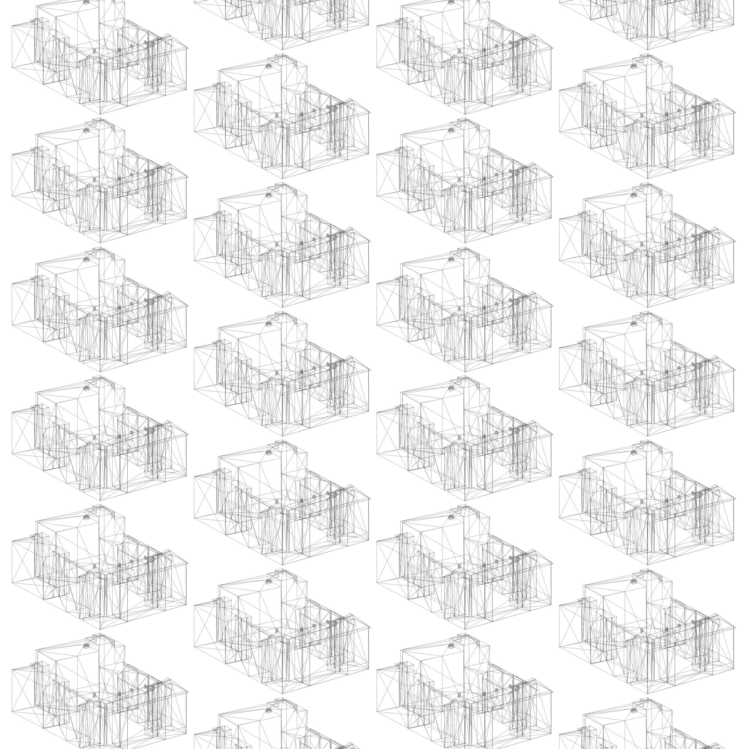Ornament_v3.3.3
Ornament_v3.3.1
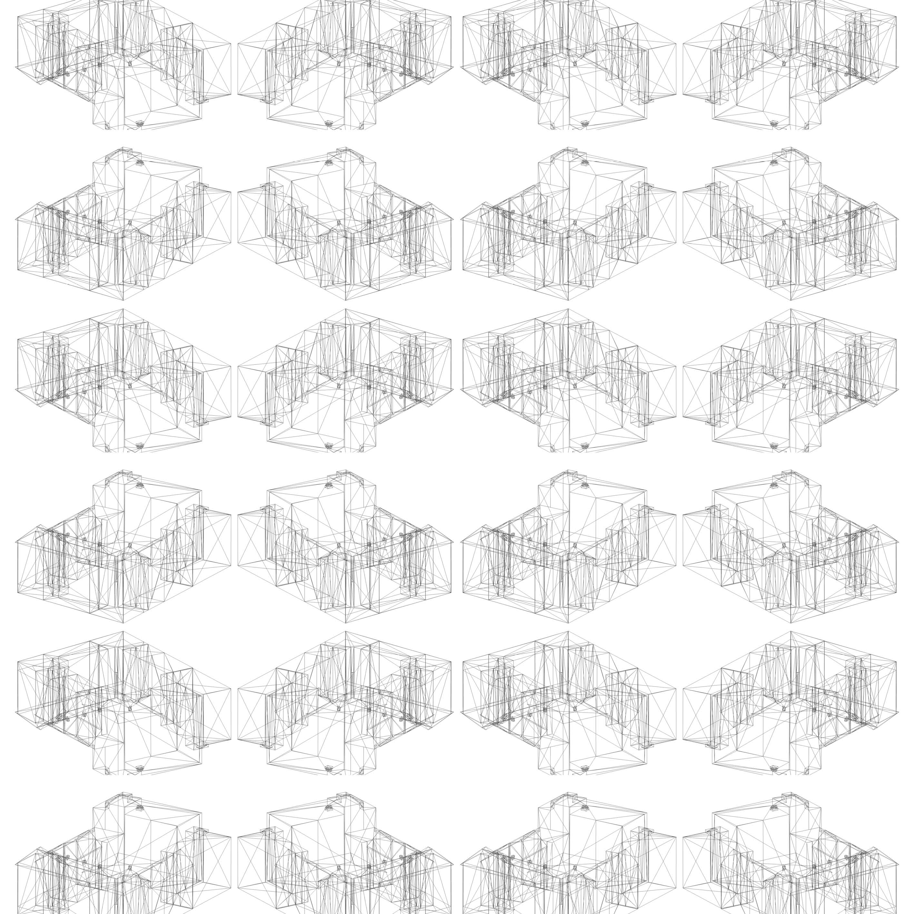Ornament_v3.3.1

# WaveFront *.obj file mtllib ./2017_Erikastrasse_v2.0.mtl
v -28.82670783996582 0.05190262570977 -9.89459133148193 v -30.33360481262207 0.05190262570977 -9.91219329833984 v 32.90450286865234 -0.00909825693816 -6.85613918304443 v 8.08530426025391 0.00290164770558 23.08704566955566 v 22.77015495300293 -0.0450979731977 -11.3099365234375 v 19.9964542388916 15.45290184020996 -21.28033065795898 v 24.3071403503418 22.38490104675293 -16.4830379486084 v 18.91178703308105 17.59090232849121 13.3046817779541 v 23.7528133392334 22.97290229797363 -16.04573440551758 v 29.75464630126953 18.18790245056152 12.59357452392578 v -7.2409987449646 0.05190262570977 -14.19407653808594 v -30.31892585754395 17.59390258789062 -11.41157341003418 v 29.11911582946777 2.95090270042419 17.19599914550781 v 26.17046737670898 22.38490104675293 5.24051284790039 v 19.99660682678223 -0.0450979731977 -21.25471878051758 v -17.41320610046387 15.26190185546875 22.6865234375 v 19.97165870666504 -0.0450979731977 -18.43324089050293 v 23.74087142944336 22.97290229797363 -16.89947891235352 v -17.4071216583252 16.60090255737305 22.05365753173828 v -7.2409987449646 -0.09209772199392 -14.19407653808594 v 7.60956430435181 14.99290180206299 13.2451286315918 v -7.30921840667725 15.26090240478516 22.84267616271973 v -21.9063663482666 20.05290222167969 -9.81495666503906 v 28.81287574768066 21.80290222167969 -7.48029041290283 v -19.81485939025879 23.26190185546875 19.37750244140625 v 21.56226921081543 19.55890274047852 -16.57387733459473 v 26.71990013122559 23.23990249633789 5.92536640167236 v 27.17070007324219 22.38490104675293 -1.16428828239441 v 23.74087142944336 21.80790138244629 -16.89947891235352 v 10.22087669372559 15.43790149688721 -21.41547966003418 v 10.22087669372559 -0.09209772199392 -21.41547966003418 v -7.03043556213379 0.00690260948613 13.00611400604248 v 28.14211845397949 17.99190139770508 23.40337944030762 v 25.85782051086426 22.08990097045898 5.19130039215088 v -16.82887268066406 -0.09609719365835 -9.7562427520752 v -28.79191970825195 18.55790138244629 -13.45234394073486 v 22.65165901184082 -0.0450979731977 -11.46103572845459 v -19.80138969421387 23.26190185546875 17.9370059967041 v 19.99660682678223 18.01490211486816 -21.25471878051758 v -19.81485939025879 25.30390167236328 19.37750244140625 v -16.66946220397949 23.26190185546875 -9.73735237121582 v 15.0651741027832 17.69290161132812 13.359694480896 v -7.15120553970337 -0.09609719365835 12.99839973449707 v 14.99480533599854 -0.00909825693816 18.23687934875488 v 19.81609153747559 -0.00909825693816 12.60198402404785 v 25.76649284362793 22.08990097045898 5.77609920501709 v 23.04984092712402 -0.00909825693816 -7.86915349960327 v 26.07913970947266 22.38490104675293 5.8253116607666 v -27.55063629150391 23.26190185546875 10.37440872192383 v 29.75464630126953 -0.00909825693816 12.59357452392578 v -7.28543901443481 17.19190216064453 15.43227195739746 v -17.4071216583252 15.26190185546875 22.05365753173828 v -7.0306224822998 -0.09609719365835 13.00111865997314 v -32.14173126220703 3.07990193367004 -0.31243950128555 v 30.92424583435059 2.8829026222229 5.72735691070557 v 19.97165870666504 17.94690132141113 -18.43324089050293 v 23.25329399108887 17.41990280151367 -10.69106578826904 v 25.00178718566895 22.25790214538574 11.84091377258301 v 33.6566162109375 17.41990280151367 -6.86169958114624 v 26.81122779846191 23.23990249633789 5.34056758880615 v -27.60094261169434 23.26190185546875 15.73718452453613 v 10.07841014862061 -0.09209772199392 -11.58379077911377 v 17.25150680541992 -0.00909825693816 18.41292190551758 v -6.95034742355347 0.05190262570977 -11.8520622253418 v -16.66946220397949 0.05190262570977 -9.73735237121582 v -23.39083862304688 24.50890159606934 7.67112588882446 v 28.14211845397949 2.93790292739868 23.40337944030762 v 7.60956430435181 0.00290164770558 13.2451286315918 v -7.09295320510864 0.05190262570977 -11.85496425628662 v -7.15120553970337 14.97590160369873 12.99839973449707 v -31.87532997131348 -0.09609719365835 -9.92990016937256 v -28.82670783996582 18.55790138244629 -9.89459133148193 v -30.33360481262207 23.26190185546875 -9.91219329833984 v 14.99480533599854 0.00290164770558 18.23687934875488 v 28.17226219177246 -0.0450979731977 -7.5817494392395 v 19.82134246826172 17.60290145874023 12.56556415557861 v -30.5053653717041 23.26190185546875 15.70991992950439 v 10.15306949615479 19.55890274047852 -16.71150970458984 v -17.29317092895508 25.78390121459961 10.47061729431152 v 8.17744636535645 19.55890274047852 18.2732982635498 v 22.65165901184082 17.56390190124512 -11.46103572845459 v 23.04984092712402 17.63790130615234 -7.86915349960327 v 18.72806549072266 17.41990280151367 13.11117744445801 v -26.85006332397461 17.59390258789062 -13.43310737609863 v 8.08530426025391 15.25590229034424 23.08704566955566 v 15.02138233184814 -0.00909825693816 16.37400436401367 v -27.55063629150391 25.78390121459961 10.37440872192383 v -17.41320610046387 -0.09609719365835 22.6865234375 v -17.41320610046387 23.26190185546875 22.6865234375 v 19.56112861633301 17.41990280151367 -11.34788703918457 v -7.2409987449646 17.14490127563477 -14.19407653808594 v -16.82887268066406 17.59390258789062 -9.7562427520752 v 19.65986061096191 17.41990280151367 12.32960414886475 v -30.61583137512207 0.05190262570977 -11.41434288024902 v -7.0306224822998 16.60090255737305 13.00111865997314 v -7.3108983039856 15.26190185546875 23.45396041870117 v -6.95933675765991 17.59390258789062 -9.58133411407471 v 26.81122779846191 21.80290222167969 5.34056758880615 v -31.87532997131348 23.26190185546875 -9.92990016937256 v 19.95462799072266 19.55890274047852 -16.59353828430176 v -30.53899955749512 25.30390167236328 19.27703285217285 v 15.0648078918457 17.73190116882324 13.4037389755249 v -24.37325859069824 23.9619026184082 7.55436134338379 v -27.62111473083496 25.78390121459961 17.86380577087402 v 35.15343856811523 -0.0450979731977 -21.14341926574707 v 22.00752639770508 19.52490234375 11.96489334106445 v -30.61583137512207 17.59390258789062 -11.41434288024902 v 24.0632209777832 22.38490104675293 18.74136924743652 v 20.39399909973145 -0.00909825693816 8.87592887878418 v -26.8851432800293 20.05290222167969 -9.87254428863525 v 28.08691024780273 -0.00909825693816 -7.59498691558838 v 29.55192565917969 22.38490104675293 -16.41953659057617 v -7.28543901443481 16.60090255737305 15.43227195739746 v 28.14211845397949 -0.00909825693816 23.40337944030762 v 17.25242233276367 -0.00909825693816 18.35685157775879 v 23.2900333404541 21.3429012298584 -16.89211654663086 v 26.9486026763916 22.08990097045898 -1.79767310619354 v -21.27226066589355 3.35190176963806 16.8325138092041 v -7.22158861160278 -0.09209772199392 -16.92228317260742 v -17.30101013183594 -0.09609719365835 10.75490665435791 v 10.15306949615479 -0.09209772199392 -16.71150970458984 v 19.45110511779785 17.41990280151367 -19.04111289978027 v 17.22389602661133 -0.00909825693816 20.31266021728516 v -7.29435396194458 19.55890274047852 18.03360176086426 v -30.29911422729492 18.55790138244629 -13.46713066101074 v 19.93731117248535 17.85690116882324 -14.66996479034424 v 28.0056037902832 -0.00909825693816 -7.08521175384521 v 17.18205261230469 17.92790222167969 23.23403549194336 v 10.22981262207031 14.91290187835693 -22.01462554931641 v -7.09295320510864 -0.09209772199392 -11.85496425628662 v 7.61602973937988 14.7149019241333 12.94007778167725 v 28.16348838806152 -0.00909825693816 23.26769256591797 v -10.68858337402344 2.9359016418457 22.79507064819336 v 8.17744636535645 0.00290164770558 18.2732982635498 v 7.51293802261353 0.00290164770558 18.0406379699707 v -30.53899955749512 23.26190185546875 19.27703285217285 v -7.3066258430481 15.26190185546875 22.14830017089844 v 18.78477668762207 17.6809024810791 13.40367126464844 v 20.39399909973145 17.59890174865723 8.87592887878418 v 28.08691024780273 -0.0450979731977 -7.59498691558838 v 21.85663414001465 19.52490234375 12.93377113342285 v 25.85782051086426 23.23990249633789 5.19130039215088 v 28.0056037902832 -0.0450979731977 -7.08521175384521 v -17.85902976989746 2.92390179634094 22.68274688720703 v -7.18806123733521 -0.09209772199392 -21.66540718078613 v 28.16348838806152 18.12090110778809 23.26769256591797 v -7.15120553970337 0.00690260948613 12.99839973449707 v 27.90278625488281 23.23990249633789 -1.64903426170349 v 14.73020553588867 17.41990280151367 13.04933166503906 v 23.30212211608887 21.3429012298584 -16.03977584838867 v -7.3066258430481 16.60090255737305 22.14830017089844 v -7.15689897537231 -0.09609719365835 15.43369770050049 v -30.29911422729492 17.59390258789062 -13.46713066101074 v 17.18205261230469 15.24990177154541 23.23403549194336 v 8.08530426025391 0.00690260948613 23.08704566955566 v 25.13747406005859 22.38490104675293 11.86228466033936 v -22.85408782958984 23.26190185546875 9.61311912536621 v -7.09209728240967 -0.09209772199392 -14.18340396881104 v -32.78285217285156 3.09690284729004 22.44902801513672 v 10.07841014862061 15.01990222930908 -11.58379077911377 v 2.84417128562927 3.06990194320679 23.00707817077637 v -23.40885543823242 24.57890129089355 9.60813331604004 v -7.01511907577515 16.60090255737305 10.85125732421875 v 7.51293802261353 0.00690260948613 18.0406379699707 v 18.78477668762207 -0.00909825693816 13.40367126464844 v 27.85961723327637 23.23990249633789 -7.63096284866333 v -7.18806123733521 17.59390258789062 -21.66540718078613 v 18.91681098937988 19.55890274047852 18.43864250183105 v 28.90464782714844 23.23990249633789 -8.06930732727051 v -7.09209728240967 0.05190262570977 -14.18340396881104 v -32.78285217285156 23.26190185546875 22.44902801513672 v 19.90901374816895 -0.0450979731977 -11.49191665649414 v -6.95034742355347 -0.09209772199392 -11.8520622253418 v 17.22389602661133 17.86090087890625 20.31266021728516 v 29.84665679931641 18.10490226745605 12.59755802154541 v 22.81832695007324 17.41990280151367 -7.90557479858398 v 10.0770959854126 14.91290187835693 -11.46305847167969 v -17.30101013183594 25.78390121459961 10.75490665435791 v 32.79065322875977 -0.0450979731977 -6.85530853271484 v 29.84665679931641 -0.00909825693816 12.59755802154541 v -6.91754293441772 15.40390205383301 -21.6618595123291 v -26.8851432800293 17.59390258789062 -9.87254428863525 v 15.0651741027832 0.00290164770558 13.359694480896 v -16.82887268066406 0.05190262570977 -9.7562427520752 v 25.13747406005859 -0.00909825693816 11.86228466033936 v 26.71990013122559 21.80290222167969 5.92536640167236 v -24.09997749328613 24.57890129089355 9.60161876678467 v -30.46612167358398 0.05190262570977 -21.92354583740234 v 22.77015495300293 17.41990280151367 -11.3099365234375 v 15.02138233184814 17.73490142822266 16.37400436401367 v 28.0056037902832 22.30290222167969 -7.08521175384521 v -17.36864471435547 16.60090255737305 17.9601993560791 v 8.18174076080322 0.00690260948613 18.04978561401367 v -7.15689897537231 16.60090255737305 15.43369770050049 v 28.83744239807129 17.41990280151367 24.01255989074707 v -30.46612167358398 17.59390258789062 -21.92354583740234 v 15.0651741027832 -0.00909825693816 13.359694480896 v 16.7201099395752 17.35490226745605 20.87117195129395 v 19.9964542388916 -0.0450979731977 -21.28033065795898 v -30.33360481262207 18.55790138244629 -9.91219329833984 v 23.34883689880371 17.41990280151367 -11.30243968963623 v 23.30212211608887 22.97290229797363 -16.03977584838867 v -24.37325859069824 23.26190185546875 7.55436134338379 v 19.9109058380127 17.78590202331543 -11.72634983062744 v 25.00178718566895 -0.00909825693816 11.84091377258301 v -7.28543901443481 0.00690260948613 15.43227195739746 v 19.40927696228027 17.41990280151367 -21.90373611450195 v 17.18205261230469 -0.00909825693816 23.23403549194336 v -28.82670783996582 17.59390258789062 -9.89459133148193 v 18.91178703308105 -0.00909825693816 13.3046817779541 v 7.60956430435181 0.00690260948613 13.2451286315918 v 17.18205261230469 0.00290164770558 23.23403549194336 v -21.87180328369141 17.59390258789062 -13.38410758972168 v 19.82134246826172 -0.00909825693816 12.56556415557861 v -7.15689897537231 0.00690260948613 15.43369770050049 v 28.08691024780273 22.30490112304688 -7.59498691558838 v -6.91754293441772 -0.09209772199392 -21.6618595123291 v 32.79065322875977 18.18790245056152 -6.85530853271484 v 14.99480533599854 19.4309024810791 18.23687934875488 v 35.15343856811523 2.76490187644958 -21.14341926574707 v -7.01511907577515 -0.09609719365835 10.85125732421875 v 27.90278625488281 21.80290222167969 -1.64903426170349 v -23.40885543823242 23.95790100097656 9.60813331604004 v -30.33360481262207 17.59390258789062 -9.91219329833984 v -27.60094261169434 25.30390167236328 15.73718452453613 v -7.02811527252197 14.7149019241333 12.71342754364014 v -7.03043556213379 -0.09609719365835 13.00611400604248 v 23.34787750244141 17.52390098571777 -10.56949615478516 v 19.90770530700684 14.91290187835693 -11.34416675567627 v -7.18806123733521 15.40390205383301 -21.66540718078613 v 16.74026107788086 19.33890151977539 18.1629524230957 v 20.2037525177002 17.41990280151367 8.84598064422607 v -17.36864471435547 25.78390121459961 17.9601993560791 v 6.85707139968872 3.4869019985199 19.78902244567871 v 20.12651062011719 17.75390243530273 11.67120361328125 v -16.66946220397949 -0.09609719365835 -9.73735237121582 v 17.25242233276367 0.00290164770558 18.35685157775879 v 32.79065322875977 -0.00909825693816 -6.85530853271484 v 23.7528133392334 21.80790138244629 -16.04573440551758 v 19.93731117248535 -0.0450979731977 -14.66996479034424 v 15.0651741027832 14.99190139770508 13.359694480896 v 27.95123863220215 22.08990097045898 -8.21857357025146 v 17.25242233276367 19.50790214538574 18.35685157775879 v -30.31892585754395 0.05190262570977 -11.41157341003418 v 28.17226219177246 -0.00909825693816 -7.5817494392395 v 17.24312019348145 17.99190139770508 23.23476600646973 v 27.81145858764648 21.80290222167969 -1.06423580646515 v -30.33360481262207 -0.09609719365835 -9.91219329833984 v 8.18174076080322 19.35590171813965 18.04978561401367 v 19.81609153747559 17.6179027557373 12.60198402404785 v -7.3108983039856 14.7149019241333 23.45396041870117 v -16.66946220397949 17.59390258789062 -9.73735237121582 v 19.90901374816895 15.04390239715576 -11.49191665649414 v 35.15343856811523 17.94790267944336 -21.14341926574707 v 16.80697822570801 19.35890197753906 15.24845886230469 v -32.29165267944336 3.03190231323242 5.01089572906494 v -21.9063663482666 17.59390258789062 -9.81495666503906 v 22.39999008178711 3.16690254211426 7.20261573791504 v 25.34206008911133 22.25590133666992 9.65195178985596 v 20.00216865539551 14.91290187835693 -21.89616966247559 v -7.09209728240967 17.13690185546875 -14.18340396881104 v -7.2409987449646 17.59390258789062 -14.19407653808594 v -22.85408782958984 23.95790100097656 9.61311912536621 v -7.30921840667725 -0.09609719365835 22.84267616271973 v -30.5053653717041 25.30390167236328 15.70991992950439 v -6.95933675765991 0.05190262570977 -9.58133411407471 v 27.81145858764648 23.23990249633789 -1.06423580646515 v 8.17744636535645 0.00690260948613 18.2732982635498 v -7.09295320510864 15.07590198516846 -11.85496425628662 v 35.13314056396484 -0.0450979731977 -21.01117324829102 v 27.95123863220215 23.23990249633789 -8.21857357025146 v 32.90450286865234 18.0869026184082 -6.85613918304443 v -24.08196067810059 24.50890159606934 7.66461133956909 v -16.99381637573242 23.26190185546875 0.36390605568886 v -6.95034742355347 17.59390258789062 -11.8520622253418 v -7.3066258430481 -0.09609719365835 22.14830017089844 v -28.79191970825195 17.59390258789062 -13.45234394073486 v -16.82887268066406 23.26190185546875 -9.7562427520752 v 23.34787750244141 -0.0450979731977 -10.56949615478516 v 19.95462799072266 -0.0450979731977 -16.59353828430176 v -17.30101013183594 16.60090255737305 10.75490665435791 v 30.6146183013916 17.41990280151367 12.63063621520996 v -24.39188957214355 23.95790100097656 9.59866809844971 v -7.30921840667725 0.00690260948613 22.84267616271973 v 7.51293802261353 19.35690116882324 18.0406379699707 v 23.2900333404541 22.97290229797363 -16.89211654663086 v -7.28543901443481 -0.09609719365835 15.43227195739746 v 15.0648078918457 -0.00909825693816 13.4037389755249 v 22.73946189880371 -0.0450979731977 -21.29349327087402 v 18.71576309204102 19.33890151977539 18.19354629516602 v -32.78285217285156 -0.09609719365835 22.44902801513672 v -17.36864471435547 23.26190185546875 17.9601993560791 v -22.83468055725098 23.26190185546875 7.56818246841431 v 30.38337898254395 2.89890217781067 9.16323852539062 v -7.18466806411743 14.91290187835693 -22.22531700134277 v -16.99381637573242 -0.09609719365835 0.36390605568886 v 17.24312019348145 -0.00909825693816 23.23476600646973 v -7.15689897537231 17.19090270996094 15.43369770050049 v 15.06945514678955 14.71390247344971 13.0551233291626 v 28.81287574768066 23.23990249633789 -7.48029041290283 v 22.73946189880371 17.94790267944336 -21.29349327087402 v 27.26202583312988 22.38490104675293 -1.74908900260925 v 23.34883689880371 8.68790149688721 -11.30243968963623 v -18.31576347351074 3.46190214157104 -11.29683971405029 v 19.95462799072266 -0.09209772199392 -16.59353828430176 v -24.09997749328613 23.95790100097656 9.60161876678467 v 23.04984092712402 -0.0450979731977 -7.86915349960327 v 17.17389106750488 14.7149019241333 23.83255195617676 v -17.4192066192627 15.26190185546875 23.35920906066895 v -7.29435396194458 0.00690260948613 18.03360176086426 v 26.9486026763916 23.23990249633789 -1.79767310619354 v 17.25150680541992 19.55890274047852 18.41292190551758 v 25.76649284362793 23.23990249633789 5.77609920501709 v 19.90901374816895 17.5609016418457 -11.49191665649414 v -19.80138969421387 25.30390167236328 17.9370059967041 v -7.22158861160278 19.55890274047852 -16.92228317260742 v -7.30921840667725 15.26190185546875 22.84267616271973 v 19.9964542388916 -0.09209772199392 -21.28033065795898 v -7.09295320510864 17.59390258789062 -11.85496425628662 v 19.52056503295898 17.41990280151367 -14.18193817138672 v 25.35650062561035 3.07190155982971 -20.92671203613281 v -6.95034742355347 15.07490158081055 -11.8520622253418 v -6.95113277435303 14.91290187835693 -11.6687068939209 v 20.12651062011719 19.41890144348145 11.67120361328125 v -26.85006332397461 20.05290222167969 -13.43310737609863 v 19.9964542388916 17.99090194702148 -21.28033065795898 v 16.67486190795898 17.41990280151367 23.82489776611328 v -7.09209728240967 17.59390258789062 -14.18340396881104 v 32.90450286865234 -0.0450979731977 -6.85613918304443 v 23.25329399108887 -0.0450979731977 -10.69106578826904 v 19.9109058380127 -0.0450979731977 -11.72634983062744 v 26.85727882385254 22.08990097045898 -1.2128723859787 v 8.07358932495117 14.7149019241333 23.69230270385742 v 19.97421264648438 17.75390243530273 12.63993453979492 v 26.85727882385254 23.23990249633789 -1.2128723859787 v 21.61071014404297 22.38490104675293 18.70329666137695 v 14.68429660797119 17.41990280151367 16.02289199829102 v 22.77015495300293 8.68790149688721 -11.3099365234375 v 28.26388549804688 22.38490104675293 -8.16936016082764 v -22.83468055725098 23.9619026184082 7.56818246841431 v -24.08196067810059 23.9619026184082 7.66461133956909 v 28.90464782714844 21.80290222167969 -8.06930732727051 v 23.25329399108887 8.68790149688721 -10.69106578826904 v 19.97421264648438 19.41890144348145 12.63993453979492 v 25.34206008911133 -0.00909825693816 9.65195178985596 v -7.15120553970337 16.60090255737305 12.99839973449707 v -23.39083862304688 23.9619026184082 7.67112588882446 v 18.84073829650879 19.35890197753906 15.27948760986328 v -24.39188957214355 23.26190185546875 9.59866809844971 v -17.29317092895508 -0.09609719365835 10.47061729431152 v -27.62111473083496 25.30390167236328 17.86380577087402 v 35.97378921508789 17.41990280151367 -21.7034969329834 v -21.87180328369141 20.05290222167969 -13.38410758972168 v 12.05645561218262 2.99490284919739 23.1513500213623 v 19.90901374816895 -0.09209772199392 -11.49191665649414 v 33.83940887451172 2.79390263557434 -12.7949914932251 v -7.03043556213379 14.98090171813965 13.00611400604248 v -26.8851432800293 0.05190262570977 -9.87254428863525 v 28.17226219177246 22.38490104675293 -7.5817494392395 v -7.18806123733521 0.05190262570977 -21.66540718078613 v -21.9063663482666 0.05190262570977 -9.81495666503906 v 17.25150680541992 0.00290164770558 18.41292190551758 v 27.85961723327637 22.08990097045898 -7.63096284866333 v 35.13314056396484 18.06990242004395 -21.01117324829102 v -17.29317092895508 23.26190185546875 10.47061729431152 v 8.18174076080322 0.00290164770558 18.04978561401367 # 366 vertices
o 2017_Erikastrasse_V1.0 usemtl default f 10 195 282 f 44 190 86 f 289 254 105 f 164 285 249 f 156 108 10 f 359 218 245 f 315 38 292 f 156 10 218 f 71 73 248 f 268 85 155 f 312 362 243 f 104 315 233 f 217 20 145 f 195 336 327 f 74 366 183 f 248 73 278 f 248 278 35 f 238 272 3 f 156 58 185 f 307 279 140 f 349 157 263 f 205 58 259 f 35 278 41 f 349 263 283 f 197 138 165 f 236 41 296 f 292 19 192 f 200 36 125 f 148 311 267 f 4 74 212 f 360 11 65 f 108 336 195 f 88 89 291 f 322 323 177 f 112 216 359 f 343 303 338 f 7 26 90 f 199 326 301 f 203 349 283 f 185 50 10 f 25 315 40 f 80 85 268 f 132 175 146 f 218 10 282 f 121 31 30 f 258 55 356 f 276 137 264 f 284 85 22 f 2 244 184 f 180 114 50 f 209 200 224 f 185 10 156 f 69 266 65 f 69 64 266 f 129 295 316 f 205 109 345 f 199 289 37 f 80 249 285 f 124 80 285 f 279 37 105 f 176 232 259 f 305 6 100 f 345 259 205 f 264 317 88 f 60 313 27 f 53 163 95 f 310 124 51 f 7 201 112 f 43 95 346 f 124 285 298 f 353 84 325 f 11 262 170 f 152 194 287 f 270 254 364 f 90 201 7 f 62 160 173 f 290 231 243 f 214 76 139 f 283 263 103 f 328 262 319 f 84 213 196 f 324 141 106 f 336 168 327 f 130 322 269 f 119 91 316 f 63 243 115 f 169 271 166 f 105 254 270 f 45 8 250 f 213 252 262 f 114 115 205 f 310 51 206 f 43 221 227 f 269 322 261 f 206 298 215 f 312 290 243 f 23 110 182 f 184 360 65 f 307 140 143 f 344 141 324 f 264 291 120 f 261 177 78 f 287 120 43 f 203 283 103 f 147 70 32 f 340 203 103 f 296 35 236 f 293 203 340 f 208 174 123 f 20 91 119 f 65 252 184 f 140 279 105 f 245 216 359 f 136 25 101 f 235 324 106 f 202 9 286 f 15 326 199 f 263 293 340 f 182 72 209 f 36 325 84 f 157 293 263 f 179 140 105 f 53 95 43 f 48 313 46 f 223 66 162 f 4 366 74 f 347 66 223 f 119 230 145 f 145 230 181 f 31 181 30 f 110 72 182 f 72 200 209 f 121 30 78 f 71 248 296 f 215 298 70 f 121 160 62 f 279 57 330 f 245 218 238 f 36 84 277 f 43 346 194 f 275 319 97 f 186 27 48 f 135 249 285 f 235 334 344 f 353 213 84 f 215 70 147 f 13 294 258 f 94 12 107 f 88 317 16 f 248 35 296 f 23 257 213 f 167 196 213 f 353 110 23 f 187 223 162 f 306 223 187 f 72 110 325 f 32 357 211 f 164 249 193 f 244 12 94 f 257 182 361 f 155 85 284 f 173 160 322 f 173 322 130 f 23 213 353 f 310 22 124 f 169 166 300 f 36 277 153 f 202 239 9 f 238 218 272 f 91 261 316 f 243 219 312 f 120 71 296 f 50 114 205 f 13 354 67 f 197 165 115 f 291 71 120 f 359 191 259 f 211 357 21 f 264 137 317 f 165 8 210 f 331 314 204 f 158 269 261 f 277 84 196 f 15 56 39 f 284 22 310 f 188 107 196 f 150 239 202 f 116 150 202 f 305 100 253 f 264 120 287 f 287 43 152 f 231 290 255 f 120 221 43 f 61 49 77 f 25 292 38 f 74 219 237 f 153 277 196 f 153 107 12 f 136 171 25 f 190 219 231 f 188 196 360 f 130 269 158 f 114 246 297 f 187 162 66 f 365 274 49 f 36 153 125 f 213 262 167 f 73 274 278 f 52 309 137 f 20 261 91 f 116 202 286 f 168 290 312 f 29 286 18 f 113 19 151 f 158 261 20 f 330 338 5 f 116 286 29 f 343 338 330 f 188 244 94 f 13 258 354 f 40 315 351 f 183 241 74 f 31 355 62 f 141 344 334 f 290 168 348 f 226 357 131 f 112 218 59 f 70 298 357 f 94 107 188 f 80 249 134 f 50 10 175 f 319 262 252 f 318 355 31 f 366 249 135 f 316 261 78 f 359 218 112 f 172 314 331 f 176 191 216 f 9 29 18 f 184 188 360 f 221 281 163 f 239 29 9 f 321 356 220 f 360 196 167 f 366 68 183 f 209 224 1 f 281 19 113 f 281 113 346 f 273 306 187 f 135 285 21 f 180 175 132 f 360 167 262 f 104 233 178 f 237 219 243 f 170 262 328 f 44 197 115 f 242 363 166 f 79 87 178 f 353 325 110 f 180 272 175 f 329 364 272 f 101 40 351 f 242 166 271 f 3 272 180 f 265 101 351 f 51 124 298 f 270 364 329 f 180 238 3 f 130 158 173 f 297 246 128 f 271 169 339 f 149 255 83 f 201 176 216 f 169 342 339 f 120 281 221 f 312 219 80 f 216 191 359 f 112 201 216 f 345 139 109 f 278 274 41 f 231 255 337 f 164 21 285 f 177 229 100 f 78 100 260 f 341 306 273 f 109 139 47 f 136 77 171 f 77 49 99 f 207 112 352 f 7 112 207 f 69 319 64 f 111 191 216 f 185 205 58 f 156 259 58 f 135 21 68 f 132 33 114 f 347 341 273 f 31 30 318 f 235 344 324 f 347 273 66 f 184 244 188 f 171 77 99 f 97 319 252 f 179 272 218 f 242 271 339 f 73 49 274 f 249 131 285 f 329 272 179 f 75 218 359 f 75 216 140 f 165 45 115 f 171 89 25 f 43 194 152 f 287 194 113 f 300 342 169 f 322 177 261 f 276 113 151 f 50 175 180 f 287 113 276 f 137 19 52 f 267 311 335 f 60 142 313 f 207 26 7 f 117 332 335 f 245 111 216 f 92 213 257 f 117 335 311 f 355 160 62 f 89 292 25 f 318 6 305 f 333 308 80 f 86 190 102 f 359 216 75 f 49 73 99 f 214 139 109 f 115 45 205 f 208 115 114 f 24 342 300 f 215 32 211 f 68 21 241 f 134 249 366 f 137 309 96 f 65 97 252 f 359 300 166 f 177 100 78 f 359 166 363 f 346 113 194 f 163 346 95 f 163 281 346 f 345 139 259 f 24 300 359 f 288 102 42 f 87 104 178 f 140 191 143 f 279 228 57 f 197 42 138 f 32 215 147 f 311 148 302 f 329 179 105 f 151 19 137 f 158 20 217 f 280 56 17 f 221 163 53 f 173 158 62 f 49 79 365 f 80 124 251 f 86 102 288 f 312 154 362 f 4 154 85 f 68 241 183 f 62 158 31 f 350 79 120 f 249 299 131 f 31 158 217 f 343 57 303 f 212 154 4 f 63 123 174 f 100 56 280 f 80 251 333 f 112 59 352 f 127 82 191 f 115 243 219 f 47 82 127 f 172 199 37 f 119 316 230 f 303 57 201 f 83 255 348 f 360 262 11 f 297 128 208 f 127 111 238 f 249 268 193 f 148 222 302 f 108 348 336 f 266 97 65 f 219 249 80 f 47 127 345 f 170 328 69 f 61 77 265 f 361 92 257 f 303 189 338 f 168 312 174 f 305 253 355 f 117 311 302 f 312 243 63 f 289 301 254 f 26 56 100 f 17 56 15 f 121 160 78 f 165 138 8 f 5 189 37 f 258 294 55 f 87 79 49 f 280 126 100 f 240 204 126 f 184 92 361 f 120 79 178 f 281 233 192 f 247 222 148 f 26 100 126 f 331 204 240 f 247 148 267 f 187 66 273 f 345 127 238 f 87 225 104 f 224 244 2 f 61 225 49 f 109 47 345 f 219 299 249 f 49 225 87 f 182 209 1 f 37 289 105 f 108 83 348 f 37 189 81 f 80 308 312 f 355 253 160 f 200 72 36 f 28 267 335 f 37 81 314 f 12 244 224 f 361 182 358 f 351 315 104 f 201 189 303 f 45 109 205 f 28 335 332 f 132 146 33 f 315 292 233 f 345 180 50 f 134 85 80 f 114 33 246 f 145 181 217 f 348 168 336 f 217 181 31 f 265 351 225 f 80 268 249 f 205 345 50 f 298 285 131 f 247 267 28 f 58 108 156 f 318 30 6 f 232 58 259 f 142 46 313 f 164 193 155 f 15 39 326 f 19 89 16 f 44 219 190 f 134 4 85 f 184 252 92 f 280 240 126 f 37 314 172 f 286 9 18 f 34 46 142 f 296 41 274 f 59 218 282 f 93 83 108 f 359 259 156 f 307 82 228 f 213 92 252 f 307 228 279 f 232 93 58 f 103 263 340 f 366 135 68 f 362 154 212 f 64 319 275 f 72 325 36 f 199 301 289 f 115 219 44 f 266 275 97 f 1 224 2 f 142 60 14 f 191 176 259 f 11 69 65 f 60 98 14 f 208 128 174 f 75 179 218 f 281 178 233 f 234 354 258 f 234 161 354 f 200 153 224 f 345 238 180 f 34 142 14 f 104 225 351 f 27 98 60 f 359 156 218 f 118 144 133 f 118 159 144 f 118 256 159 f 25 38 315 f 196 107 153 f 243 362 237 f 101 25 40 f 10 108 195 f 265 136 101 f 140 216 191 f 78 260 129 f 77 136 265 f 74 237 212 f 357 298 131 f 143 191 82 f 64 275 266 f 206 215 284 f 206 51 298 f 210 8 45 f 32 70 357 f 127 191 111 f 186 98 27 f 337 255 149 f 61 265 225 f 47 139 82 f 350 274 365 f 255 290 348 f 45 250 76 f 164 155 284 f 231 219 243 f 211 21 164 f 122 26 207 f 90 26 320 f 296 274 350 f 170 69 11 f 19 16 52 f 48 27 313 f 23 182 257 f 292 89 19 f 291 89 171 f 143 82 307 f 45 76 214 f 327 168 198 f 288 42 197 f 291 171 99 f 291 99 71 f 182 1 358 f 63 174 312 f 74 241 219 f 200 125 153 f 71 99 73 f 58 93 108 f 35 41 236 f 215 211 164 f 69 328 319 f 215 164 284 f 129 316 78

Rendering_v3.1 - v3.3
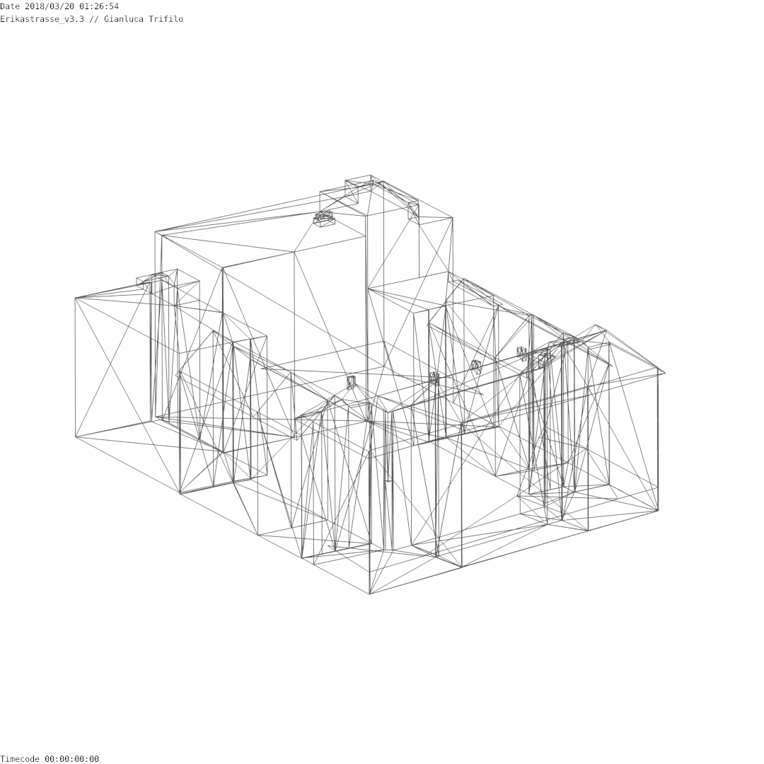Rendering_v3.3
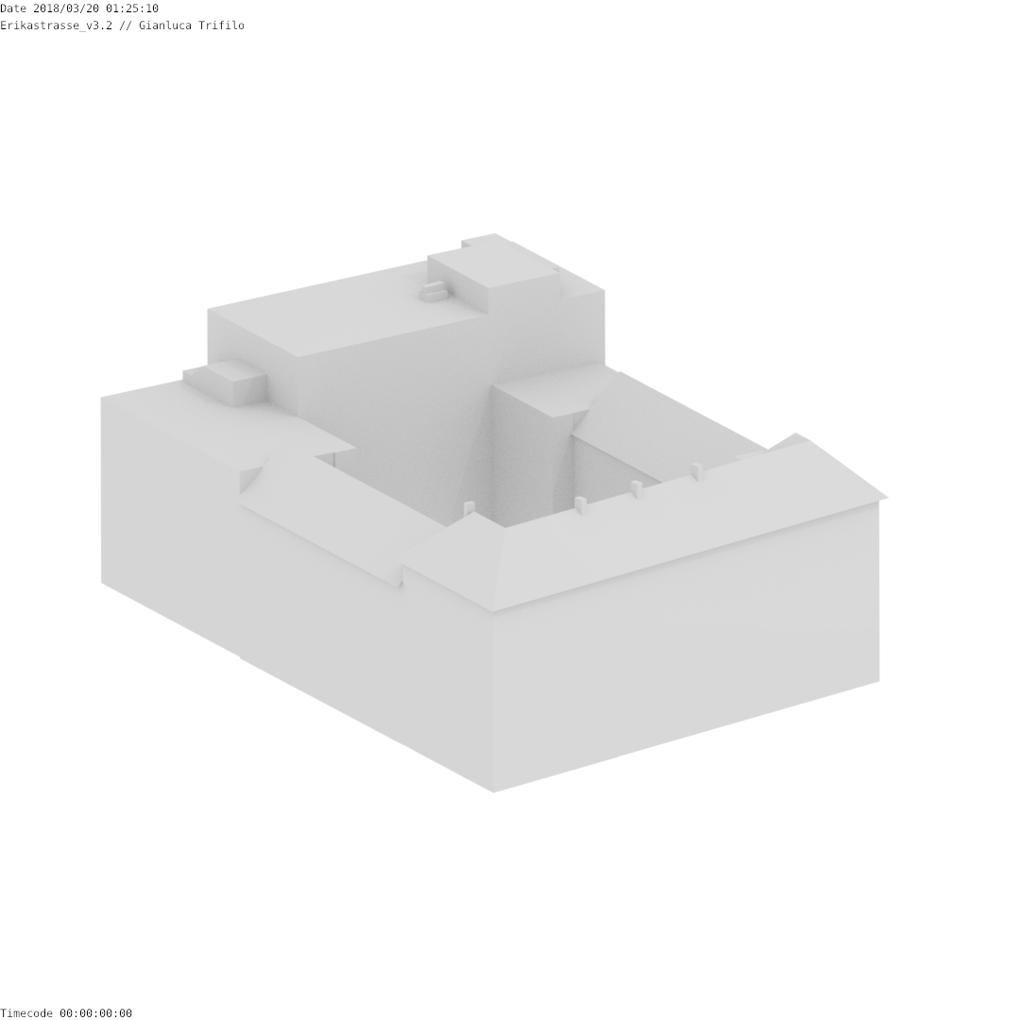Rendering_v3.2
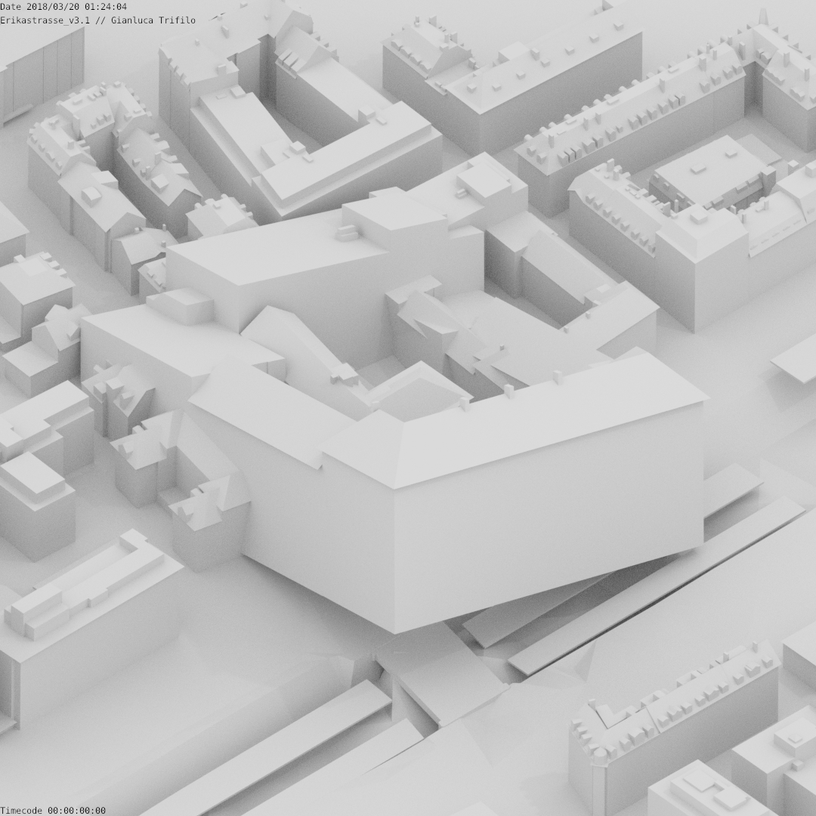Rendering_v3.1

Rendering_v2.1
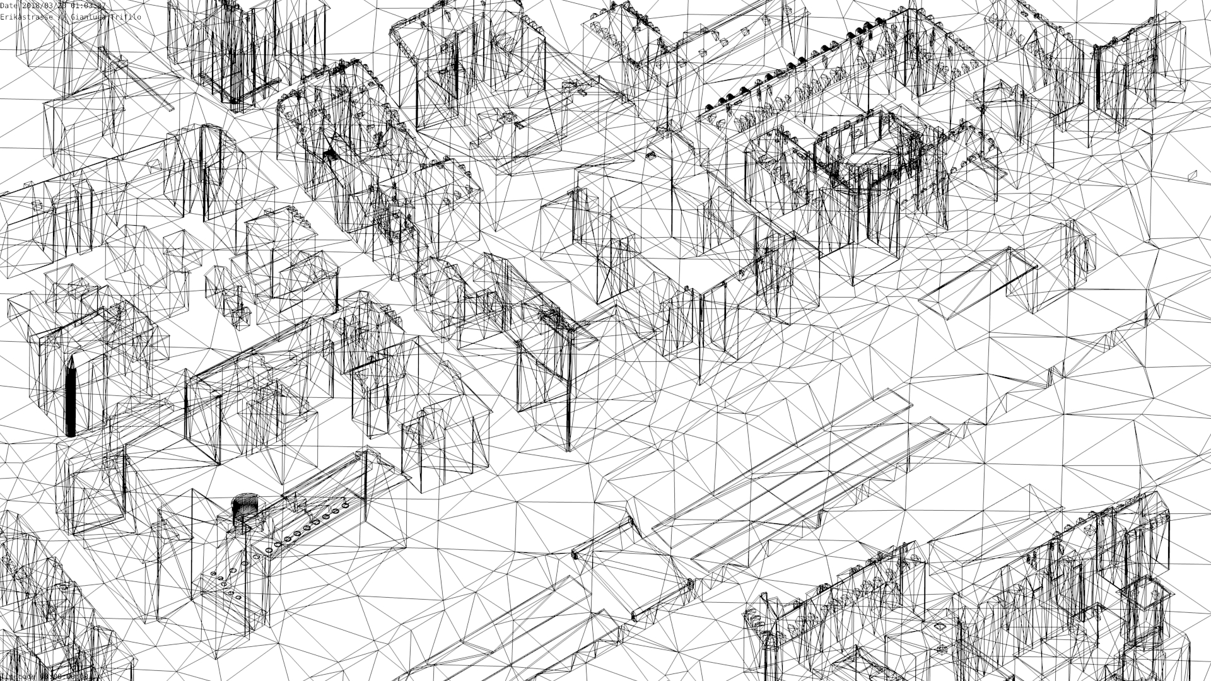Rendering_v2.1

Rendering_v1.1
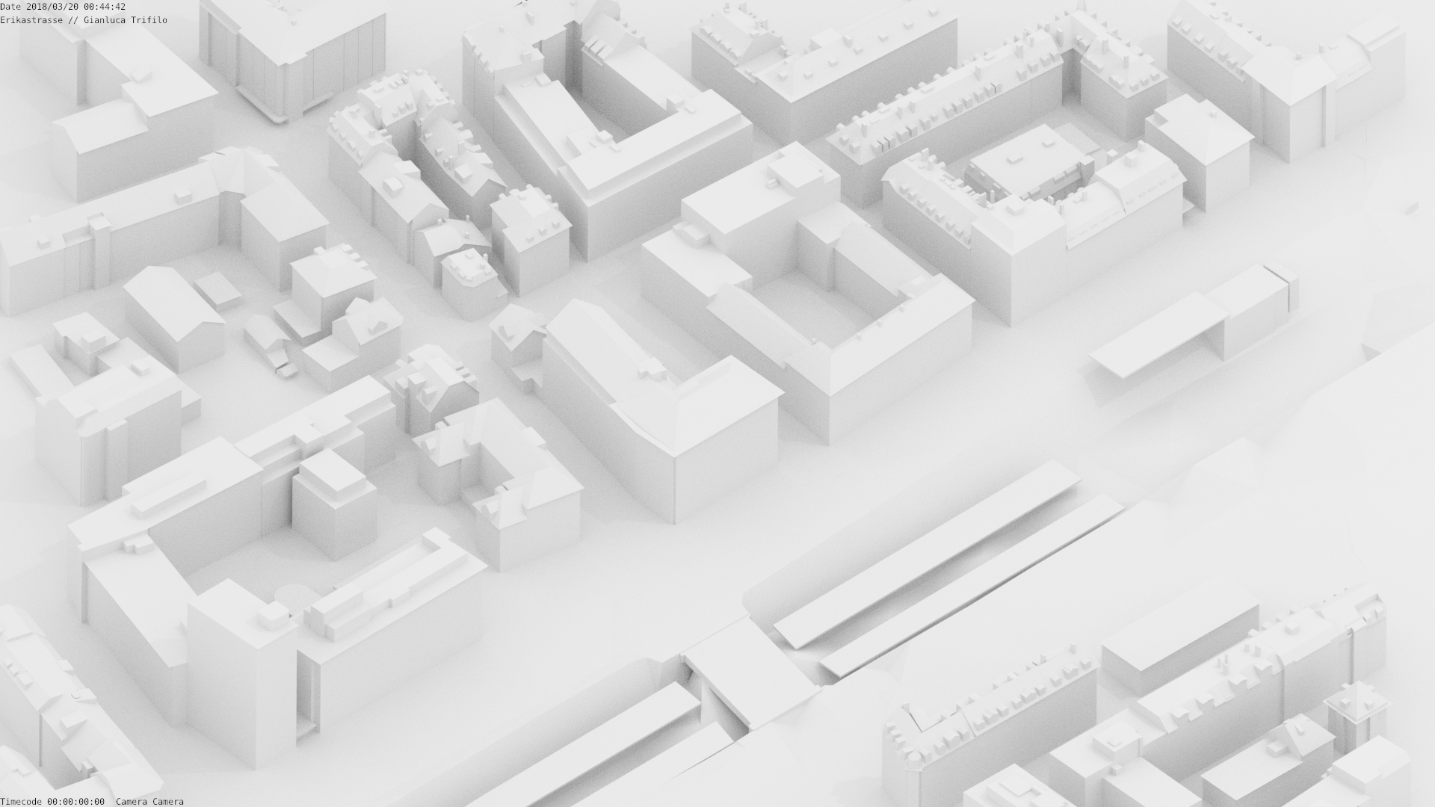Rendering_v1.1

Siegerprojekt «lucy» von Zita Cotti Architekten AG, Zürich; Bild: © Ernst Basler + Partner AG, Zürich
—-
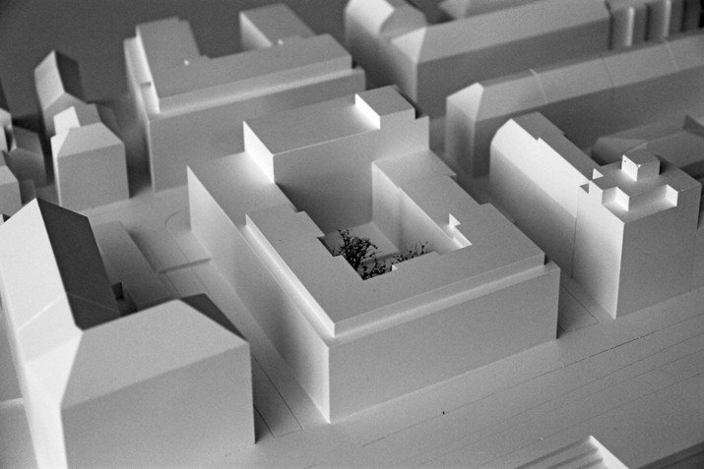Siegerprojekt «lucy» von Zita Cotti Architekten AG, Zürich; Bild: © Ernst Basler + Partner AG, Zürich
Auszug aus dem Bericht des Preisgerichts: Neubau Siedlung Erikastrasse

Rendering_v1.0
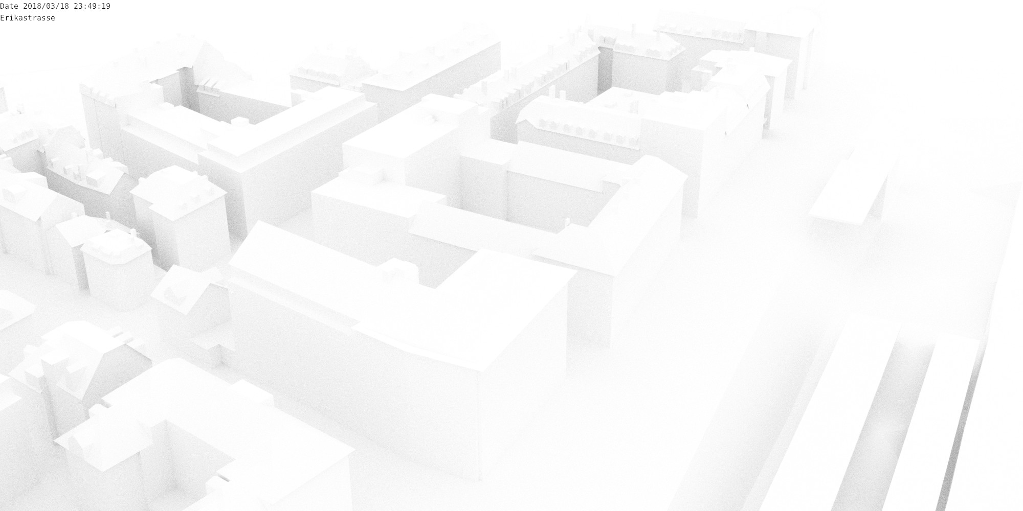Rendering_v1.0
3D PDF Ansicht

3D-View Erikastrasse
Unlock PDF
Katasterauskunft Zürich
Anleitung Download 3D-PDF in der Katasterauskunft

Off Spaces

Rote Fabrik
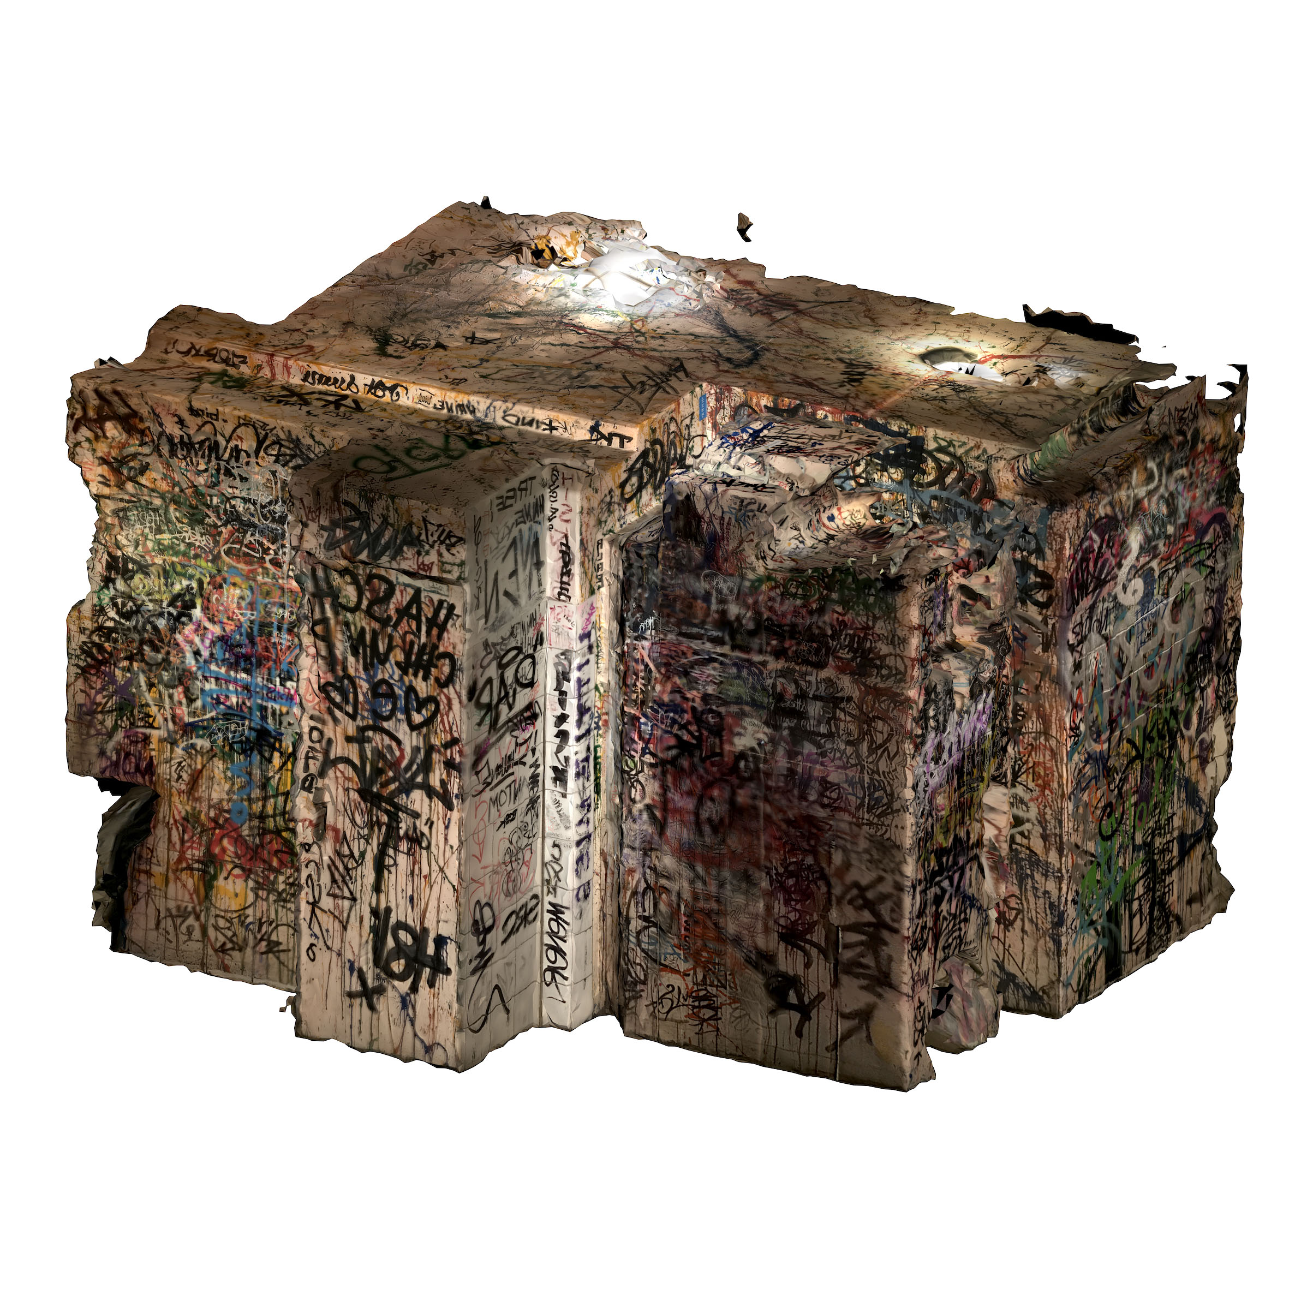

Open Source 3D Creation Software
Photogammetry Software

