A HOTCHPOTCH OF WORKS
The references given on this page relate to works and topics addressed in workshop contexts.

PAINTERS/ARTISTS
Janine Antoni Jan Anüll Phyllida Barlow Jean-Michel Basquiat Sabian Baumann Lynda Benglis Reto Boller Juliana Borinski Stan Brakhage Georg Dokoupil Tatjana Gerhard Sandra Gibson & Luis Recoder Katharina Grosse Philip Guston Lori Hersberger Susan Hiller Leni Hoffmann Dominique Lämmli Lang Baumann Moondog Victorine Müller Oscar Muñoz Rivane Neuenschwander Jason Rhoades Robin Rhode Christoph Schreiber Jessica Stockholder Yvonne Oerlemans Yongseok Oh Hans Op de Beek Junebum Park Léopold Rabus David Reed David Shrigley Gordon Shrigley Christine Streuli Philip Taaffe Yuken Teruya Trinh T. Minh-Ha Bernard Voïta Franz West Christopher Wool

Painting, drawing & smell
Move the mouse curser over the pictures to see the names of the painters, exhibitions etc.
Removing scent Special purpose coatings PCI
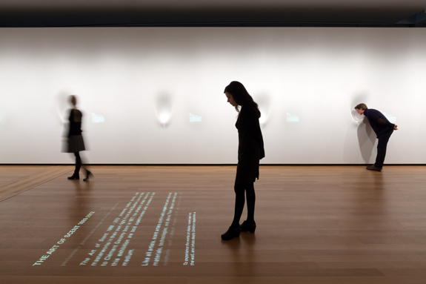The Art of the Scent exhibition
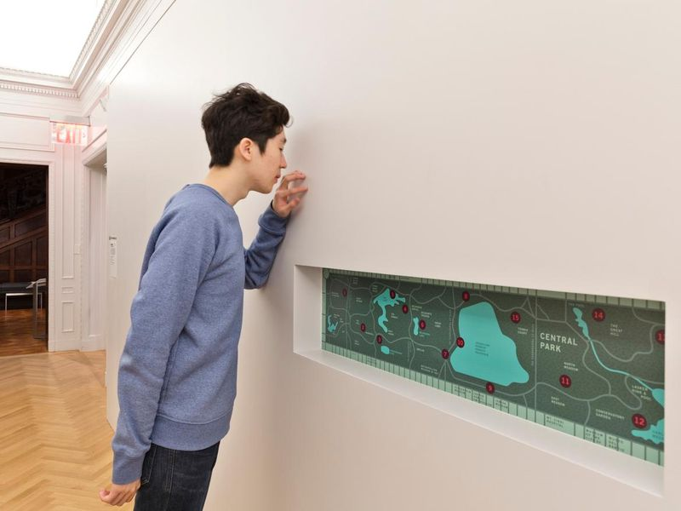Smithsonian Design Museum
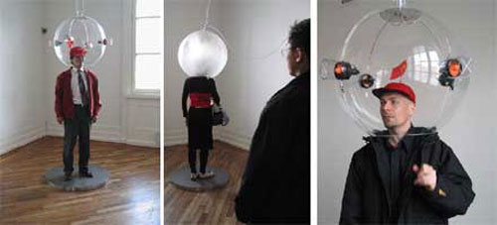Urban Olfactory
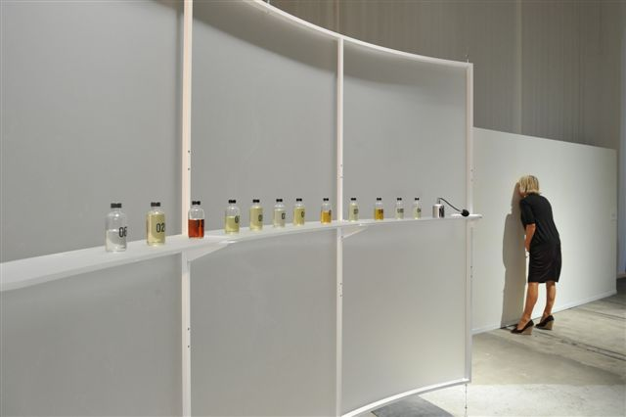|Sissel Tolaas & The Art of Smell
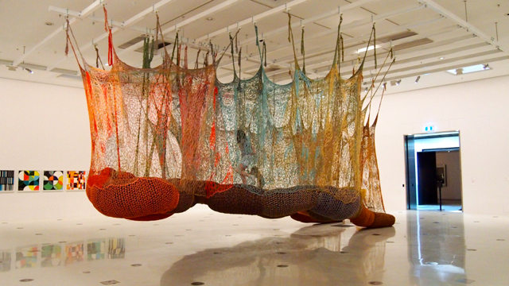Ernesto Neto
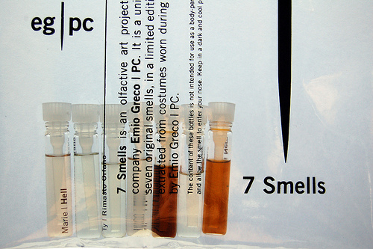Maki Ueda
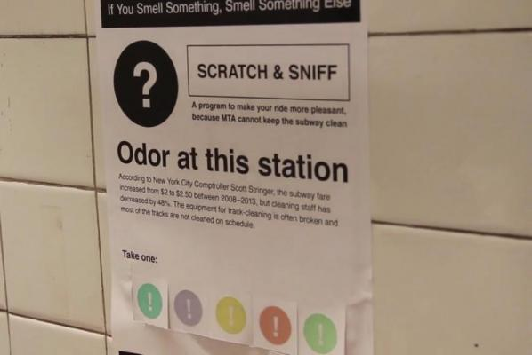New York subway smell
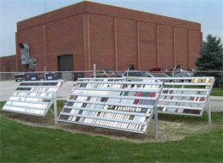Paint Technology Center

Printing vegetables and fruits

Textures
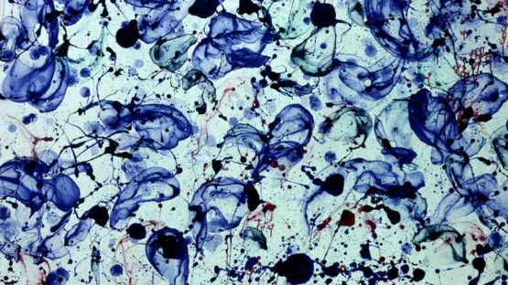DOKOUPIL
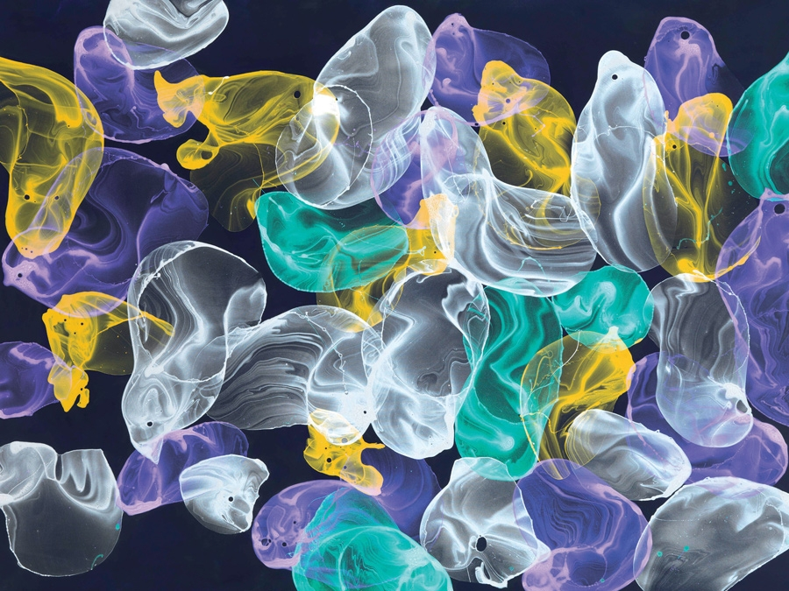DOKOUPIL
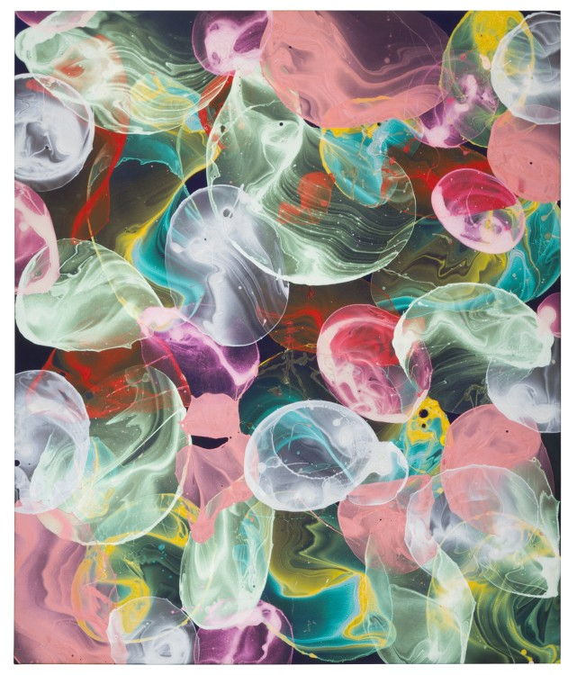DOKOUPIL
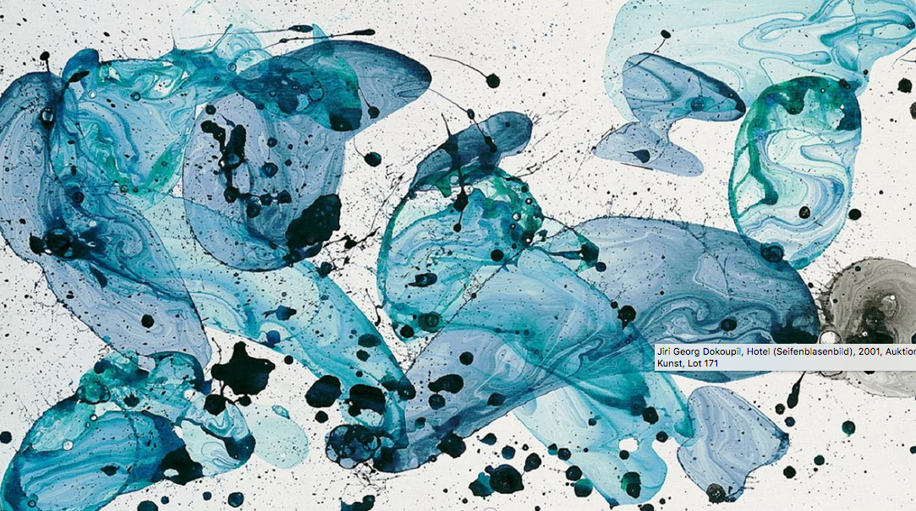DOKOUPIL

PAINTING, DRAWING & SPACE
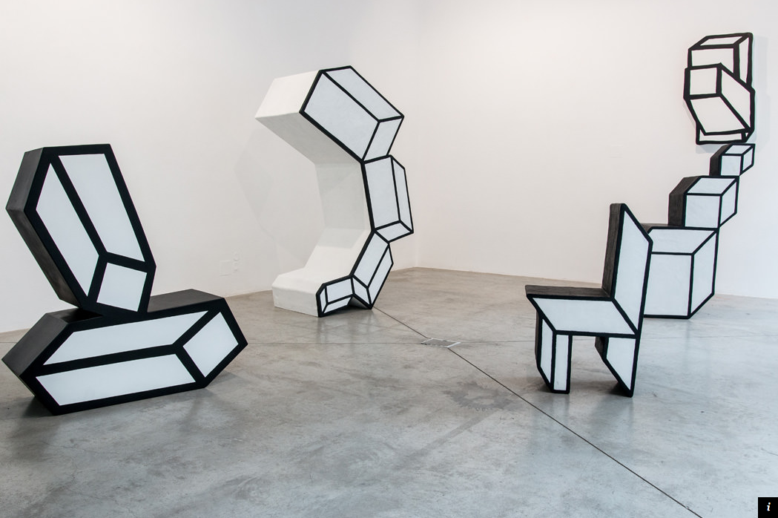DOKOUPIL

PRINTS

