Dominique Lämmli
Autumn semester 2017
EXPERIMENT I am experimenting with Touch Sensitive Prints. For info see our wiki page on ELECTRIC PAINT. Image source
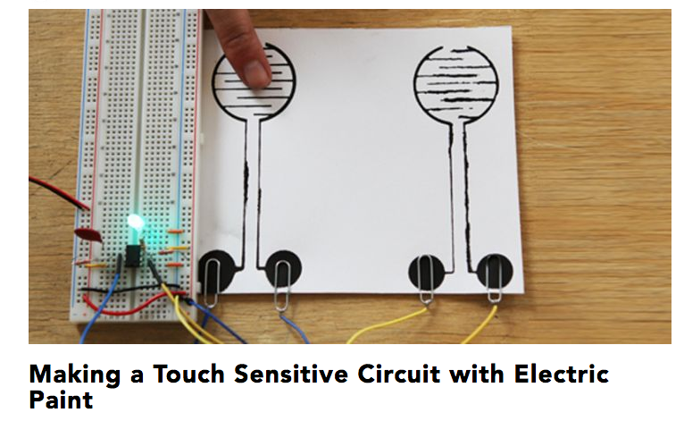
PRINTING & DIGITAL WORK Spray drawing on mono print lithography with chameleon and aluminium pigments UV-print, lithography, and painting Moving painting Collaborative printing: wood and digital print, lithography, painting] [[http://dominiquelaemmli.kleio.com/record/work/6|Lithography wall painting with mirrored paper Lithography papered on ceiling with mirrored paper Laser cut metal drawing Drawing on lithography Drawing on lithography Digital images processes on lambda Lithographies

