


The Performance Practice of Electroacoustic Music: a practice-based exchange between musicology and practice

Project presentation

Introduction
60 years after the birth of electroacoustic music, questions concerning performance practice are becoming increasingly relevant. Many composers who traditionally have been the foremost interpreters of their own music are now at old age or no longer alive. The same can be said of other important witnesses to history such as instrumentalists, conductors, technicians, studio assistants and musicians concerned with performance and sound projection. Younger generations of musicians and researchers are now becoming involved with this repertoire. For any of them, but particularly for performers, the question of how to perform a piece taking into account its specific artistic, historic and technical genesis becomes critical, considering that the technical means available nowadays are completely different from historical conditions. The disappearance of old technologies and the availability of new ones present challenges while opening up new possibilities. Different attitudes and experiences of today’s audiences must be taken into account as well. As in (instrumental) performance practice of older music, those questions lead into an area marked by the tension between historical performance practice and modern reception. The preservation of knowledge about the genesis of electroacoustic works, the original performance conditions and the development of a performance tradition is an essential prerequisite for developing an adequately informed interpretation practice. In order to gather the evidence necessary for developing adequate interpretation criteria for specific works, thorough philological investigations of different sources like sketches, scores, diagrams, photographs, films, letters and audio documents must be undertaken. The study of audio material like base recordings, working materials reflecting different compositional stages, preliminary mixes, different versions and historical performances must be done in hearing in analogy to the composition process in the studio. Hypotheses on issues like versions, number of channels, spatial configuration of sound sources and the audience’s position, channel distribution, kind and properties of technical means, dynamics and spatialization of projected audio, amplification of instruments, etc. must then be validated in a dialogue with experienced performers and historical witnesses under spatial and technical conditions corresponding to real performances. The possibility to experiment with different sound projection devices and configurations according to artistic intentions and spatial conditions is a prerequisite. Accordingly, the project aims to establish a research methodology for performance practice of electroacoustic music where musicologists and performers enter into a practice-based dialogue. Such a dialogue between theory and practice serves a double purpose: to deliver a model for research methodology and to yield concrete results with respect to compositions that can be considered exemplary study subjects in terms of the problems they present to performers. Providing methods of study and practice-validated evidence that allow performers to formulate their own interpretation criteria, the overarching objective of the project is thus to contribute to the realization of artistically adequate performances of electroacoustic works. The collaboration with the Paul Sacher Stiftung and the continuing collaboration with a select group of universities, archives, publishers, musicologists and performers constitutes a unique network allowing to integrate precious knowledge and experience and provides the basis for a broad impact.

Works studied

György Ligeti

Glissandi

Introduction
Glissandi was realized in 1957 at the Cologne studio of WDR (Westdeutscher Rundfunk). It was Ligeti's first electroacoustic piece. Ligeti himself called the piece an “exercise” (Ligeti, Gesammelte Schriften, Vol. 1, p. 246).While there is no realization score for the piece, some sketches exist (Paul Sacher Stiftung, Basel, Sammlung György Ligeti). The sound material consists of synthetically produced impulse sounds and glissandi presented in different registers, in different speeds and dynamics that are generally developed through repetition and variation. Formally, two roughly symmetrical parts can be distinguished. In the first part, an increased in density leads to a climax at the connection point. This is marked by acute impulse sounds starting numerous short glissandi. The second part is a heavily filtered mirrored version of the first part with additional variations of materials and motifs.

Audio sources
Rent material
The performance material was received from Schott on an Audio CD. the source tape for this digitization is not identified. The audio file has two identical mono tracks at 44.1 Hz/16 Bit. The duration is 7’35:43. The recording is split into 2 tracks, probably due to IDs having been automatically set at pauses. A hum is heard at 50 Hz (+ harmonics); it is not constant but changes according to cuts or independently of them. It is more present in the second part of the piece. There are many dropouts and “scratches”. However, sound quality is clearly superior to that of the commercial releases.
Archived material
-The Paul Sacher Stiftung has a cassette tape (GL TC 128 B mono C60) that was used by Doati for analytical purposes. There are no reel-to-reel tapes containing Glissandi at PSS.
-The Institute of Sonology (Den Haag) has three copies of Glissandi made at the WDR. They are marked “Original”, “Ersatzoriginal” (replacement original) and “Hauptkopie” (main copy). The latter is 15', the others are 30' tapes. The “original” tape has a defect in the beginning, however, it has the best sound quality of the three. The copies were made using the Telcom noise reduction system. Digitization of these tapes was carried out by Kees Tazelaar.
Commercial releases
Two CD releases were compared, György Ligeti (Wergo, 1988) and Acousmatrix 6: Cologne-WDR: Early Electronic Music (BVHAAST, 1991). They differ in filtering and loudness. Both have the 50Hz hum and the harmonics described above. Sound quality is inferior to the Schott material and to the WDR copies. Duration is different to the Schott material in both the Wergo (7’34:07) and the Acousmatrix release (7’36:12).

Technical reports

Performance
There is no documented performance practice of Glissandi by Ligeti himself or people associated with the WDR at the time. Although it was not common for many composers to realize a live or prepared spatialization of a monophonic tape composition, a dynamic sound projection through multiple loudspeakers is not to be ruled out. There are compositional features that can be highlighted and/or differentiated through such a performance:
Movement of the glissandi (register, direction, speed); attacks of impulse sounds; specific motifs and their variations; distinguishing near and far with respect to strongly filtered sounds; dynamics.
Such an approach was chosen for the concert on January 29, 2015. It was realized using more than 20 speakers on two levels. The audio used was a restored version based on the publisher’s rented audio file.

Select bibliography
Doati Roberto, György Ligeti’s Glissandi: An Analysis, in Interface, Vol. 20 (1991), S. 79-87.
Koenig Gottfried Michael, Ligeti und die elektronische Musik, in György Ligeti: Personalstil - Avantgardismus – Popularität, hrsg. von Otto Kolleritsch, 1987, Wien, Universal Edition
Levy, Benjamin Robert, The electronic works of György Ligeti and their influence on his later style, Ann Arbor, Michigan: UMI Dissertation Services, 2006
Ligeti, György, 1968, Auswirkungen der elektronischen Musik auf mein kompositorisches Schaffen, Gesammelte Schriften, hrsg. Von Monika Lichtenfeld, Main, Schott 2007, Bd. 2, S. 86-94.
–, 1980. Musik et Technik, Gesammelte Schriften, hrsg. Von Monika Lichtenfeld, Main, Schott 2007, Bd. 1, S. 237-261.
– ,1983, György Ligeti in conversation with Péter Várnai, Josef Häusler, Claude Samuel and himself, London, Eulenburg, S.
Nordwall Ove, Ligeti-dokument: brev, skizzer, partitur, kommentarer, om musikteater, om musikalisk form, verklistor, Stockholm: Norstedt & Söners, 1968
–, György Ligeti: eine Monographie, Mainz, Schott, 1971
Toop, Richard, György Ligeti, London, Phaidon Press, 1999

Artikulation

Pièce électronique No. 3
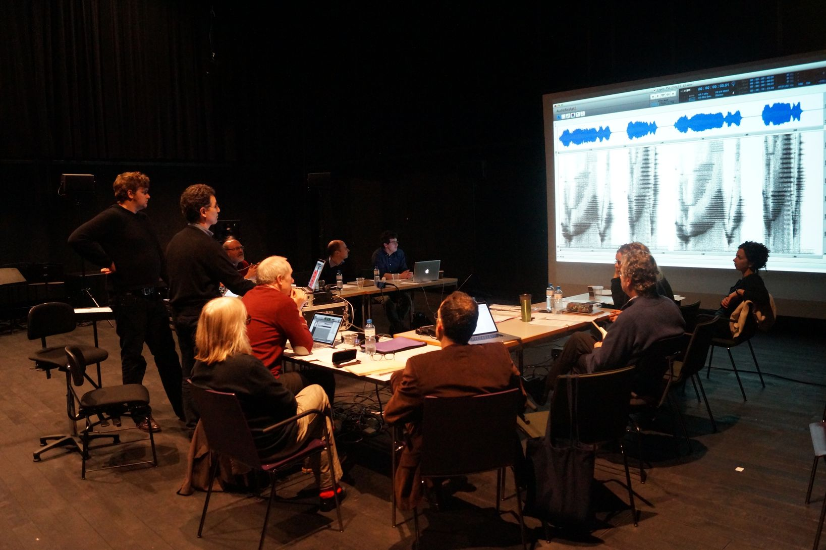Studying test recordings of //Pièce électronique No.3//

Workshops


